**28 CHELTENHAM ROAD, CHELTENHAM**

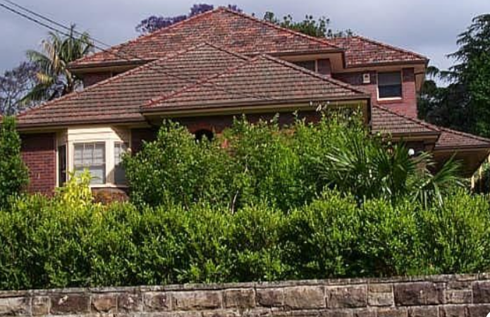

Lot 5 DP 18542

**Hornsby Shire Council details**

**Heritage Register: (NONE)**

Part of Mount Pleasant Estate – Cheltenham 2nd Subdivision 1918

In 1943 the house was occupied by David Douglas Eyre (architect), Elsie Newland Eyre, and Winifred Ellen Eyre (machinist).

David and Elsie Eyre continued to live at 28 Cheltenham-road into the 1950’s, occasionally with other family members.

**Bibliography: none**

**Resources available (varies):**

* Sands Directories 1858-1933 City of Sydney [Sands Postal Directory | City of Sydney Archives (nsw.gov.au)](https://archives.cityofsydney.nsw.gov.au/nodes/view/495003)
* Newspaper articles – TROVE - [Search - Trove (nla.gov.au)](https://trove.nla.gov.au/search/advanced/category/newspapers)
* Ancestry.com (subscription only) [Genealogy, Family Trees and Family History Records online - Ancestry.com](https://www.ancestry.com.au/) – Sands Directories, Electoral Rolls, Family photos (Public Member photos), Census lists, marriage details, + miscellaneous
* N.S.W. Births, Deaths & Marriages [Family history search | NSW Government](https://www.nsw.gov.au/family-and-relationships/family-history-search) (QLD & Victoria also obtainable online)
* House photos and information via Hornsby Shire Council website for Property Search and Heritage Register [Heritage | Hornsby Shire Council (nsw.gov.au)](https://www.hornsby.nsw.gov.au/property/build/heritage)
* House photos and associated information via Internet search on address via Real Estate websites (from 2005)
* “Beecroft and Cheltenham Heritage Walks” - Beecroft-Cheltenham History Group Inc. 2004 book (1st edition)
* Australian War Museum website [Home | Australian War Memorial (awm.gov.au)](https://www.awm.gov.au/)