**28 THE BOULEVARD, CHELTENHAM (“Tibbereenah”, prev. “Verona”)**

Alternate Address(es):  
193 Beecroft Road CHELTENHAM NSW 2119

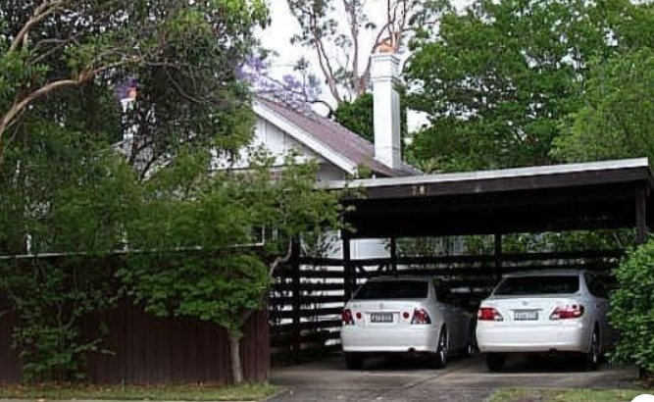

28 The Boulevard Lot 16 DP 5440

193 Beecroft Road Lot 16 DP 5440

**Hornsby Shire Council details**

**Heritage Register: (NONE)**

Part of Mount Pleasant Estate – Cheltenham 1st Subdivision 1908

In May 1912 tenders were called for a large BUNGALOW RESIDENCE, Beecroft-road and Boulevard, Cheltenham, for F. W. Sindel. Plans and specification at the office of the Architect. Tenders close 5th June 1912.

W. HENRY LUMLEY Architect, 113 Pitt-street, city. Tel. 2508 City.

By 1913 Frank William Sindel and Williamena Sindel were living at “Verona.”

*[Frank W. Sindel married Williamena (‘Ena’) Henderson in 1906, district of St. Leonards]*

*Harold Arthur Sindel, brother of Francis William (‘Frank’) Sindel, was living at “Glenview,” 26 The Boulevard in 1913.*

Sands Directories 1915-1920: Frank Sindell “Verona” (died 1919); 1921-1925 W. Kerridge; 1926-1932/3 Wm Davis “Tibbereen”

Electoral Roll 1933: William Davies? No. 28

In 1917 the infant son of Frank & Ena, Wilfred C. Sindel, died at the house.

By 1919 Frank William Sindel had become the North Coast representative of Messrs. Farleigh, Nettheim and Coy., Sydney, and had moved to Lismore.

In July 1919 he died at Lismore of influenza, aged 39 years, survived by a widow and five children.

In October 1919 “Verona” (called “Werona” in the ad) was put up for sale, described as follows:  
CHELTENHAM. – Modern D. F. Brick COTT., slate roof, 5 large rms., kitchen, laundry, every conv., large corner lot, elevated, 4 min. stn., £1450, half cash. WERONA, Boulevard, Cheltenham.

In March 1919 at “Tibbereenah,” previously called “Verona,” a son was born to Walter & Eileen Kerridge, who would later have “Ginjulla,” 50 The Crescent, Cheltenham, built in 1928 as their family home.

By 1927 William Percy Davies (merchant) and Doris Isabel Davies were living at “Tibbereenah.”

*[William P. Davies married Doris I. Austin in 1924, Sydney]*

Electoral Rolls during the 1930’s give their address as 28 The Boulevard, Cheltenham.

William and Doris Davies were still living at the home in 1954 but by 1958 had moved to 23 Mary-street, Beecroft. William died in 1974.

**Bibliography: none**

**Resources available (varies):**

* Sands Directories 1858-1933 City of Sydney [Sands Postal Directory | City of Sydney Archives (nsw.gov.au)](https://archives.cityofsydney.nsw.gov.au/nodes/view/495003)
* Newspaper articles – TROVE - [Search - Trove (nla.gov.au)](https://trove.nla.gov.au/search/advanced/category/newspapers)
* Ancestry.com (subscription only) [Genealogy, Family Trees and Family History Records online - Ancestry.com](https://www.ancestry.com.au/) – Sands Directories, Electoral Rolls, Family photos (Public Member photos), Census lists, marriage details, + miscellaneous
* N.S.W. Births, Deaths & Marriages [Family history search | NSW Government](https://www.nsw.gov.au/family-and-relationships/family-history-search) (QLD & Victoria also obtainable online)
* House photos and information via Hornsby Shire Council website for Property Search and Heritage Register [Heritage | Hornsby Shire Council (nsw.gov.au)](https://www.hornsby.nsw.gov.au/property/build/heritage)
* House photos and associated information via Internet search on address via Real Estate websites (from 2005)
* “Beecroft and Cheltenham Heritage Walks” - Beecroft-Cheltenham History Group Inc. 2004 book (1st edition)
* Australian War Museum website [Home | Australian War Memorial (awm.gov.au)](https://www.awm.gov.au/)
* Beecroft and Cheltenham History Group website [Beecroft and Cheltenham History - Beecroft Cheltenham History Group (bchg.org.au)](https://bchg.org.au/)