**28 THE CRESCENT, CHELTENHAM (“Oriel”)**

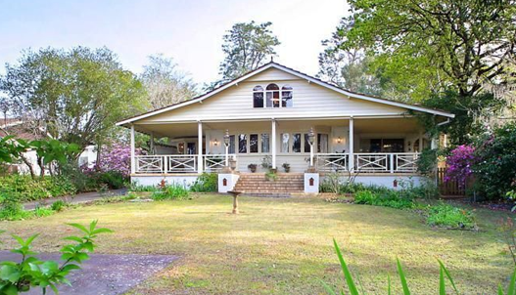

Lot 11 DP 7132

**Hornsby Shire Council details**

**Heritage Register: (NONE)**

Part of Warwick Estate – Cheltenham Subdivision 1913

Currently 28 The Crescent is a house with 6 bedrooms, 4 bathrooms and 3 parking spaces.

Sands Directories 1921-1932/3 James V. Mackaness “Oriel”

Electoral Roll 1933: J. Mackaness No. 28

First reference to “Oriel” was in 1922 was on the birth of George B. Mackaness, son of James & Eleanor Mackaness.

*[James Vincent Mackaness married Eleanor Frances Bellamy in 1915, district of Chatswood]*

In 1923 occurred the death of Edward Bellamy (‘Teddy’) Mackaness, aged 5 years and 4 months, son of James and Eleanor Mackaness.

In 1931 James Mackaness was the secretary of the Cheltenham Bowling Club.

By 1936 the Mackaness family moved to Gladesville and the property was occupied by Charles Henry Golby (dentist), Ethel Jane Golby and Nancy Marian Golby, who would move to 48 The Crescent, Cheltenham by 1943, then no. 28 was occupied by Ralph Abons Earl Delaney (carpet planner) and Eleanor Bellamy Delaney.

The house was last sold in 2007.1

James Vincent Mackaness died in 1956, aged 68 years, in the district of Ashfield.

**Bibliography: none**

1 [28 The Crescent, Cheltenham, NSW 2119 - realestate.com.au](https://www.realestate.com.au/property/28-the-crescent-cheltenham-nsw-2119/)

**Resources available (varies):**

* Sands Directories 1858-1933 City of Sydney [Sands Postal Directory | City of Sydney Archives (nsw.gov.au)](https://archives.cityofsydney.nsw.gov.au/nodes/view/495003)
* Newspaper articles – TROVE - [Search - Trove (nla.gov.au)](https://trove.nla.gov.au/search/advanced/category/newspapers)
* Ancestry.com (subscription only) [Genealogy, Family Trees and Family History Records online - Ancestry.com](https://www.ancestry.com.au/) – Sands Directories, Electoral Rolls, Family photos (Public Member photos), Census lists, marriage details, + miscellaneous
* N.S.W. Births, Deaths & Marriages [Family history search | NSW Government](https://www.nsw.gov.au/family-and-relationships/family-history-search) (QLD & Victoria also obtainable online)
* House photos and information via Hornsby Shire Council website for Property Search and Heritage Register [Heritage | Hornsby Shire Council (nsw.gov.au)](https://www.hornsby.nsw.gov.au/property/build/heritage)
* House photos and associated information via Internet search on address via Real Estate websites (from 2005)
* “Beecroft and Cheltenham Heritage Walks” - Beecroft-Cheltenham History Group Inc. 2004 book (1st edition)
* Australian War Museum website [Home | Australian War Memorial (awm.gov.au)](https://www.awm.gov.au/)