**3 CHELTENHAM ROAD, CHELTENHAM (“Stonehenge”)**

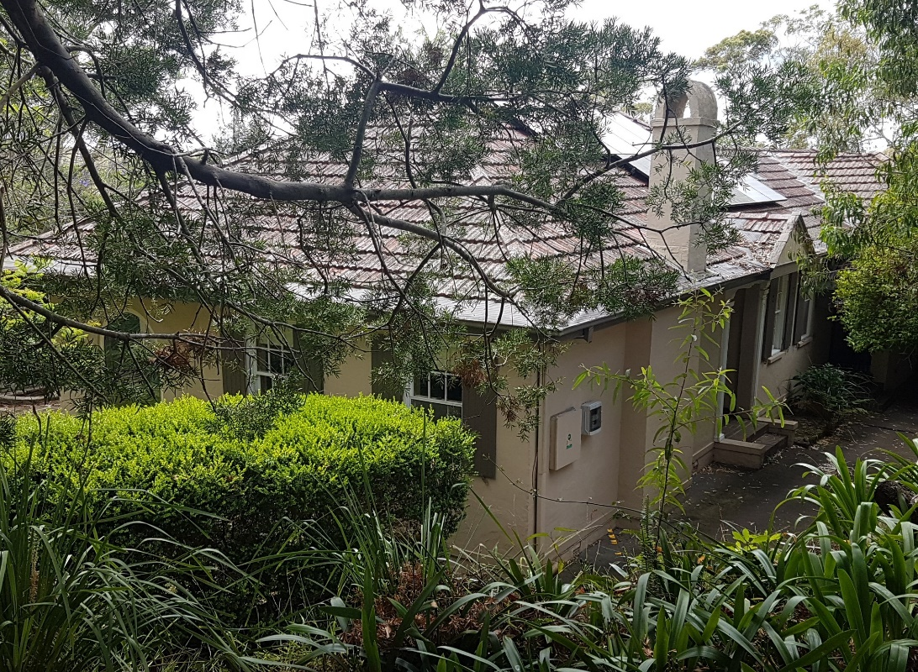

Lot 1 DP 535516

**Hornsby Shire Council details**

**Heritage Register: (NONE)**

Sands Directories

**NOTE**: On the 1901 Crown Lands Subdivision Plan, at the N.S.W. State Library, there is written in pencil the name ‘Allison’ at the commencement of Cheltenham-road (odd numbers) being Lot 588, of 4a 2r 2p. Immediately following, for Lot 589, of 3a 1r 9p, is written the name ‘Chorley.’

These names would have been entered many years later. Joseph A. Allison would live at 3 Cheltenham-road which would have been on Lot 588.

The house was built for Ada Chorley by her father upon her marriage to Joseph Alain Allison.

*[Joseph Alain Allison born 25 Sept 1887, died 5 Mar 1973; married Ada Maud Chorley 26th December 1922, Ryde, N.S.W.]*

***See 4 The Promenade Cheltenham for more particulars on the lives of Joseph and Ada Allison***.

They moved to QLD after their marriage and returned by 1930, residing at 4 The Promenade, Cheltenham.

They occupied *Stonehenge* in 1932 or 1933. The walls are rendered cement over brick. It is still possible to see some of the stonework edging on the garden beds that was done by Mr. Allison. The house has valley views.

They resided there until 1936 but by 1937 had moved to Newcastle, N.S.W.

They celebrated their silver wedding anniversary in 1947. They were then living at “Chorley,” Meron-street, Southport, QLD.

**Bibliography: none**

**Resources available (varies):**

* Sands Directories 1858-1933 City of Sydney [Sands Postal Directory | City of Sydney Archives (nsw.gov.au)](https://archives.cityofsydney.nsw.gov.au/nodes/view/495003)
* Newspaper articles – TROVE - [Search - Trove (nla.gov.au)](https://trove.nla.gov.au/search/advanced/category/newspapers)
* Ancestry.com (subscription only) [Genealogy, Family Trees and Family History Records online - Ancestry.com](https://www.ancestry.com.au/) – Sands Directories, Electoral Rolls, Family photos (Public Member photos), Census lists, marriage details, + miscellaneous
* N.S.W. Births, Deaths & Marriages [Family history search | NSW Government](https://www.nsw.gov.au/family-and-relationships/family-history-search) (QLD & Victoria also obtainable online)
* House photos and information via Hornsby Shire Council website for Property Search and Heritage Register [Heritage | Hornsby Shire Council (nsw.gov.au)](https://www.hornsby.nsw.gov.au/property/build/heritage)
* House photos and associated information via Internet search on address via Real Estate websites (from 2005)
* “Beecroft and Cheltenham Heritage Walks” - Beecroft-Cheltenham History Group Inc. 2004 book (1st edition)
* Australian War Museum website [Home | Australian War Memorial (awm.gov.au)](https://www.awm.gov.au/)