**3 LYNE ROAD, CHELTENHAM**

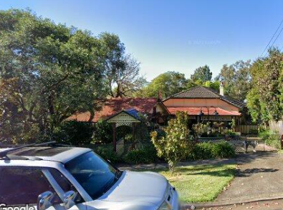

Lot 7 DP 7811

**Hornsby Shire Council details**

**Heritage Register: (NONE)**

From information online the property was last sold in January 1930.

**Problem: The BCHG website states that No. 3 was lived in from at least 1921 until 1933 by Edward Austin; and No. 5, *Stoke*, was lived in from at least 1922 by Mrs A Burrows and then from 1923 to 1932 by the Harton family.**

[No. 3 should be No. 5 and No. 5 should be No. 7}

**Note**: Sheffield Ernest Harton also owned “Stoke,” no. 7 Lyne-road, Cheltenham, although “Stoke” is referred to in the BCHG website as No.5.

In February 1933 No. 3 was offered for rent, described as follows:

‘Bungalow, 4 bedrooms, 2 reception, kitchen, large sleeping-out verandah.’

However, in August 1933, Sheffield Ernest Harton advertised to Agents and others that his property, No. 3 Lyne-road, Cheltenham, was withdrawn from sale and letting.

**Bibliography: none**

**Resources available (varies):**

* Sands Directories 1858-1933 City of Sydney [Sands Postal Directory | City of Sydney Archives (nsw.gov.au)](https://archives.cityofsydney.nsw.gov.au/nodes/view/495003)
* Newspaper articles – TROVE - [Search - Trove (nla.gov.au)](https://trove.nla.gov.au/search/advanced/category/newspapers)
* Ancestry.com (subscription only) [Genealogy, Family Trees and Family History Records online - Ancestry.com](https://www.ancestry.com.au/) – Sands Directories, Electoral Rolls, Family photos (Public Member photos), Census lists, marriage details, + miscellaneous
* N.S.W. Births, Deaths & Marriages [Family history search | NSW Government](https://www.nsw.gov.au/family-and-relationships/family-history-search) (QLD & Victoria also obtainable online)
* House photos and information via Hornsby Shire Council website for Property Search and Heritage Register [Heritage | Hornsby Shire Council (nsw.gov.au)](https://www.hornsby.nsw.gov.au/property/build/heritage)
* House photos and associated information via Internet search on address via Real Estate websites (from 2005)
* “Beecroft and Cheltenham Heritage Walks” - Beecroft-Cheltenham History Group Inc. 2004 book (1st edition)
* Australian War Museum website [Home | Australian War Memorial (awm.gov.au)](https://www.awm.gov.au/)