**30 BORONIA AVENUE, CHELTENHAM (“Acacia”)**

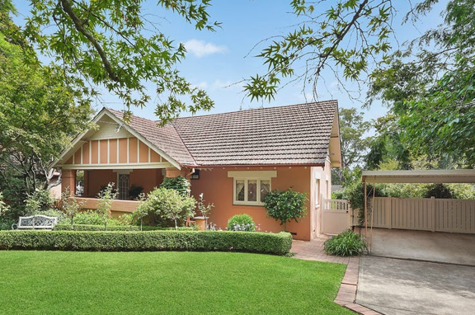

Lot 21 DP 588523

**Hornsby Shire Council details**

**Heritage Register: (NONE)**

In 1913 the house was occupied by Mervyn Kenneth Mackenzie (master engineer) and Jessica Muriel Mackenzie.

*[Mervyn K. Mackenzie married Jessica M. Tanner in 1910, in the district of Randwick]*

In 1915 their son was born there, the house then referred to as “Acacia.”

1915-1916 Merv. McKenzie “Acacia”; 1917 William Allsep; 1918 John Adair; 1920 Hartley; 1921-2 George E. Davis; 1923 Edward H. Hayes; 1924 Allan Ferguson; 1925 E. J. Giles “Acacia”; 1931-1932/3 Alex Sneddon

Electoral Roll 1933 ?

By 1917 the house was occupied by William Allsep.

By 1924 Alan Ferguson occupied the house, His wife, Amy Margaret, died there in that year, aged 29 years. Soon after, E. J. Giles was resident.

By 1930 Geoffrey Robinson was in residence.

The house was put up for sale in 1931, described as:

‘CHELTENHAM, 30 Boronia-ave. - Modern Home, 1 acre, suit flowers, poultry, some bush, £1450. Take small Home, close city, and cash difference. Owner on property.’

Robert Algernon Fox (medical practitioner), and his wife Mary Isabella Fox, then lived there.

[ Robert A. Fox - M.B., M.S., 1898, Univ. Edin. Fox, Walter, New Zealand. M.B., M.S., 1886, Univ. Glasg.]

By 1934 they had moved to Wollstonecraft.

By 1936 it was the home of Austin Bernard Lodge Campion (dairy farmer) & Maria Day Campion.

Austin Campion died in 1942, at Yaralla Military Hospital in Sydney, survived by a widow and one daughter. He was a Lieutenant in the 1914-18 war, and saw service in France. For a number of years after the war he was Secretary of Beecroft-Pennant Hills Sub-Branch of the RSS and AILA, and when WW2 broke out he enlisted again, and was a Corporal at Victoria Barracks.

In 1943 his widow, Lillian Constance May Campion, was still in residence at 30 Boronia-avenue, Cheltenham.

The house was last sold in 2020.**1**

**Bibliography:**

1 [30 Boronia Avenue, Cheltenham, NSW 2119 - Property Details (realestate.com.au)](https://www.realestate.com.au/sold/property-house-nsw-cheltenham-132892478)

**Resources available (varies):**

* Sands Directories 1858-1933 City of Sydney [Sands Postal Directory | City of Sydney Archives (nsw.gov.au)](https://archives.cityofsydney.nsw.gov.au/nodes/view/495003)
* Newspaper articles – TROVE - [Search - Trove (nla.gov.au)](https://trove.nla.gov.au/search/advanced/category/newspapers)
* Ancestry.com (subscription only) [Genealogy, Family Trees and Family History Records online - Ancestry.com](https://www.ancestry.com.au/) – Sands Directories, Electoral Rolls, Family photos (Public Member photos), Census lists, marriage details, + miscellaneous
* N.S.W. Births, Deaths & Marriages [Family history search | NSW Government](https://www.nsw.gov.au/family-and-relationships/family-history-search) (QLD & Victoria also obtainable online)
* House photos and information via Hornsby Shire Council website for Property Search and Heritage Register [Heritage | Hornsby Shire Council (nsw.gov.au)](https://www.hornsby.nsw.gov.au/property/build/heritage)
* House photos and associated information via Internet search on address via Real Estate websites (from 2005)
* “Beecroft and Cheltenham Heritage Walks” - Beecroft-Cheltenham History Group Inc. 2004 book (1st edition)
* Australian War Museum website [Home | Australian War Memorial (awm.gov.au)](https://www.awm.gov.au/)