**30 THE CRESCENT, CHELTENHAM**

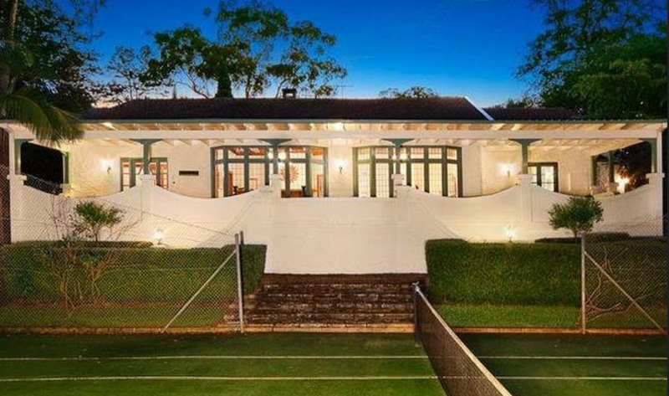

Lot 22 DP 544044

**Hornsby Council details**

**Heritage Register: (NONE)**

No, 32 (Lot 21 DP 544044), a new house, is built in front of No. 30. Assumed to be portion of the site of the home of Frank Buckle (No. 30).

**[Problem: some confusion with numbering, e.g., Weetalabah,” No. 18 was renumbered No. 24a. Houses only done from No. 28 as preceding houses are now within Beecroft]**

Sands Directories 1921-22 Kenneth McEvoy; 1924-1932/3 Francis Buckle Cheltenham-crescent

Electoral Roll 1933: moved to Warringah

Houses from Murray-road to The Promenade in 1924, and for some years after, are “Oriel” No. 28 (James Mackaness), Frank Buckle and “Yallambee” (Robert Vicars). Therefore No. 30 is a logical choice for Frank Buckle’s home.

Nothing is known of perhaps the 1st occupant, Kenneth McEvoy.

Frank Buckle was an architect who may have either built an entirely new house or extensively renovated the original house.

Frank was born in 1891, the son of Francis & Dora Buckle, in Sydney.

*The father of Francis Buckle senior was a steamboat proprietor and owned many of the wharves in the Balmain district, which later became very valuable, leaving the family independent. His family was quite large, consisting of 9 children. He was managing director of the shipping firm of F. Buckle and Sons. On the 20th November 1909 a major fire broke out in the timber yards of Pyrmont and severely damaged Mr. Buckle’s bond stores. He assisted in saving the 10-12 horses in the yards of the British and Imperial Oil Company. The following day Mr. Buckle (the elder) died, aged 73 years.*

Francis Buckle (III), son of Francis Buckle (II) and grandson of Francis Buckle (I), married Doris Robertson Glover in 1921, district of Sydney.

He was known as a noted hard-hitting grade cricket captain, and former manager of the N.S.W. XL in his younger days.

[NOTE: Frank Buckle was related to the Perdriau family of Beecroft – Frank’s cousin, Alexander Croll Buckle, married in 1919 Florence, daughter of Henry Perdriau, founder of the rubber empire.

The Buckles were apparently living in Cheltenham or nearby in late 1922. In August he accepted the tender for a large block of two-storey stores to be built at Pyrmont, as well as accepting the tender to erect a garage at Cheltenham. When in November 1922 the Cheltenham green was officially re-opened for the season, a flag was presented by Mrs. F. Buckle.

In February 1923 tenders were accepted for the erection of a large residence at Cheltenham: Frank Buckle [architect], 107 Pitt-street. Closing February 19. Later that month tenders were open for a large quantity of stonewalling to a residence at Cheltenham.

*(This may be 10-12 The Boulevard, the home of his brother, John Wiseman Buckle)*

In April 1924 tenders were accepted for the erection of a large residence at Cheltenham; Buckle and Carfrae, 84 Pitt-street (assumed to be another residence to that of one mentioned above).

In February 1928 another large Cheltenham residence was designed by Messrs. Buckle, Carfrae, and Turner, architects. Mr. H. V. Horwood, of Parramatta, was the builder.

In August 1928 it was reported that Frank Buckle, architect, and a keen collector of birds (aviculturist], had at that time 400-500 birds in his aviary – at one time he had 2000 - comprising such kinds as the piliated finch, red-crested finch, Cuban finch, indigo bunting, nonpareil bunting, green strawberry finch, paradise tanager, blue tanager, palm tanager, scarlet tanager, and many others, including the little mistletoe bird, which eats a banana a day — more than its own weight in food. His collection was then worth over £500. His aviaries were considered being among the most extensive and best-kept in the Commonwealth. Mostly specialising in finches, however, Mr. Buckle had species from many parts of the world. In 1931 Frank Buckle was president of the Avicultural Society of N.S.W.

Other aviculturists in the area were Mr. Heumann, at Beecroft, and Mr. Waxman [Wachsmann] at Cheltenham. There was keen but friendly rivalry between the breeders.

That year the book “Australian Finches in Bush and Aviary,” was published, in which Frank Buckle, R.A.U.O., contributed a chapter on the housing and feeding of the birds.

In 1933 Frank Buckle moved to Warringah and the house was put up for sale, described as follows:

Attractive Modern Bungalow, In spacious Grounds,

CHELTENHAM

30 CHELTENHAM-AVENUE

Commanding extensive views and within 5 minutes’ walk of Station

MODERN BUNGALOW RESIDENCE, standing in extensive and attractive grounds substantially constructed of Brick, roughcast with Roof of Tiles, having 2 Front Verandahs, Hall, Large LIVING ROOM (with attractive Fireplace Beamed Celling), DINING ROOM, 3 BED-ROOMS, Tiled BATHROOM with every modern convenience. Modern KITCHEN, separate Laundry with Gas Copper, etc., 2 Lavatories, Linen Press, Walk-in Pantry.

FLOORS of main rooms are of polished Jarrah.

Detached Commodious GARAGE of Fibro, with Concrete Wash.

GROUNDS have been attractively laid out with gravelled drives and paths, fish pond and rock garden, about 20 fruit Trees, Kitchen Garden, extensive Poultry Runs, Water Service throughout Garden.

THE LAND has a frontage of about 129ft [39.3m] to CHELTENHAM AVENUE, by depths of about 452ft [138m] and 493ft [150.2m] respectively, rear line about 114ft 6in [34.7m].

TORRENS TITLE. VERY EASY TERMS.1

*[During 1937 & 1938 Frank Buckle was tendering for additions to a pavilion at Chatswood Park; a dance hall at the Mechanics’ Institute, Mudgee; additions to Duco Works in Mudgee; and a residence at Wahroonga.*

*Frank Buckle (III) died in 1982.]*

Sands Directories: 1925-1932/3 Francis Goulder 14 The Crescent

Francis Goulder, chemist, who had been living at “Winbourne,” [14] The Crescent, Cheltenham/Beecroft since 1925, would become the new owner/occupier of No. 30 The Crescent.

*[Francis Goulder, born abt. 1891, married Edith Crowther Farmilo 1920, Sydney]*

In 1935 Francis Goulder, aged 44 years, died at his residence, leaving his widow and four children. During WW1 he was with the 1st Field Company Engineers.

In 1937 Edith Goulder was still living at No. 30 with Elizabeth Marjorie O’Brien living at No. 14 (the Goulder’s previous house).

In 1942 Edith’s daughter, Muriel Ada Goulder, was engaged to Edward Phillip, only son of Mr. and Mrs. E. P. Austin, of Cheltenham.

Edith Goulder remained at No. 30 into the 1960’s.

The house was last sold in 2012.2

**Bibliography:**

1 Sydney Morning Herald, 16th September 1933

2 [30 The Crescent, Cheltenham, NSW 2119 - Property Details (realestate.com.au)](https://www.realestate.com.au/sold/property-house-nsw-cheltenham-109735266)

**Resources available (varies):**

* Sands Directories 1858-1933 City of Sydney [Sands Postal Directory | City of Sydney Archives (nsw.gov.au)](https://archives.cityofsydney.nsw.gov.au/nodes/view/495003)
* Newspaper articles – TROVE - [Search - Trove (nla.gov.au)](https://trove.nla.gov.au/search/advanced/category/newspapers)
* Ancestry.com (subscription only) [Genealogy, Family Trees and Family History Records online - Ancestry.com](https://www.ancestry.com.au/) – Sands Directories, Electoral Rolls, Family photos (Public Member photos), Census lists, marriage details, + miscellaneous
* N.S.W. Births, Deaths & Marriages [Family history search | NSW Government](https://www.nsw.gov.au/family-and-relationships/family-history-search) (QLD & Victoria also obtainable online)
* House photos and information via Hornsby Shire Council website for Property Search and Heritage Register [Heritage | Hornsby Shire Council (nsw.gov.au)](https://www.hornsby.nsw.gov.au/property/build/heritage)
* House photos and associated information via Internet search on address via Real Estate websites (from 2005)
* “Beecroft and Cheltenham Heritage Walks” - Beecroft-Cheltenham History Group Inc. 2004 book (1st edition)
* Australian War Museum website [Home | Australian War Memorial (awm.gov.au)](https://www.awm.gov.au/)