**32 BORONIA AVENUE, CHELTENHAM**

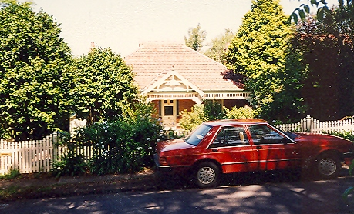

Lot 1 DP 556740

**Hornsby Shire Council details**

**Heritage Register: Item 270**

This listed Federation bungalow was built c1910, however this date cannot be determined.

No. 30 “Acacia” has no heritage listing and can be traced back to 1913. This property consisted of 1 acre in 1931.

In 1933 “Acacia” was occupied by Robert Algernon Fox.

No. 34 “Tarawera” has no heritage listing and can be traced back to 1907. This property consisted of 2 acres in 1907.

In 1933 “Tarawera” was occupied by Frederick Charles Johnson.

Sands Directories 1931 G. Powell; 1932/3 A. H. Tozer “Galteemore”

Electoral Roll 1932/3: Rachel Tozer No. 32

The early Sands Directories do not place a house between No. 30 and No. 34.

The Heritage Study (1993) may shed some light on the matter.

In 1933 No. 32 was occupied by Thomas Stewart (boot merchant), Rachel Stewart, Jeanie Jackson Hunter, Mary Hunter (shop assistant) and Rachel Tozer (home duties)

In 1935 Jeannie Jackson Hunter died, her late residence being 32 Boronia-avenue.

In 1937 Thomas Hunter was still living at this address.

By 1943 the house was occupied by Harold Sydney Blake (advertiser), Ethel Blake and Elsie Winfred Clarke.

In 1947 William Joseph Henry Burton, resident of this address, died, aged 47 years.

The house was last sold in 1991.