**32 CHELTENHAM ROAD, CHELTENHAM (“Coorong”)**

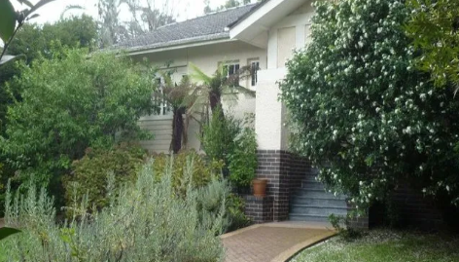

Lot Y DP 400351

**Hornsby Shire Council details**

**Heritage Register: (NONE)**

Part of Mount Pleasant Estate – Cheltenham 2nd Subdivision 1918

Said to have been occupied by members of the Arnott family.

Sands Directories 1920-1932/33 A. N. Brodie “Coo-ee”

Electoral Roll 1933: Alexander Brodie No. 32

In 1920 A. N. Brodie is living in Cheltenham-road, Cheltenham.

*[Alexander Neil Brodie married Ellen Elizabeth Savage Dill-Macky in 1911, Sydney]*

**Alexander Neil Brodie (1878-1944)**

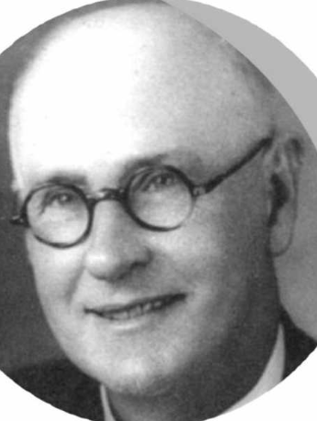

In 1925 A. N. Brodie is listed as living at “Cooyong,” Cheltenham-road.

In 1933 Alexander Neil Brodie (dentist) & Ellen Elizabeth Savage Brodie were still in occupancy.

In 1937 Alexander Neil Brodie (dentist), Ellen Elizabeth Savage Brodie, Gordon Marcus Brodie (student), Nellie West (home duties) are residents.

In 1944, at his Cheltenham residence, Alexander Neil Brodie, died, leaving his widow Ellen Elizabeth Brodie, and sons Len (Tooraweenah), Captain Gordon (A.I.F.), Ian, and Signaller Arthur (A.I.F.). *[In 1946 Arthur Brodie married June Fitzhardinge of Springwood]*

Up to 1972 Ellen Elizabeth Savage Brodie continued living at 32 Cheltenham-road.

Ellen died in 1979.

The house was probably later sold to a member of the Arnott family.

**Bibliography: none**

**Resources available (varies):**

* Sands Directories 1858-1933 City of Sydney [Sands Postal Directory | City of Sydney Archives (nsw.gov.au)](https://archives.cityofsydney.nsw.gov.au/nodes/view/495003)
* Newspaper articles – TROVE - [Search - Trove (nla.gov.au)](https://trove.nla.gov.au/search/advanced/category/newspapers)
* Ancestry.com (subscription only) [Genealogy, Family Trees and Family History Records online - Ancestry.com](https://www.ancestry.com.au/) – Sands Directories, Electoral Rolls, Family photos (Public Member photos), Census lists, marriage details, + miscellaneous
* N.S.W. Births, Deaths & Marriages [Family history search | NSW Government](https://www.nsw.gov.au/family-and-relationships/family-history-search) (QLD & Victoria also obtainable online)
* House photos and information via Hornsby Shire Council website for Property Search and Heritage Register [Heritage | Hornsby Shire Council (nsw.gov.au)](https://www.hornsby.nsw.gov.au/property/build/heritage)
* House photos and associated information via Internet search on address via Real Estate websites (from 2005)
* “Beecroft and Cheltenham Heritage Walks” - Beecroft-Cheltenham History Group Inc. 2004 book (1st edition)
* Australian War Museum website [Home | Australian War Memorial (awm.gov.au)](https://www.awm.gov.au/)