**33 CHELTENHAM ROAD, CHELTENHAM (“Hopetoun”)**

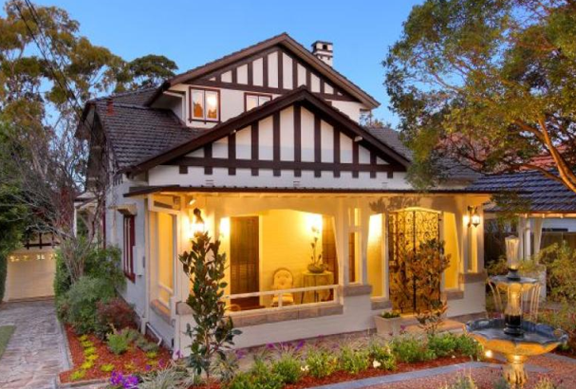

Lot 38 DP 5440

**Hornsby Shire Council details**

**Heritage Register: (NONE)**

Part of Mount Pleasant Estate – Cheltenham 1st Subdivision 1908

Sands Directories 1921-30 Edwin F. Taylor

Electoral Roll 1933: ?

In 1923 Edwin Sydney Taylor occupied the house and lived there until 1930.

*[Edwin S. Taylor married Isobel Fallover in 1916, district of Ashfield]*

In 1937 Isaac Joll Broad (no occupation; born N.Z.) and his wife Monica Irene were living there.

In 1949 Monica Irene Broad, of 33 Cheltenham-road, Cheltenham, died.

In 1955 Isaac Joll Broad, of the same address also died.

The house was last sold in 2008, named “Hopetoun.”1

**Bibliography:**

1 [33 Cheltenham Road, Cheltenham, NSW 2119 - Property Details (realestate.com.au)](https://www.realestate.com.au/sold/property-house-nsw-cheltenham-104974168)

**Resources available (varies):**

* Sands Directories 1858-1933 City of Sydney [Sands Postal Directory | City of Sydney Archives (nsw.gov.au)](https://archives.cityofsydney.nsw.gov.au/nodes/view/495003)
* Newspaper articles – TROVE - [Search - Trove (nla.gov.au)](https://trove.nla.gov.au/search/advanced/category/newspapers)
* Ancestry.com (subscription only) [Genealogy, Family Trees and Family History Records online - Ancestry.com](https://www.ancestry.com.au/) – Sands Directories, Electoral Rolls, Family photos (Public Member photos), Census lists, marriage details, + miscellaneous
* N.S.W. Births, Deaths & Marriages [Family history search | NSW Government](https://www.nsw.gov.au/family-and-relationships/family-history-search) (QLD & Victoria also obtainable online)
* House photos and information via Hornsby Shire Council website for Property Search and Heritage Register [Heritage | Hornsby Shire Council (nsw.gov.au)](https://www.hornsby.nsw.gov.au/property/build/heritage)
* House photos and associated information via Internet search on address via Real Estate websites (from 2005)
* “Beecroft and Cheltenham Heritage Walks” - Beecroft-Cheltenham History Group Inc. 2004 book (1st edition)
* Australian War Museum website [Home | Australian War Memorial (awm.gov.au)](https://www.awm.gov.au/)