**34 BORONIA AVENUE, CHELTENHAM (“Tarawera”)**

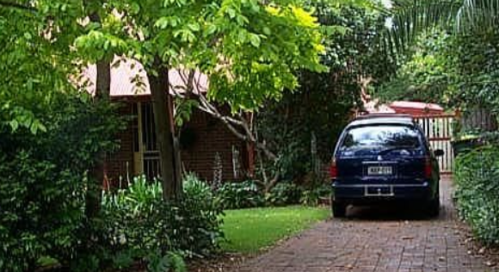

Lot 1 DP 565364

**Hornsby Shire Council details**

**Heritage Register: (NONE)**

The first known occupant was Frederick Charles Johnson.

Sands Directories 1915-1932/3: Frederick Johnson “Tarawera”

Electoral Roll 1933: Frederick Johnson No. 34

1934 Electoral Roll: Frederick Charles Johnson, Frances Johnson – 34 Boronia-avenue, Cheltenham

In 1901 Frederick Charles Johnson was the occupant of the house, the household consisted of 2 males and one female.

*[Frederick C. Johnson married Frances Barker in 1899, in the district of St. Leonards; a son, Frederick C. was born in 1900]*

The Hornsby Council Rates Books of 1907-09 give the following details:

Owner & Occupier: Frederick Johnson, clerk, Castle Howard Road, Beecroft - 2 acres, 77 x 331ft.

In 1913 Frederick C. Johnson is recorded as a civil servant, but by the 1930’s a draftsman.

The house was first referred to as “Tarawera” in 1915, perhaps named after a volcano in the north island of New Zealand.

In 1952 Frances Johnson died at 34 Boronia-avenue, Cheltenham, survived by her husband and three children.

**Bibliography:**

1

**Resources available (varies):**

* Sands Directories 1858-1933 City of Sydney [Sands Postal Directory | City of Sydney Archives (nsw.gov.au)](https://archives.cityofsydney.nsw.gov.au/nodes/view/495003)
* Newspaper articles – TROVE - [Search - Trove (nla.gov.au)](https://trove.nla.gov.au/search/advanced/category/newspapers)
* Ancestry.com (subscription only) [Genealogy, Family Trees and Family History Records online - Ancestry.com](https://www.ancestry.com.au/) – Sands Directories, Electoral Rolls, Family photos (Public Member photos), Census lists, marriage details, + miscellaneous
* N.S.W. Births, Deaths & Marriages [Family history search | NSW Government](https://www.nsw.gov.au/family-and-relationships/family-history-search) (QLD & Victoria also obtainable online)
* House photos and information via Hornsby Shire Council website for Property Search and Heritage Register [Heritage | Hornsby Shire Council (nsw.gov.au)](https://www.hornsby.nsw.gov.au/property/build/heritage)
* House photos and associated information via Internet search on address via Real Estate websites (from 2005)
* “Beecroft and Cheltenham Heritage Walks” - Beecroft-Cheltenham History Group Inc. 2004 book (1st edition)
* Australian War Museum website [Home | Australian War Memorial (awm.gov.au)](https://www.awm.gov.au/)