**34 CHELTENHAM ROAD, CHELTENHAM**

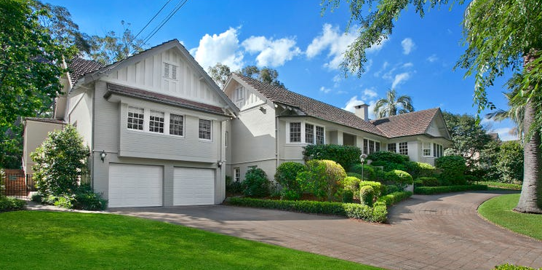

Lots 69 & 70 DP 9085

Sands Directories 1931-32/3 Geoff. Arnot

Electoral Roll 1933: Geoffrey Arnott No. 34

**Hornsby Shire Council details**

**Heritage Register: (NONE)**

Geoffrey Arnott was the first occupant in 1931.

*[In January 1926 Geoffrey Harold Arnott, second son of Mr. and Mrs. H. L. Arnott, of Beecroft, was married to Helen Annie (Nellie), eldest daughter of Mr. and Mrs. F. C. Johnson, of Cheltenham.]*

In 1933 occupants were Geoffrey Harold Arnott (engineer) and Helen Annie Arnott.

In 1943 occupants were Geoffrey Harold Arnott (engineer), Helen Annie Arnott, Lillian Maude Bushell, Zelda Hayman (nurse).

In 1954 Brian Keith, younger son of Mr. and Mrs. G. H. Arnott, of Cheltenham, was married to Patricia, elder daughter of Mr. and Mrs. R. R. Wood of Pennant Hills.

In 1981 Helen Annie Arnott, of Cheltenham, died.

In 1986 Geoffrey Harold Arnott, company director, of Cheltenham, died.

The house was last sold in 2018.1

**Bibliography:**

1 [34 Cheltenham Road, Cheltenham, NSW 2119 - Property Details (realestate.com.au)](https://www.realestate.com.au/sold/property-house-nsw-cheltenham-126819018)

**Resources available (varies):**

* Sands Directories 1858-1933 City of Sydney [Sands Postal Directory | City of Sydney Archives (nsw.gov.au)](https://archives.cityofsydney.nsw.gov.au/nodes/view/495003)
* Newspaper articles – TROVE - [Search - Trove (nla.gov.au)](https://trove.nla.gov.au/search/advanced/category/newspapers)
* Ancestry.com (subscription only) [Genealogy, Family Trees and Family History Records online - Ancestry.com](https://www.ancestry.com.au/) – Sands Directories, Electoral Rolls, Family photos (Public Member photos), Census lists, marriage details, + miscellaneous
* N.S.W. Births, Deaths & Marriages [Family history search | NSW Government](https://www.nsw.gov.au/family-and-relationships/family-history-search) (QLD & Victoria also obtainable online)
* House photos and information via Hornsby Shire Council website for Property Search and Heritage Register [Heritage | Hornsby Shire Council (nsw.gov.au)](https://www.hornsby.nsw.gov.au/property/build/heritage)
* House photos and associated information via Internet search on address via Real Estate websites (from 2005)
* “Beecroft and Cheltenham Heritage Walks” - Beecroft-Cheltenham History Group Inc. 2004 book (1st edition)
* Australian War Museum website [Home | Australian War Memorial (awm.gov.au)](https://www.awm.gov.au/)