**35 CHELTENHAM ROAD, CHELTENHAM (“Fairhaven”)**

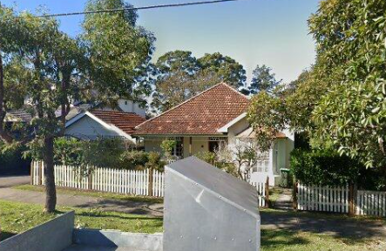

Lot 39 DP 5440

**Hornsby Shire Council details**

**Heritage Register: (NONE)**

Part of Mount Pleasant Estate – Cheltenham 1st Subdivision 1908

Sands Directory 1915-22 Percival C. Greaves “Fairhaven”; 1923 Henry Buckle; 1926-1932/33 Roland Isherwood

Electoral Roll 1933: Rowland Isherwood No. 30

In 1913 occupants of “Fairhaven” were Percival Charles Greaves (accountant), and Ellen Greaves. That year their daughter, Barbara E., was born at “Fairhaven.”

*[Percival C. Greaves married Ellen Holland 21 Dec 1906 Marrickville]*

The 1918 Mount Pleasant Estate-Cheltenham Subdivision Plan shows the home of Mr. Greaves.

By 1923 Mr Greaves had moved to Campsie and Henry Buckle occupied the house.

*[Henry J. Buckle married Katherine L. Mayman in 1913, district of Hurstville]*

By 1927 Roland Isherwood (clerk) and his wife Alice Mary were the occupants.

By 1943 the Isherwoods had moved to Strathfield and the house was then occupied by Florence Margaret Whittle.

**Bibliography: none**

**Resources available (varies):**

* Sands Directories 1858-1933 City of Sydney [Sands Postal Directory | City of Sydney Archives (nsw.gov.au)](https://archives.cityofsydney.nsw.gov.au/nodes/view/495003)
* Newspaper articles – TROVE - [Search - Trove (nla.gov.au)](https://trove.nla.gov.au/search/advanced/category/newspapers)
* Ancestry.com (subscription only) [Genealogy, Family Trees and Family History Records online - Ancestry.com](https://www.ancestry.com.au/) – Sands Directories, Electoral Rolls, Family photos (Public Member photos), Census lists, marriage details, + miscellaneous
* N.S.W. Births, Deaths & Marriages [Family history search | NSW Government](https://www.nsw.gov.au/family-and-relationships/family-history-search) (QLD & Victoria also obtainable online)
* House photos and information via Hornsby Shire Council website for Property Search and Heritage Register [Heritage | Hornsby Shire Council (nsw.gov.au)](https://www.hornsby.nsw.gov.au/property/build/heritage)
* House photos and associated information via Internet search on address via Real Estate websites (from 2005)
* “Beecroft and Cheltenham Heritage Walks” - Beecroft-Cheltenham History Group Inc. 2004 book (1st edition)
* Australian War Museum website [Home | Australian War Memorial (awm.gov.au)](https://www.awm.gov.au/)