**36 CHELTENHAM ROAD, CHELTENHAM (“Kailoa”)**

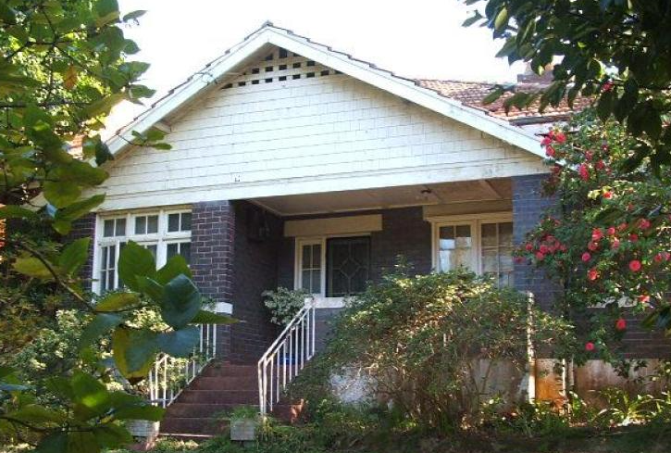

Lot 71 DP 9085

**Hornsby Shire Council details**

**Heritage Register: (NONE)**

Part of Mount Pleasant Estate – Cheltenham 2nd Subdivision 1918

Sands Directories 1924-1930 Arthur E. Snowball “Kailon”; 1931-1932/33 J. Gardener “Kailsa”

Electoral Roll 1933: Meophani Gardner “Kailoa”

**Sands Directories**

In 1924 Arthur E. Snowball was living at this address.

*[Arthur Edward Snowball married Jean McGregor Fairweather in 1923, Drummoyne]*

His brother, Frederick Restell Snowball, moved into his home, “Woongara,” 46 Cheltenham-road, Cheltenham, about the same time.

In 1931 the Snowball family moved to 4 The Promenade, Cheltenham.

The house was then occupied by Meopham Methuen Gardner (civil servant) and his wife Elizabeth Gardner.

In 1935 Mrs. Gardner’s mother, Alma Ann Ash, aged 80 years, died at 36 Cheltenham-road.

The Gardner family were still living in the house in 1943.

The house was last sold in 2006.1

**Bibliography:**

1 [36 Cheltenham Road, Cheltenham, NSW 2119 - Property Details (realestate.com.au)](https://www.realestate.com.au/sold/property-house-nsw-cheltenham-106297865)

**Resources available (varies):**

* Sands Directories 1858-1933 City of Sydney [Sands Postal Directory | City of Sydney Archives (nsw.gov.au)](https://archives.cityofsydney.nsw.gov.au/nodes/view/495003)
* Newspaper articles – TROVE - [Search - Trove (nla.gov.au)](https://trove.nla.gov.au/search/advanced/category/newspapers)
* Ancestry.com (subscription only) [Genealogy, Family Trees and Family History Records online - Ancestry.com](https://www.ancestry.com.au/) – Sands Directories, Electoral Rolls, Family photos (Public Member photos), Census lists, marriage details, + miscellaneous
* N.S.W. Births, Deaths & Marriages [Family history search | NSW Government](https://www.nsw.gov.au/family-and-relationships/family-history-search) (QLD & Victoria also obtainable online)
* House photos and information via Hornsby Shire Council website for Property Search and Heritage Register [Heritage | Hornsby Shire Council (nsw.gov.au)](https://www.hornsby.nsw.gov.au/property/build/heritage)
* House photos and associated information via Internet search on address via Real Estate websites (from 2005)
* “Beecroft and Cheltenham Heritage Walks” - Beecroft-Cheltenham History Group Inc. 2004 book (1st edition)
* Australian War Museum website [Home | Australian War Memorial (awm.gov.au)](https://www.awm.gov.au/)