**36 THE CRESCENT, CHELTENHAM (“YALLAMBEE”)**

**(Demolished – property now Cheltenham Girls High School)**

**“Yallambee” - The home of Robert and Violet Vicars**

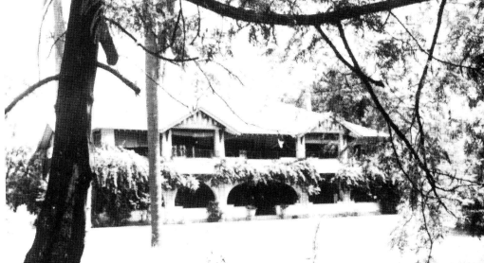

The word “Yallambee” is derived from an aboriginal word “nglambi”, which means “to rest or to remain” but interpreted to mean “to dwell at ease.”

Sands Directories 1917-1932/3 Robert Vicars “Yallambee”

Electoral Roll 1933: Robert Vicars No. 36

**Robert and Violet Vicars**

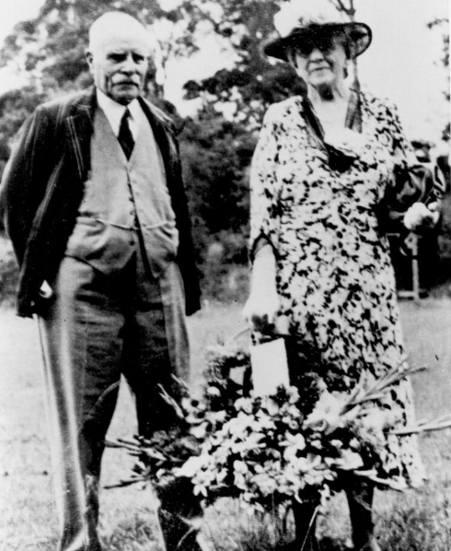

**The Land**

In September 1915 Violet Halliday Vicars purchased 2 ½ acres of land on the southern side of The Crescent (known then as Cheltenham Crescent), from Lily Virginia Chorley. The original grantee was William Chorley in 1894, who had transferred it to his wife Lily in 1900.

Lily Chorley laid a restrictive covenant on the land when she sold it to Mrs Vicars: *“To erect on this land a residence to cost and be of the value of £2000 such residence to be built of brick or stone with a roof of slates, tiles or shingles and to be erected within 18 months from the 28th day of March 1915.”*

The Vicars purchased more land from the Chorleys, increasing the “Yallambee” property to a five-acre block between Beecroft Road, The Promenade (which was put in at this time), and The Crescent.

The house was built well back from The Promenade, facing east.

After Robert Vicar’s died in 1962, part of the property was purchased by the Department of Education for the building of Cheltenham Girls High School. After Mrs. Vicars's death in 1970, the remainder of the property was taken for school extensions, and the house was demolished in 1971.

**The House**

Covering 11,500 square feet, “Yallambee” was designed by Robert’s brother, James Vicars, an architect-engineer. The builder was Edward Newlyn, and the cost £4250.

It was two-storeyed, of brick with a rough-cast exterior and deep verandahs with curved stone arches.

The entrance hall was fully panelled in Queensland oak, and the front stairs were of the same timber; the ceiling of the entrance hall was timbered with beams.

A large circular leadlight window on the stair landing was of a sailing ship and bore the motto 'East west Hame's best'.

Billiard room, drawing room, dining room and the children's dining room were also panelled in the dark Queensland oak. The fireplace in the billiard room had a mantle and surround of that timber.

On the upper floor were five bedrooms, two maids' rooms, and three bathrooms. Wall tiles were imported from the United States. Flooring was Dorrigo pine and jarrah, and the verandah floors white beech. The roof was Welsh purple Bangor slate.

Gas fires were installed when the house was built, but one of these - in the billiard room - was turned into an open wood-burning fireplace. The house had its own generator for electric light. (Electricity did not arrive in Beecroft until the 1920’s.)

A gardener's cottage stood in the grounds behind the house. A septic tank was installed in 1916, whilst the house was being built. A large garage was built in 1921, and during the Second World War it was used to house ambulances; the house cellar was designated an Air Raid Shelter.

Gardens were extensive. A long curving driveway from the entrance gates on the corner of The Crescent and The Promenade wound under native gum trees to a huge oak opposite the front door. There were palms, jacarandas, many azaleas and rhododendrons, a bush house of ferns, and a wisteria-covered pergola behind the lawn tennis court. A bougainvillea grew over the front verandah. There were vegetable gardens and poultry yards. A stone fence surrounded the property.1

**Bibliography:**

1 Houses of Hornsby Shire, Vol. 1. The Large Houses 1886-1926 by Helen Barker & May Elven pp106