**37 BORONIA AVENUE, CHELTENHAM (“Myoori” then “Kenella”, later “Ashington”)**

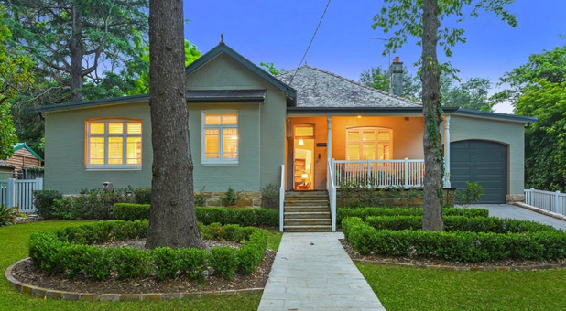

Lot 1 DP 1173219

**Hornsby Shire Council details**

**Heritage Register: (NONE)**

It is a modest single storey Federation style dwelling with a front gable, verandah with turned timber posts and slate roof. It was significantly altered by the additions on the north and a garage on the south, with a subdivision to the rear, in 2012

The land was purchased in 1907 by Julia Deborah Hodgson widow. She may have built the house. In 1910 Thomas Sherington Alexander Kenyon, labourer, then law stationer, of Beecroft Road owned the house. The Kenyons sold the house in 1919 to Walter Rothwell commercial traveller.

**1913 Electoral Roll:** John Stanley Moffatt (accountant), Annie Kathleen Moffatt – Boronia-avenue, Cheltenham

Sands Directories 1915-1916 John S. Moffatt “Myoori”; 1918-1920 Harry S. Mort; 1922 Herbert R. Rothwell; 1923-1932/3 – Charles S. Willis “Kenella”

Sands Directories 1930-1931: William H. Maxey {Moxey]

Electoral Roll 1933: Charles Willis No. 37; William Moxey No. 37

**Sydney Morning Herald (NSW: 1842 - 1954), Saturday 2 June 1917, page 20**

WANTED, GENERAL, sleep home, two adults, two children, nurse kept, all duties, 16s. Apply Myoorie, Boronia-avenue, Cheltenham

By 1923 Charles Samuel Willis was the owner of the property.

*[Charles Stanley Willis married Euphemia Arnott Moxey in 1907, district of Newcastle; Euphemia was born 1881, daughter of William Henry & Janet Smith Thomson Moxley, district of Newcastle*

*Charles Samuel Willis was born 1879, son of Charles & Emma Willis, district of Armidale.]*

The 1933 Electoral Roll lists Charles Samuel Willis (salesman), Euphemia Arnott Willis, Jean Ella Willis (clerk), Kenneth Charles Willis (traveller), William Henry Moxey (estate agent) & Janet Smith Thomson Moxey – 37 Boronia-avenue, Cheltenham

In 1938 Charles Samuel Willis, produce merchant, died at his home.

In 1943 Euphemia Arnott Willis and her mother Janet Smith Thomson Moxey were still living at 37 Boronia-road, Cheltenham

Euphemia died in 1948 at Cronulla.

The house was last sold in 2013, renamed “Ashington.”

**Bibliography: none**

**Resources available (varies):**

* Sands Directories 1858-1933 City of Sydney [Sands Postal Directory | City of Sydney Archives (nsw.gov.au)](https://archives.cityofsydney.nsw.gov.au/nodes/view/495003)
* Newspaper articles – TROVE - [Search - Trove (nla.gov.au)](https://trove.nla.gov.au/search/advanced/category/newspapers)
* Ancestry.com (subscription only) [Genealogy, Family Trees and Family History Records online - Ancestry.com](https://www.ancestry.com.au/) – Sands Directories, Electoral Rolls, Family photos (Public Member photos), Census lists, marriage details, + miscellaneous
* N.S.W. Births, Deaths & Marriages [Family history search | NSW Government](https://www.nsw.gov.au/family-and-relationships/family-history-search) (QLD & Victoria also obtainable online)
* House photos and information via Hornsby Shire Council website for Property Search and Heritage Register [Heritage | Hornsby Shire Council (nsw.gov.au)](https://www.hornsby.nsw.gov.au/property/build/heritage)
* House photos and associated information via Internet search on address via Real Estate websites (from 2005)
* “Beecroft and Cheltenham Heritage Walks” - Beecroft-Cheltenham History Group Inc. 2004 book (1st edition)
* Australian War Museum website [Home | Australian War Memorial (awm.gov.au)](https://www.awm.gov.au/)
* Beecroft and Cheltenham History Group website [Beecroft and Cheltenham History - Beecroft Cheltenham History Group (bchg.org.au)](https://bchg.org.au/)