**37 CHELTENHAM ROAD, CHELTENHAM (“Lilianfels”, prev. “Snaefell”)**

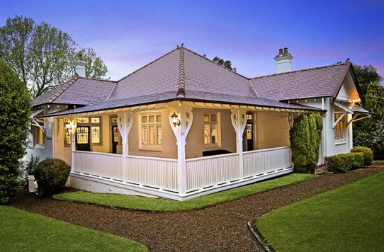

Lots 40 & 41 DP 5440

**Hornsby Shire Council details**

**Heritage Register: (NONE)**

Part of Mount Pleasant Estate – Cheltenham 1st Subdivision 1908

Sands Directories 1915-1917 Oliver M. Wallace “Snaefell”; 1918-1932/33 Arthur E. Pierce “Lilianfels”

Electoral Roll 1933: ?

The house, originally “*Snaefell”* and then *“Lilianfels*,” was purchased as vacant land from William Chorley in 1913 by Oliver Wallace, a mining engineer. He built this home shortly afterwards.

The 1913 Electoral Roll lists Ida Wallace at Cheltenham-road, Cheltenham with later references to her husband Oliver M. Oliver.

*[Oliver M. Wallace married Ida Holland in 1909, at Marrickville]*

In April 1917 the house was put up for sale, described as follows:

Modern Bungalow Residence, brick on concrete, slate roof, hall, connected drawing and dining rooms 32 x 14, four bedrooms, one 23 x 13½, others 12 x 12, breakfast-room, kitchen, laundry, tiled bathroom, gas heater, pantry, linen presses, etc., gas stove. Verandahs 60 x 10. Built under close supervision three years ago. Land 117 x 194; gravel paths, lawns, and orchard, fowl runs. Adjoining land, 107 x 194, at purchaser'« option at low price. PRICE £1600.

Owner, who Is leaving district, has no further use for property, and will sell.

Apply SNAEFELL, Cheltenham-road, Cheltenham.1

Oliver Wallace sold the house to Arthur Ernest Pierce, an optician in the city. They moved to Cheltenham to help with Mrs. (Lilian Martha) Pierce’s health. They changed the house name to “Lilianfels” to reflect both Mrs Pierce’s name and because of a house they admired in Katoomba {Lilianfels Park Estate, Katoomba).

Mr. and Mrs. Pierce were previously living at “Hillview,” 52 The Crescent, Cheltenham. At the time of the house being advertised Mr. Pierce had his Read American Car advertised for sale at £185, presumably for a deposit on the house.

In July 1917 a garage was built. They later built a tennis court alongside the house and laid out extensive gardens as Mr. Pierce was a keen gardener. They employed a gardener to help one day a week. Mr. Pierce was the foundation Master of the Beecroft Masonic Lodge.

The Mount Pleasant Estate – Cheltenham (2nd Subdivision) 1918 shows the house being occupied by Mr. Pierce.

By 1922 Arthur Pierce was Chairman of Directors, Cheltenham Recreation Club.

In 1933 Arthur Pierce acquired the Rodwell property on the old Maharatta Estate, Bombala. He was also an accomplished golfer. It was written of him: “Arthur Pierce, like brother Ernest, has for years been one of Cheltenham's best performers as a pennant skipper. He is the immediate past president and takes a keen interest in the club's affairs. Arthur is second player and Ernest is skipper of the Cheltenham rink that has done such a lot towards putting that club into the final of the President's Two Rink.”

In 1935 the house was occupied by Arthur Ernest Pierce (optician), Lilian Martha Pierce, Esma Pierce & Lorna May Pierce

That year Esma Pierce was engaged to Spencer Hamilton, younger son of Mr. and Mrs. Gordon G. Rae, of Beecroft. They were married the following year.

Arthur and Lilian were still living at “Lilianfels” in 1943.

The house was last sold in 2015.2

**Bibliography:**

1 Sydney Morning Herald, 14th April 1917

2 [Sold House 37 Cheltenham Road, Cheltenham NSW 2119 - Oct 29, 2015 - Homely](https://www.homely.com.au/homes/37-cheltenham-road-cheltenham-nsw-2119/1620576)

**Resources available (varies):**

* Sands Directories 1858-1933 City of Sydney [Sands Postal Directory | City of Sydney Archives (nsw.gov.au)](https://archives.cityofsydney.nsw.gov.au/nodes/view/495003)
* Newspaper articles – TROVE - [Search - Trove (nla.gov.au)](https://trove.nla.gov.au/search/advanced/category/newspapers)
* Ancestry.com (subscription only) [Genealogy, Family Trees and Family History Records online - Ancestry.com](https://www.ancestry.com.au/) – Sands Directories, Electoral Rolls, Family photos (Public Member photos), Census lists, marriage details, + miscellaneous
* N.S.W. Births, Deaths & Marriages [Family history search | NSW Government](https://www.nsw.gov.au/family-and-relationships/family-history-search) (QLD & Victoria also obtainable online)
* House photos and information via Hornsby Shire Council website for Property Search and Heritage Register [Heritage | Hornsby Shire Council (nsw.gov.au)](https://www.hornsby.nsw.gov.au/property/build/heritage)
* House photos and associated information via Internet search on address via Real Estate websites (from 2005)
* “Beecroft and Cheltenham Heritage Walks” - Beecroft-Cheltenham History Group Inc. 2004 book (1st edition)
* Australian War Museum website [Home | Australian War Memorial (awm.gov.au)](https://www.awm.gov.au/)