**38 CHELTENHAM ROAD, CHELTENHAM (“Wilfran”)**

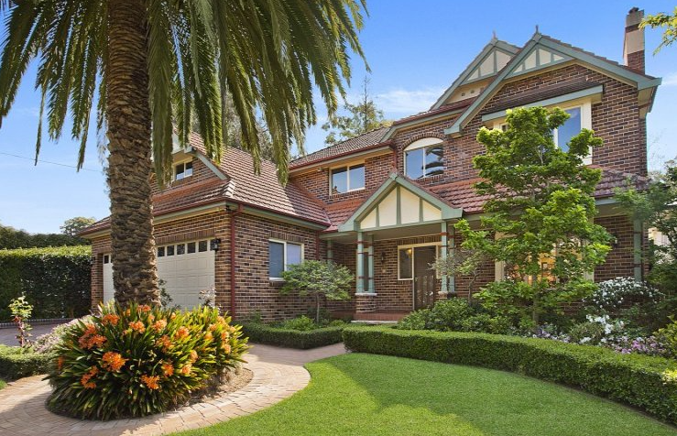

Lot 72 DP 9085

The house may have been occupied by Mrs. R. Parnwell between 1924-27.

By 1930 Robert William Pearse was living at this residence, named “Wilfran.”

*[Robert W. Pearse (1885-1965), of Granville, married Elizabeth Frances Lavor, of Parramatta, in 1909, at Granville]*

The house name is most likely an abbreviation of ‘William’ and ‘Frances.’

In 1933 occupants were Robert William Pearse (machinist), Elizabeth Francis Pearse and Edna Lavor Pearse (typist)

In 1943 occupants were Robert William Pearse (machinist), Elizabeth Frances Pearse, Albert William Pearse (clerk) and George Lavor Pearse (electrical fitter)

By 1949 the house had been sold and Robert Pearse had moved to Woy Woy. He died in 1965.

The house was last sold in 2014.1

**Bibliography:**

1 [34 Cheltenham Road, Cheltenham, NSW 2119 - Property Details (realestate.com.au)](https://www.realestate.com.au/sold/property-house-nsw-cheltenham-126819018)

**Resources available (varies):**

* Sands Directories 1858-1933 City of Sydney [Sands Postal Directory | City of Sydney Archives (nsw.gov.au)](https://archives.cityofsydney.nsw.gov.au/nodes/view/495003)
* Newspaper articles – TROVE - [Search - Trove (nla.gov.au)](https://trove.nla.gov.au/search/advanced/category/newspapers)
* Ancestry.com (subscription only) [Genealogy, Family Trees and Family History Records online - Ancestry.com](https://www.ancestry.com.au/) – Sands Directories, Electoral Rolls, Family photos (Public Member photos), Census lists, marriage details, + miscellaneous
* N.S.W. Births, Deaths & Marriages [Family history search | NSW Government](https://www.nsw.gov.au/family-and-relationships/family-history-search) (QLD & Victoria also obtainable online)
* House photos and information via Hornsby Shire Council website for Property Search and Heritage Register [Heritage | Hornsby Shire Council (nsw.gov.au)](https://www.hornsby.nsw.gov.au/property/build/heritage)
* House photos and associated information via Internet search on address via Real Estate websites (from 2005)
* “Beecroft and Cheltenham Heritage Walks” - Beecroft-Cheltenham History Group Inc. 2004 book (1st edition)
* Australian War Museum website [Home | Australian War Memorial (awm.gov.au)](https://www.awm.gov.au/)