**4 CHORLEY AVENUE, CHELTENHAM (“Belvedere”)**

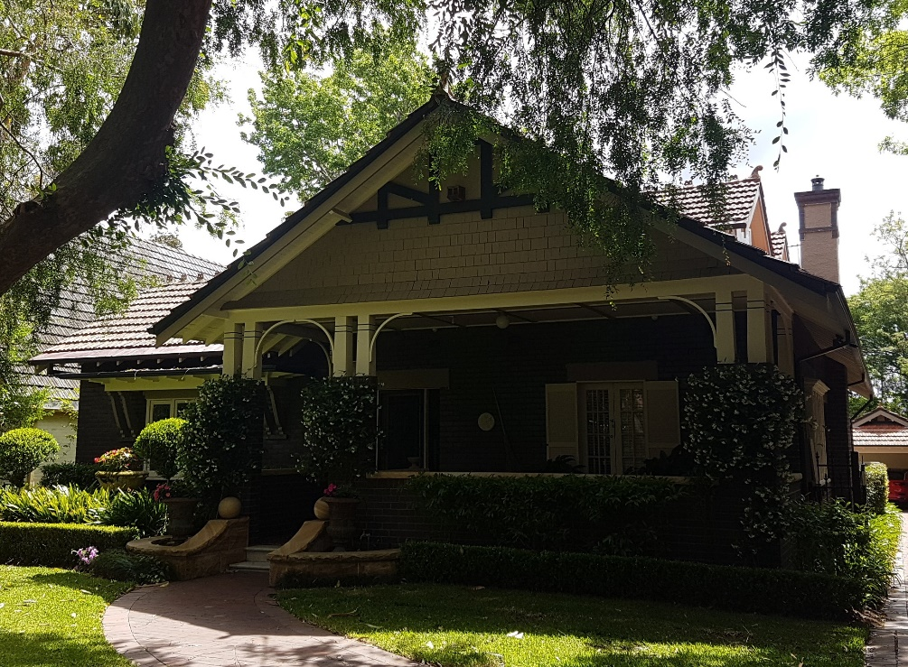

Lot 1 DP 509732

Sands Directories 1931-32/3 F. Biggs

Electoral Roll 1933: Frank Biggs “Belvedere”

The house was occupied in 1930 by Frank Biggs.

In 1933 occupants were Frank Biggs (solicitor), Mary Biggs, William John Biggs (solicitor), Noeline Alma Biggs, Dorothy Kathleen Biggs and Gladys Mary Biggs (teacher) – “Belvedere,” Chorley-crescent, Cheltenham

In 1936 Dorothy, the younger daughter of Mr. and Mrs. F. Biggs, of Cheltenham, was married to Charles, eldest son of Mr. Stewart and the late F. F. Stewart, of Beecroft.

In 1943 Frank Biggs, Mary Biggs and Gladys Mary Biggs (teacher) were still in occupancy at this address.

**Bibliography:**

1

**Resources available (varies):**

* Sands Directories 1858-1933 City of Sydney [Sands Postal Directory | City of Sydney Archives (nsw.gov.au)](https://archives.cityofsydney.nsw.gov.au/nodes/view/495003)
* Newspaper articles – TROVE - [Search - Trove (nla.gov.au)](https://trove.nla.gov.au/search/advanced/category/newspapers)
* Ancestry.com (subscription only) [Genealogy, Family Trees and Family History Records online - Ancestry.com](https://www.ancestry.com.au/) – Sands Directories, Electoral Rolls, Family photos (Public Member photos), Census lists, marriage details, + miscellaneous
* N.S.W. Births, Deaths & Marriages [Family history search | NSW Government](https://www.nsw.gov.au/family-and-relationships/family-history-search) (QLD & Victoria also obtainable online)
* House photos and information via Hornsby Shire Council website for Property Search and Heritage Register [Heritage | Hornsby Shire Council (nsw.gov.au)](https://www.hornsby.nsw.gov.au/property/build/heritage)
* House photos and associated information via Internet search on address via Real Estate websites (from 2005)
* “Beecroft and Cheltenham Heritage Walks” - Beecroft-Cheltenham History Group Inc. 2004 book (1st edition)
* Australian War Museum website [Home | Australian War Memorial (awm.gov.au)](https://www.awm.gov.au/)