**4 THE PROMENADE, CHELTENHAM**

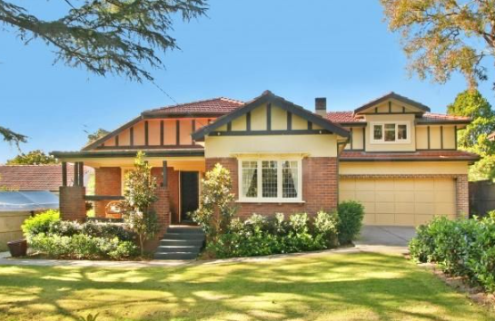

Lot 86 DP 9085

**Hornsby Shire Council details**

**Heritage Register: (NONE)**

Part of Mount Pleasant Estate – Cheltenham 2nd Subdivision 1918

In 1930 the house was occupied by Joseph Allain Allison (Dep. Manager), and Ada Maud Allison.

*[Joseph Allain Allison (born 25 Sept 1887, died 5 Mar 1973) married Ada M. Chorley (1891-1979) in 1922, Ryde, N.S.W. They moved to QLD then returned to Cheltenham about 1930]*

In 1933 they moved to 3 Cheltenham-road, Cheltenham, and residency at 4 The Promenade was taken up by Arthur Edward Snowball (manufacturer) and Jean McGregor

[By 1934 the Snowball family had moved to Roseville]

In 1943 David Valentine Fowler (accountant) and Lila May Fowler were living at 4 The Promenade, Cheltenham

Background of Joseph Allain Allison

Joseph A. Allison, born 1887, arrived in Australia, disembarking in QLD, on the ship “Waipara” in 1911. He married Alice May Shale in 1913, at Brisbane, QLD. They were living at Toowoomba in 1913. His occupation was salesman. In 1916 they were at Indooroopilly, and in 1917-19 at Roma, QLD. In August 1921 Alice May Allison died at Toowoomba.

In 1922 he married Ada Maud Chorley. In 1925 they were living at Wooloowin, QLD, and Joseph was now working as a draper. They returned to Cheltenham about 1930 for a few years, living at 4 The Promenade and later at 3 Cheltenham-road. They moved to Newcastle for a few years. By 1946 they were living in Southport, QLD, where Joseph had a store for Men’s and Boys’ Wear named “Allisons.” They lived at 37 Meron-street, Southport, into the 1970’s. Joseph died in 1973 and Ada died in 1979.

NOTE: On the 1901 Crown Lands Subdivision Plan, at the N.S.W. State Library, there is written in pencil the name ‘Allison’ at the commencement of Cheltenham-road (odd numbers) being Lot 588, of 4a 2r 2p. Immediately following, for Lot 589, of 3a 1r 9p, is written the name ‘Chorley.’

These names would have been entered many years later. Joseph A. Allison would live at 3 Cheltenham-road which would have been on Lot 588.

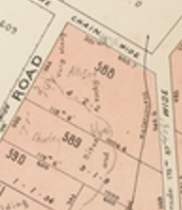

**Bibliography: none**

**Resources available (varies):**

* Sands Directories 1858-1933 City of Sydney [Sands Postal Directory | City of Sydney Archives (nsw.gov.au)](https://archives.cityofsydney.nsw.gov.au/nodes/view/495003)
* Newspaper articles – TROVE - [Search - Trove (nla.gov.au)](https://trove.nla.gov.au/search/advanced/category/newspapers)
* Ancestry.com (subscription only) [Genealogy, Family Trees and Family History Records online - Ancestry.com](https://www.ancestry.com.au/) – Sands Directories, Electoral Rolls, Family photos (Public Member photos), Census lists, marriage details, + miscellaneous
* N.S.W. Births, Deaths & Marriages [Family history search | NSW Government](https://www.nsw.gov.au/family-and-relationships/family-history-search) (QLD & Victoria also obtainable online)
* House photos and information via Hornsby Shire Council website for Property Search and Heritage Register [Heritage | Hornsby Shire Council (nsw.gov.au)](https://www.hornsby.nsw.gov.au/property/build/heritage)
* House photos and associated information via Internet search on address via Real Estate websites (from 2005)
* “Beecroft and Cheltenham Heritage Walks” - Beecroft-Cheltenham History Group Inc. 2004 book (1st edition)
* Australian War Museum website [Home | Australian War Memorial (awm.gov.au)](https://www.awm.gov.au/)