**40 BORONIA AVENUE, CHELTENHAM (“Colwyn”, prev. “Raiville”)**

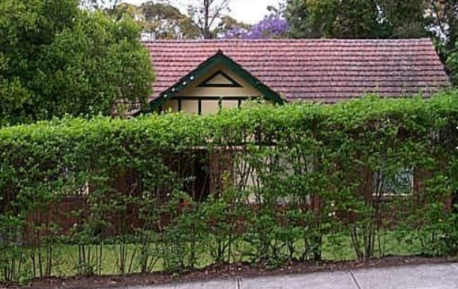

Lot 1 DP 209134

**Hornsby Shire Council details**

**Heritage Register: (NONE)**

Sands Directories 1917-1920 William J. Boyce; 1921-1927 Montford Longfield S.M.; 1930-1 F. Powis “Colwyn”; 1932/3 L. McCarthy “Colwyn”

Electoral Roll 1933 Ivan McCarthy No. 40

From 1917 to 1920 William J. Boyce occupied “Raiville”.

*[William J. Boyce married Rachel Collins in 1906, Sydney]*

From 1921 to 1928 it was occupied by Montford (spelling varies) Rees Longfield S.M.

*[Mountiford R. Longfield married Ida King in 1902, district of Bathurst]*

*[Mountiford R. Longfield born 1864, district of Goulburn, parents: John & Elizabeth]*

In November 1928 Mr Longfield, Stipendiary Magistrate, died at his residence, 40 Boronia-avenue, leaving behind his wife, Ida, and three daughters.

His illness had extended over four weeks. He had undergone a serious operation in 1926, and from the effects had never fully recovered.

His obituary gives a good overview of his life.**1**

His sister, May Grace, was married to William Frederick Brett who lived at “Bryntirion,” 48 Boronia-avenue, Cheltenham.

In September 1929 his wife, Ida Longfield, died at her residence.

**M. R. Longfield**

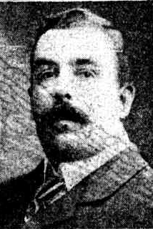

By 1930 F. Powis had purchased and occupied the house which was renamed “Colwyn.”

In 1931 he advertised to rent or sell the property, worded as ‘Furnished Attractive Bungalow, 4 rooms, 2 sleep-outs, garage, garden. Moderate rental or sell. 40 Boronia-avenue.’

In 1933 the occupants were Ivan Francis McCarthy (pensioner), Michael Greta McCarthy (labourer) and Ettie Stella Greta McCarthy

In 1935 occupants were Thomas Slade Loney (retired), Emily Jane Loney, Sidney Thomas Loney (pharmacist).

Thomas Slade Loney, of this address, died in 1935, aged 86 years.

His widow, Emily Jane, continued to live there until her death in 1952.

**Bibliography:**

1 Sydney Morning Herald, 8th November 1928

**Resources available (varies):**

* Sands Directories 1858-1933 City of Sydney [Sands Postal Directory | City of Sydney Archives (nsw.gov.au)](https://archives.cityofsydney.nsw.gov.au/nodes/view/495003)
* Newspaper articles – TROVE - [Search - Trove (nla.gov.au)](https://trove.nla.gov.au/search/advanced/category/newspapers)
* Ancestry.com (subscription only) [Genealogy, Family Trees and Family History Records online - Ancestry.com](https://www.ancestry.com.au/) – Sands Directories, Electoral Rolls, Family photos (Public Member photos), Census lists, marriage details, + miscellaneous
* N.S.W. Births, Deaths & Marriages [Family history search | NSW Government](https://www.nsw.gov.au/family-and-relationships/family-history-search) (QLD & Victoria also obtainable online)
* House photos and information via Hornsby Shire Council website for Property Search and Heritage Register [Heritage | Hornsby Shire Council (nsw.gov.au)](https://www.hornsby.nsw.gov.au/property/build/heritage)
* House photos and associated information via Internet search on address via Real Estate websites (from 2005)
* “Beecroft and Cheltenham Heritage Walks” - Beecroft-Cheltenham History Group Inc. 2004 book (1st edition)
* Australian War Museum website [Home | Australian War Memorial (awm.gov.au)](https://www.awm.gov.au/)