**42 CHELTENHAM ROAD, CHELTENHAM (“Rowallan”)**

**House either extensively renovated or a new house**

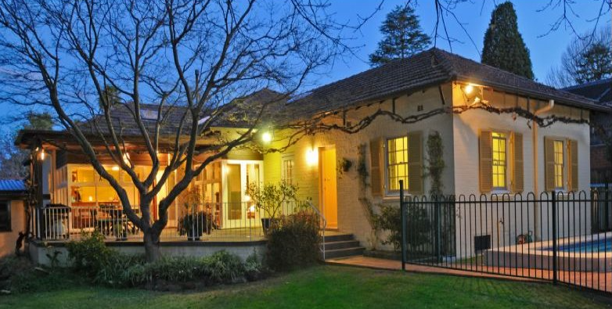

Lot 74 DP 9085

**Hornsby Shire Council details**

**Heritage Register: (NONE)**

Sands Directory 1926-1927 W. F. Milne “Rowallan”; 1928-32/33 H. N. Milner

Electoral Roll 1933: Wiliam Milne “Rowallan”

The first known occupant was William Francis Milne in 1926. A daughter was born that year.

*[William F. Milne married Colina Campbell McCall 1919 Hornsby]*

The following year he was declared bankrupt.

In 1930 occupants of “Rowallan” were William Francis Milne (engineer) and Colina Campbell Milne.

William Francis Milne died at this residence in 1943, leaving a wife and two children.

In 1958 Colina Campbell Milne and Joan Elizabeth Milne (stenographer) were still living there.

The house was last sold in 2022.**1**

**Bibliography:**

1 [42 Cheltenham Road, Cheltenham, NSW 2119 - Property Details (realestate.com.au)](https://www.realestate.com.au/sold/property-house-nsw-cheltenham-110668469)

**Resources available (varies):**

* Sands Directories 1858-1933 City of Sydney [Sands Postal Directory | City of Sydney Archives (nsw.gov.au)](https://archives.cityofsydney.nsw.gov.au/nodes/view/495003)
* Newspaper articles – TROVE - [Search - Trove (nla.gov.au)](https://trove.nla.gov.au/search/advanced/category/newspapers)
* Ancestry.com (subscription only) [Genealogy, Family Trees and Family History Records online - Ancestry.com](https://www.ancestry.com.au/) – Sands Directories, Electoral Rolls, Family photos (Public Member photos), Census lists, marriage details, + miscellaneous
* N.S.W. Births, Deaths & Marriages [Family history search | NSW Government](https://www.nsw.gov.au/family-and-relationships/family-history-search) (QLD & Victoria also obtainable online)
* House photos and information via Hornsby Shire Council website for Property Search and Heritage Register [Heritage | Hornsby Shire Council (nsw.gov.au)](https://www.hornsby.nsw.gov.au/property/build/heritage)
* House photos and associated information via Internet search on address via Real Estate websites (from 2005)
* “Beecroft and Cheltenham Heritage Walks” - Beecroft-Cheltenham History Group Inc. 2004 book (1st edition)
* Australian War Museum website [Home | Australian War Memorial (awm.gov.au)](https://www.awm.gov.au/)