**44 BORONIA AVENUE, CHELTENHAM (“Avilion”)**

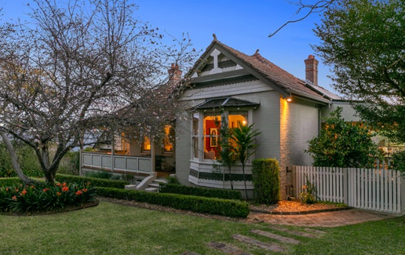

Lot X DP 416676

**Hornsby Shire Council details**

**Heritage Register: (NONE)**

Archibald McNab Booth was living at “Avilion” in 1915.

*[Archibald M. Booth married Mary Frances (surname unknown, date unknown)*

In 1913 Eric Edwin Booth, mining engineer of Burraga (near Oberon), born 1881, son of Archibald and Frances Booth, married Lily Dorothea Deberie Wachsmann, only daughter of Mr. and Mrs. A. E. W. Wachsmann, of "Maitai," Murray-road, Beecroft. The ceremony was held in St. John's, Beecroft, which was so crowded that the bridal party had difficulty in getting into the building.

Sands Directories 1915-1932/3: Archibald Booth “Avilion”

Electoral Roll 1933: Archibald Booth “Avilion”

In 1917 Archibald advertised for a ‘reliable YOUNG MAN, married, thoroughly up in Vine-growing and Wine-making, to take charge of small Vineyard.’

In 1930 Mary Frances Booth died at the Cheltenham home, aged 76 years, survived by her husband and five children.

In 1933 Archibald McNab Booth (teacher), Christine Edith Booth (typist) & Edith Mary Witherspoon (typist) were living at “Avilion.”

In 1937 Archibald McNab Booth died at his Cheltenham home, aged 81 years.

A daughter, Christine Edith Booth, was still at 44 Boronia-avenue in 1943.

The house was last sold in 2021.1

**Bibliography:**

1 [44 Boronia Avenue, Cheltenham, NSW 2119 - Property Details (realestate.com.au)](https://www.realestate.com.au/sold/property-house-nsw-cheltenham-137159890)

**Resources available (varies):**

* Sands Directories 1858-1933 City of Sydney [Sands Postal Directory | City of Sydney Archives (nsw.gov.au)](https://archives.cityofsydney.nsw.gov.au/nodes/view/495003)
* Newspaper articles – TROVE - [Search - Trove (nla.gov.au)](https://trove.nla.gov.au/search/advanced/category/newspapers)
* Ancestry.com (subscription only) [Genealogy, Family Trees and Family History Records online - Ancestry.com](https://www.ancestry.com.au/) – Sands Directories, Electoral Rolls, Family photos (Public Member photos), Census lists, marriage details, + miscellaneous
* N.S.W. Births, Deaths & Marriages [Family history search | NSW Government](https://www.nsw.gov.au/family-and-relationships/family-history-search) (QLD & Victoria also obtainable online)
* House photos and information via Hornsby Shire Council website for Property Search and Heritage Register [Heritage | Hornsby Shire Council (nsw.gov.au)](https://www.hornsby.nsw.gov.au/property/build/heritage)
* House photos and associated information via Internet search on address via Real Estate websites (from 2005)
* “Beecroft and Cheltenham Heritage Walks” - Beecroft-Cheltenham History Group Inc. 2004 book (1st edition)
* Australian War Museum website [Home | Australian War Memorial (awm.gov.au)](https://www.awm.gov.au/)