**44 CHELTENHAM ROAD, CHELTENHAM (“Haselmere”)**

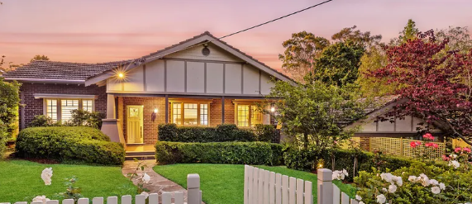

Lot 75 DP 9085

**Hornsby Shire Council details**

**Heritage Register: (NONE)**

Part of Mount Pleasant Estate – Cheltenham 2nd Subdivision 1918

Sands Directories 1921-1926 James A. Murray “Haselmere”; 1927-1932/33 W. H. Curgenven, med. pract.

Electoral Roll 1933: William Curgenven No. 44

In 1925 James A. Murray was living at “Haselmere,” 44 Cheltenham-road, Cheltenham. He had previously lived at “Brackland,” 63 Cheltenham-road, Cheltenham.

[James Aubrey Gibbes Murray, retired civil servant, died 1933, .]

By 1927 W. B. Curvengen, medical practitioner, was living at this address.

*[William Brendon Curgenven (born 28 Jul 1868 Kensington, London) married Mary Ada Murray 1909 Sydney – not a daughter of James Aubrey Murray]*

In 1933 they moved to Woollahra (William died 11 May 1941, aged 72; Mary Ada died 1951.)

For 1935-7 Catherine Jane Moody was living at 44 Cheltenham-road.

In 1943 it was occupied by William Goldsworthy Cowman.

**Bibliography:**

1

**Resources available (varies):**

* Sands Directories 1858-1933 City of Sydney [Sands Postal Directory | City of Sydney Archives (nsw.gov.au)](https://archives.cityofsydney.nsw.gov.au/nodes/view/495003)
* Newspaper articles – TROVE - [Search - Trove (nla.gov.au)](https://trove.nla.gov.au/search/advanced/category/newspapers)
* Ancestry.com (subscription only) [Genealogy, Family Trees and Family History Records online - Ancestry.com](https://www.ancestry.com.au/) – Sands Directories, Electoral Rolls, Family photos (Public Member photos), Census lists, marriage details, + miscellaneous
* N.S.W. Births, Deaths & Marriages [Family history search | NSW Government](https://www.nsw.gov.au/family-and-relationships/family-history-search) (QLD & Victoria also obtainable online)
* House photos and information via Hornsby Shire Council website for Property Search and Heritage Register [Heritage | Hornsby Shire Council (nsw.gov.au)](https://www.hornsby.nsw.gov.au/property/build/heritage)
* House photos and associated information via Internet search on address via Real Estate websites (from 2005)
* “Beecroft and Cheltenham Heritage Walks” - Beecroft-Cheltenham History Group Inc. 2004 book (1st edition)
* Australian War Museum website [Home | Australian War Memorial (awm.gov.au)](https://www.awm.gov.au/)