**44 CHELTENHAM AVENUE (THE CRESCENT), CHELTENHAM**

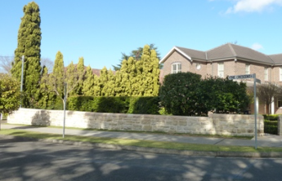

Lot 1 DP 18542

**Hornsby Council details**

**Heritage Register: No. 289 (Fence)**

A new two-storey residence built after the demolition of the c1940 house previously on the site. The lot was also subdivided, with a new house (28 The Promenade) being built in the rear garden of the former house.

The heritage listing applies to the rusticated sandstone boundary fence which has been rebuilt or at least repointed since construction of the new dwelling.

The fence appears to be contemporary with the c1940s house previously on the site prior to demolition and subdivision.

**Bibliography: none**

**Resources available (varies):**

* Sands Directories 1858-1933 City of Sydney [Sands Postal Directory | City of Sydney Archives (nsw.gov.au)](https://archives.cityofsydney.nsw.gov.au/nodes/view/495003)
* Newspaper articles – TROVE - [Search - Trove (nla.gov.au)](https://trove.nla.gov.au/search/advanced/category/newspapers)
* Ancestry.com (subscription only) [Genealogy, Family Trees and Family History Records online - Ancestry.com](https://www.ancestry.com.au/) – Sands Directories, Electoral Rolls, Family photos (Public Member photos), Census lists, marriage details, + miscellaneous
* N.S.W. Births, Deaths & Marriages [Family history search | NSW Government](https://www.nsw.gov.au/family-and-relationships/family-history-search) (QLD & Victoria also obtainable online)
* House photos and information via Hornsby Shire Council website for Property Search and Heritage Register [Heritage | Hornsby Shire Council (nsw.gov.au)](https://www.hornsby.nsw.gov.au/property/build/heritage)
* House photos and associated information via Internet search on address via Real Estate websites (from 2005)
* “Beecroft and Cheltenham Heritage Walks” - Beecroft-Cheltenham History Group Inc. 2004 book (1st edition)
* Australian War Museum website [Home | Australian War Memorial (awm.gov.au)](https://www.awm.gov.au/)