**46-48 THE CRESCENT, CHELTENHAM (“Mount Pleasant”)**

**HOUSE DEMOLISHED 1930’s.**

The home of William Chorley, master tailor, a profession followed by his two sons, William Charles Chorley and Henry James Alder Chorley.

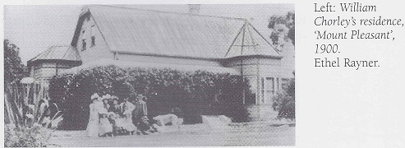

**1904 Marriage of George Graham to Edith Chorley (taken at “Mount Pleasant”)**

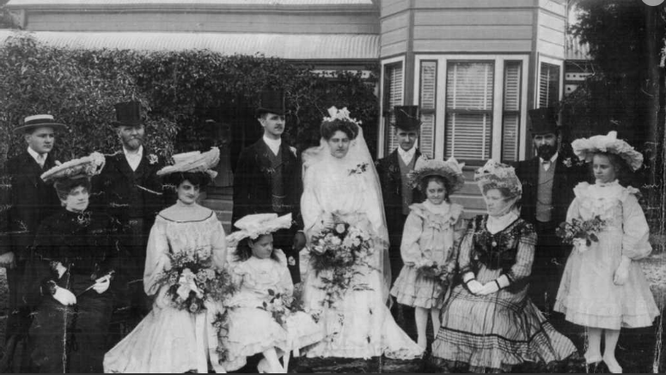

“Mount Pleasant” was built on high land with a long view south during the 1890’s.

It was a two-storey timber construction with an iron roof and verandas on three sides. A stone wall that can still be seen in part, was built around the property, with an iron grill topping the Cheltenham Road and The Crescent walls. There was a full stone wall along The Promenade boundary for privacy. The stone came from Chorley’s quarry across the line close to Sutherland and Cobran Roads.

The main bedroom and a library were on the ground floor and four more bedrooms on the upper floor.

A tennis court was present from early in the life of the house.

A large garden, including a conservatory, was established when the house was built together with an orchard planted with many kinds of fruit, as well as macadamia nuts and several varieties of grapes. The first consignment of fruit (in November 1898) sent from the new Cheltenham station to the Sydney markets was a dozen cases of apricots and plums from the *Mount Pleasant* orchard. The gardener lived in quarters above a workshop and two extra gardeners were often employed.

There were cows and horses in the paddocks and stables and sheds for the sulkies, buggies and four-wheelers. Maize and oats were grown for fodder.

The 1891 Census lists William Chorley as living in Murray-road, Beecroft with a household consisting of 4 males and 4 females.

**William Chorley in 1892**

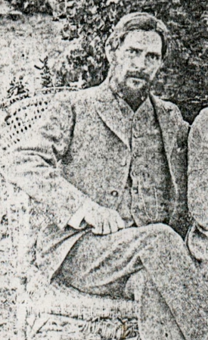

The 1901 Census lists William Chorley as living in Cheltenham-road, Cheltenham, with a household consisting of 3 males and 8 females.

**William Chorley in 1904**

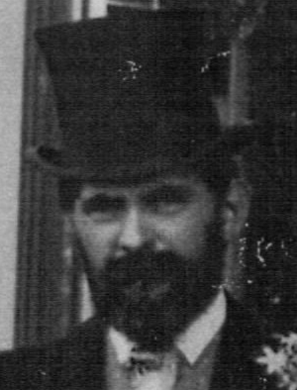

The 1913 Electoral Roll lists William Chorley (merchant tailor), Lily Virginia Chorley, Ada Maud Chorley, Amy Maud Chorley, Mabel Lily Chorley, and Henry James Chorley (master tailor) living at “Mt. Pleasant,” Cheltenham

Sands Directories 1915-1932/3 Wm. C. Chorley “Mount Pleasant”

Electoral Roll 1933: William Chorley No. 44

The Mount Pleasant Estate – Cheltenham (2nd Subdivision) 1918 shows the extent of the “Mt. Pleasant,” along The Crescent, between Cheltenham-road and The Promenade.

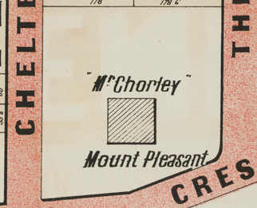

In 1920, when William retired, alterations were made, with the front and side verandas replaced with a larger veranda and a sleep-out above. The lower walls of the extension were of sandstone. A bowling green and croquet lawn were laid out between the house and The Promenade.

In 1928 Lily Virginia Chorley, wife of William, died.

The 1930 Electoral Roll lists William Chorley (merchant tailor), Lily May Chorley, Ethel Florence Chorley and Constance Mary Franks (home duties) at “Mt. Pleasant,” Cheltenham-avenue, Cheltenham

**William Chorley late in life**

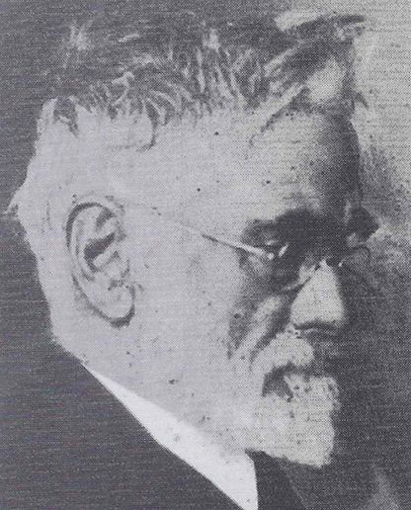

Following Lily’s death in 1928, William lived at home with his unmarried daughter May, until his death on 22nd April 1935 at the age of 76 years.

As he would have wished, the house was then demolished, the land subdivided and sold, and only the stone walls and a few pine trees on the verge remain to mark the site of the extensive ‘Mount Pleasant’ estate.”

Gardens related to Nos. 44, 46 & 48 The Crescent are listed on the Hornsby Shire Council Heritage Register (Items 289, 290 & 291).

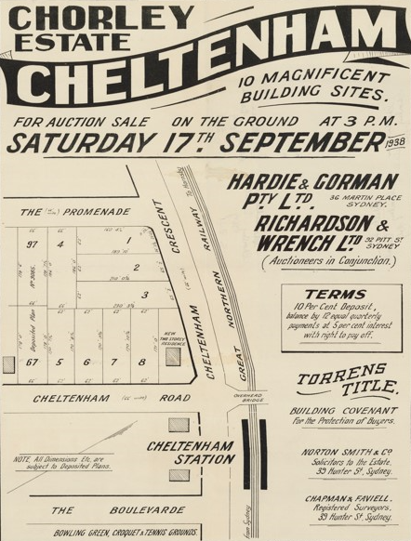

NOTE: The new two-storey residence (22 Cheltenham Road) was built in 1938 for May Chorley after her parent’s home was demolished.

**Bibliography:**

1

**Resources available (varies):**

* Sands Directories 1858-1933 City of Sydney [Sands Postal Directory | City of Sydney Archives (nsw.gov.au)](https://archives.cityofsydney.nsw.gov.au/nodes/view/495003)
* Newspaper articles – TROVE - [Search - Trove (nla.gov.au)](https://trove.nla.gov.au/search/advanced/category/newspapers)
* Ancestry.com (subscription only) [Genealogy, Family Trees and Family History Records online - Ancestry.com](https://www.ancestry.com.au/) – Sands Directories, Electoral Rolls, Family photos (Public Member photos), Census lists, marriage details, + miscellaneous
* N.S.W. Births, Deaths & Marriages [Family history search | NSW Government](https://www.nsw.gov.au/family-and-relationships/family-history-search) (QLD & Victoria also obtainable online)
* House photos and information via Hornsby Shire Council website for Property Search and Heritage Register [Heritage | Hornsby Shire Council (nsw.gov.au)](https://www.hornsby.nsw.gov.au/property/build/heritage)
* House photos and associated information via Internet search on address via Real Estate websites (from 2005)
* “Beecroft and Cheltenham Heritage Walks” - Beecroft-Cheltenham History Group Inc. 2004 book (1st edition)
* Australian War Museum website [Home | Australian War Memorial (awm.gov.au)](https://www.awm.gov.au/)