**47 CHELTENHAM ROAD, CHELTENHAM (“Lyndhurst”)**

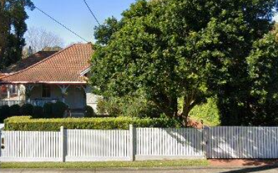

Lot 46 DP 5440

Sands Directories 1927 Allan S. Kirby; 1930-32/3 E. C. Bond “Lyndhurst”

Electoral Roll 1933: Elgar Bond No. 47

**Hornsby Shire Council details**

**Heritage Register: (NONE)**

Allan S. Kirby was seemingly in residence there in 1927.

In 1930 Edgar Charles Bond was in residency, the house named “Lyndhurst.”

*[Edgar C. Bond married Florence Walker in 1901, district of Sydney]*

In 1933 occupants were Edgar Charles Bond (commercial traveller) and Florence Rachel Bond.

That year they moved to 78 Cheltenham-crescent (The Crescent), Cheltenham. In June 1933 Florence Rachel Bond died at this address, aged 55 years.

In 1943 Harold Walter Dunstan (customs agent), Joy Olive Dunstan (stenographer) and Kathleen Frances Marks (student) were living at 47 Cheltenham-road.

**Bibliography:**

1

**Resources available (varies):**

* Sands Directories 1858-1933 City of Sydney [Sands Postal Directory | City of Sydney Archives (nsw.gov.au)](https://archives.cityofsydney.nsw.gov.au/nodes/view/495003)
* Newspaper articles – TROVE - [Search - Trove (nla.gov.au)](https://trove.nla.gov.au/search/advanced/category/newspapers)
* Ancestry.com (subscription only) [Genealogy, Family Trees and Family History Records online - Ancestry.com](https://www.ancestry.com.au/) – Sands Directories, Electoral Rolls, Family photos (Public Member photos), Census lists, marriage details, + miscellaneous
* N.S.W. Births, Deaths & Marriages [Family history search | NSW Government](https://www.nsw.gov.au/family-and-relationships/family-history-search) (QLD & Victoria also obtainable online)
* House photos and information via Hornsby Shire Council website for Property Search and Heritage Register [Heritage | Hornsby Shire Council (nsw.gov.au)](https://www.hornsby.nsw.gov.au/property/build/heritage)
* House photos and associated information via Internet search on address via Real Estate websites (from 2005)
* “Beecroft and Cheltenham Heritage Walks” - Beecroft-Cheltenham History Group Inc. 2004 book (1st edition)
* Australian War Museum website [Home | Australian War Memorial (awm.gov.au)](https://www.awm.gov.au/)