**48 BORONIA AVENUE, CHELTENHAM ((“Bryntirion”)**

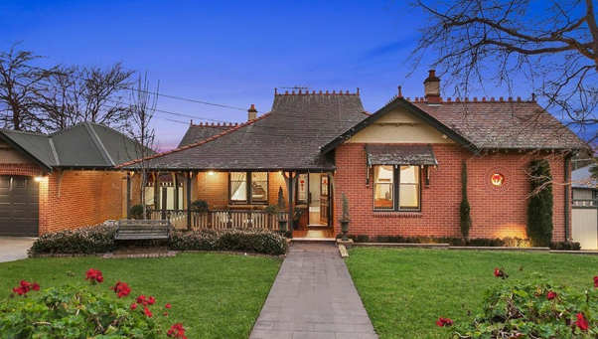

Lot 1 DP 1161369

**Hornsby Shire Council details**

**Heritage Register: (NONE)**

In August 1912 a tender was called for the erection of a brick cottage at Cheltenham for W. Brett, of Cheltenham.

[The house was named “Bryntirion,” most likely named after a locality within Bridgend, Wales.]

In 1913 the house was occupied by William Frederick Brett (civil servant), May Grace Brett, Travers Longfield Brett (clerk), Elizabeth Mary Longfield. A daughter was born the following year at “Bryntirion.”

*[William F. Brett married May G. Longfield in 1890, in the district of Gosford]*

Sands Directories 1915-1932/3 William F. Brett “Bryntiron”

Electoral Roll: William Brett

In 1916 Lieut. Travers Longfield Brett (4th Battalion), only son of Mr. and Mrs. W. F. Brett, Boronia, Cheltenham, was married to Miss Louie Estelle (Essie) Mutton, third daughter of Mr. and Mrs. Oswald Mutton, of Roseville, at St. Philip’s, Church Hill, Sydney.

In 1917 May’s mother, Elizabeth Mary Longfield, widow of the late Mr. John Longfield, of Goulburn, died at Boronia Avenue, Cheltenham, aged 87 years.

The late Mr. Longfield was a dentist in Goulburn for many years. He was severely wounded by the Ben Hall’s bushranging gang on the night before the railway was opened to Goulburn in 1869 and lost the sight of one eye. John Longfield died at the residence of his brother-in-law, E. P. Laycock, Esq., Ingleburn, in 1886, aged 65 years.

In 1921 a son, Oswald Longfield, was born to Travers Longfield & Louie Estelle Brett, at “Bryntirion.” Travers would move to 72 Cheltenham-road, Cheltenham, with Boronia-avenue being the nearest cross-street. Oswald would later become a famous painter of ships.

From 1921 to 1928 May Grace Brett’s brother, Mountford Longfield, Stipendiary Magistrate, also was living in Boronia-avenue, Cheltenham.

He died in 1928 at his residence, 40 Boronia-avenue, Cheltenham, aged 65 years, leaving a widow, Ida, and four children.

**Mountford Rees Longfield**

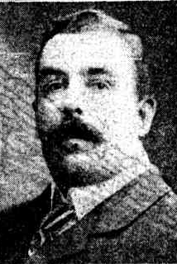

In 1929 “Bryntirion” was burgled and jewellery valued at £32 was stolen.

That year, Ida, widow of Mountford Longfield, died at her residence in Boronia-avenue.

In 1935 Miss Grace Longfield Brett, daughter of William and May Brett, of “Bryntirion,”, nurse, aged 36, died after being scratched from a rose thorn, resulting in streptococcal septicaemia.

By 1937 William Frederick Brett had retired.

In 1943 the household consisted of William Frederick Brett (retired), May Grace Brett & daughter Mary Longfield Brett, at 48 Boronia-avenue, Cheltenham.

Mary Longfield Brett was born in January 1914 at Cheltenham. She served during WW2 (service no. NF392297).

In 1950 William Frederick Brett died at his home, aged 92 years, leaving a widow, May Grace, and two surviving children (Travers and Mary).

In 1962 May Grace Brett, of 48 Boronia-avenue, Cheltenham, died.

Mary Longfield Brett would continue to live at the family home until her death in 1970.

The house was last sold in 2015.1

**Bibliography:**

1 [48 Boronia Avenue, Cheltenham, NSW 2119 - Property Details (realestate.com.au)](https://www.realestate.com.au/sold/property-house-nsw-cheltenham-120336113)

**Resources available (varies):**

* Sands Directories 1858-1933 City of Sydney [Sands Postal Directory | City of Sydney Archives (nsw.gov.au)](https://archives.cityofsydney.nsw.gov.au/nodes/view/495003)
* Newspaper articles – TROVE - [Search - Trove (nla.gov.au)](https://trove.nla.gov.au/search/advanced/category/newspapers)
* Ancestry.com (subscription only) [Genealogy, Family Trees and Family History Records online - Ancestry.com](https://www.ancestry.com.au/) – Sands Directories, Electoral Rolls, Family photos (Public Member photos), Census lists, marriage details, + miscellaneous
* N.S.W. Births, Deaths & Marriages [Family history search | NSW Government](https://www.nsw.gov.au/family-and-relationships/family-history-search) (QLD & Victoria also obtainable online)
* House photos and information via Hornsby Shire Council website for Property Search and Heritage Register [Heritage | Hornsby Shire Council (nsw.gov.au)](https://www.hornsby.nsw.gov.au/property/build/heritage)
* House photos and associated information via Internet search on address via Real Estate websites (from 2005)
* “Beecroft and Cheltenham Heritage Walks” - Beecroft-Cheltenham History Group Inc. 2004 book (1st edition)
* Australian War Museum website [Home | Australian War Memorial (awm.gov.au)](https://www.awm.gov.au/)