**48 CHELTENHAM ROAD, CHELTENHAM (“Ballentrae”, prev. “Berowra”)**

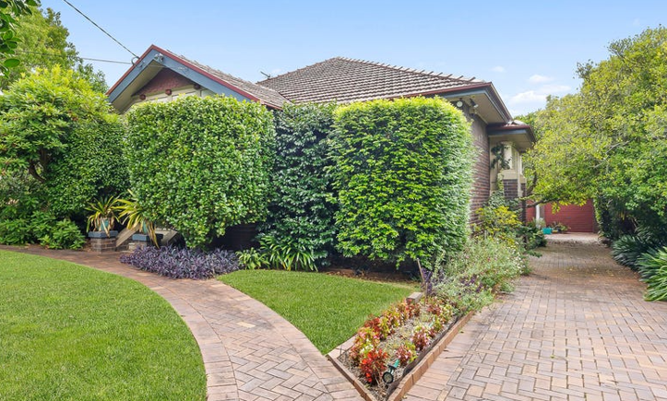

Lot 77 DP 9085

**Hornsby Council details**

**Heritage Register: (NONE)**

Sands Directories 1930-32/3 Ernest R. Edwards

Electoral Roll 1933: Ernest Edwards No. 48

The first-known occupant was Ernest Arthur Edwards in 1930.

The house was named “Berowra,” the name of his previous house in Epping.

In 1933 occupants were Ernest Arthur Edwards (furniture warehouseman), Edith May Edwards, Sidney Austen Edwards (manufacturer’s representative).

*[Ernest A. Edwards married Edith M. Austen in 1910, district of Sydney]*

In 1936 Edith May Edwards died, aged 49 years.

In 1937 occupants were Ernest Arthur Edwards (furniture warehouseman), Sidney Austen Edwards (manufacturer’s representative) and, Ruby Linda Piesse (home duties)

By 1943 occupants were Denver Forrester Joyce (labourer), Camille Ursula Joyce, Maud Lorraine Black (no occupation)

The house (now named “Ballentrae”) was last sold in 2023.1

**Bibliography:**

1 [Sold 48 Cheltenham Road, Cheltenham NSW 2119 on 03 Mar 2023 - 2018410906 | Domain](https://www.domain.com.au/48-cheltenham-road-cheltenham-nsw-2119-2018410906)

**Resources available (varies):**

* Sands Directories 1858-1933 City of Sydney [Sands Postal Directory | City of Sydney Archives (nsw.gov.au)](https://archives.cityofsydney.nsw.gov.au/nodes/view/495003)
* Newspaper articles – TROVE - [Search - Trove (nla.gov.au)](https://trove.nla.gov.au/search/advanced/category/newspapers)
* Ancestry.com (subscription only) [Genealogy, Family Trees and Family History Records online - Ancestry.com](https://www.ancestry.com.au/) – Sands Directories, Electoral Rolls, Family photos (Public Member photos), Census lists, marriage details, + miscellaneous
* N.S.W. Births, Deaths & Marriages [Family history search | NSW Government](https://www.nsw.gov.au/family-and-relationships/family-history-search) (QLD & Victoria also obtainable online)
* House photos and information via Hornsby Shire Council website for Property Search and Heritage Register [Heritage | Hornsby Shire Council (nsw.gov.au)](https://www.hornsby.nsw.gov.au/property/build/heritage)
* House photos and associated information via Internet search on address via Real Estate websites (from 2005)
* “Beecroft and Cheltenham Heritage Walks” - Beecroft-Cheltenham History Group Inc. 2004 book (1st edition)
* Australian War Museum website [Home | Australian War Memorial (awm.gov.au)](https://www.awm.gov.au/)