**49 CHELTENHAM ROAD, CHELTENHAM (“Wiahola”)**

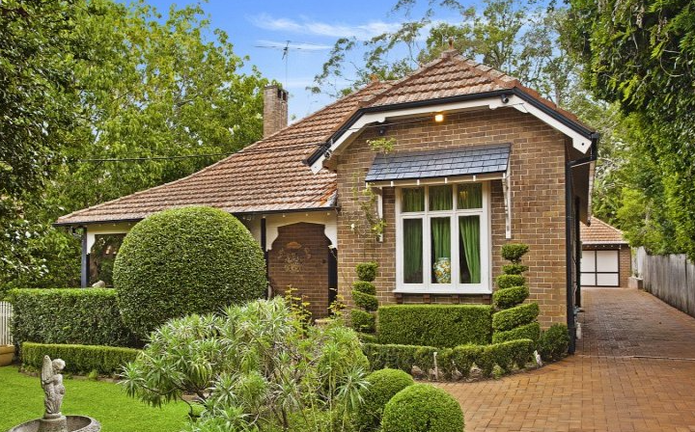

Lot 47 DP 5440

**Hornsby Shire Council details**

**Heritage Register: (NONE)**

Part of Mount Pleasant Estate – Cheltenham 1st Subdivision 1908

A Real Estate reference to this house having been a station-master’s home in the early 1900’s, however unverified.

Sands Directories 1916-1917 Albert A. Armstrong “Wyahola”; 1918-27 Mrs. Aileen/Eileen Shepherd “Wiahola”; 1930 Mrs. M. A. Shepherd “Wiahola”; 1932/33 Raymond J. Brown “Wiahola”

Electoral Roll 1933: ?

From various sources the house name was spelt as “Wynhola” in 1917, “Wishola” in 1925, and “Wiahola” between 1927 and 1933. Perhaps a misspelling of Waihola, a township in Otago, New Zealand.

In 1913 Albert Arthur Armstrong (manufacturer) and Emily Maud Armstrong were living at the house. They remained there until 1915 and were gone by 1917.

*[Albert Armstrong married Emily M. Grinsell in 1900, in Sydney]*

By 1920 Mrs. Aileen (or Eileen} Shepherd (Mrs. M. A. Shepherd) was living there up to 1930, after which the home was occupied by Edith Winifred Brown.

From 1934 Frank Speight (draughtsman) & Irene Speight were living at 49 Cheltenham-road, and were still there in 1949, but by 1958 had moved to Ferndale-road, Beecroft.

*[Frank Speight married Irene Douglas in 1933, district of Drummoyne]*

The house was last sold in 2015, then named “Cornucopia House,” dated c1903.1

**Bibliography:**

1 [49 Cheltenham Road, Cheltenham, NSW 2119 - Property Details (realestate.com.au)](https://www.realestate.com.au/sold/property-house-nsw-cheltenham-119055339)

**Resources available (varies):**

* Sands Directories 1858-1933 City of Sydney [Sands Postal Directory | City of Sydney Archives (nsw.gov.au)](https://archives.cityofsydney.nsw.gov.au/nodes/view/495003)
* Newspaper articles – TROVE - [Search - Trove (nla.gov.au)](https://trove.nla.gov.au/search/advanced/category/newspapers)
* Ancestry.com (subscription only) [Genealogy, Family Trees and Family History Records online - Ancestry.com](https://www.ancestry.com.au/) – Sands Directories, Electoral Rolls, Family photos (Public Member photos), Census lists, marriage details, + miscellaneous
* N.S.W. Births, Deaths & Marriages [Family history search | NSW Government](https://www.nsw.gov.au/family-and-relationships/family-history-search) (QLD & Victoria also obtainable online)
* House photos and information via Hornsby Shire Council website for Property Search and Heritage Register [Heritage | Hornsby Shire Council (nsw.gov.au)](https://www.hornsby.nsw.gov.au/property/build/heritage)
* House photos and associated information via Internet search on address via Real Estate websites (from 2005)
* “Beecroft and Cheltenham Heritage Walks” - Beecroft-Cheltenham History Group Inc. 2004 book (1st edition)
* Australian War Museum website [Home | Australian War Memorial (awm.gov.au)](https://www.awm.gov.au/)