**5 CHORLEY AVENUE, CHELTENHAM (“Etonville”)**

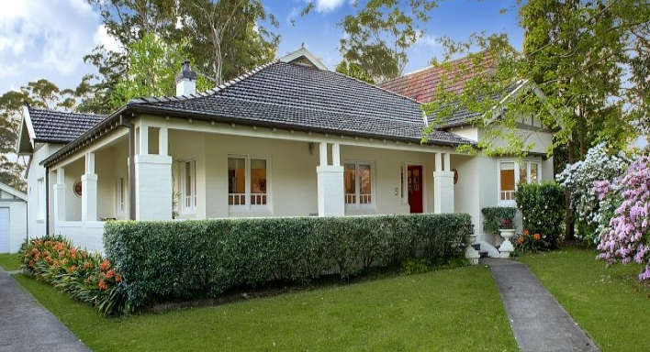

Lot 132 DP 12364

**Sands Directories 1927-32/3 Edward Porter, “Eatonville”**

**Electoral Roll 1933: Harold Porter No. 5**

The first-known occupant was Edward Porter in 1927.

*[Edward Porter married Lilian E. Humphreys in 1885, district of Newtown]*

In 1931 Edward Porter, retired business manager, died at his residence “Etonville,” Chorley Crescent, aged 73 years.

His estate was valued at £27,112 and bequeathed to his wife and sons.

In 1933 occupants were Lillian Eustace Porter, Harold Edward Porter (builder) and Annie Gray (home duties)

In 1936 Harold Edward Porter died, aged 47 years.

In 1937 Lillian Eustace Porter and Annie Gray were still living there, however in 1943 Emilie May Watson was in residency.

The house was last sold in 2014.1

**Bibliography:**

1 [5 Chorley Avenue, Cheltenham, NSW 2119 - Property Details (realestate.com.au)](https://www.realestate.com.au/sold/property-house-nsw-cheltenham-118113987)

**Resources available (varies):**

* Sands Directories 1858-1933 City of Sydney [Sands Postal Directory | City of Sydney Archives (nsw.gov.au)](https://archives.cityofsydney.nsw.gov.au/nodes/view/495003)
* Newspaper articles – TROVE - [Search - Trove (nla.gov.au)](https://trove.nla.gov.au/search/advanced/category/newspapers)
* Ancestry.com (subscription only) [Genealogy, Family Trees and Family History Records online - Ancestry.com](https://www.ancestry.com.au/) – Sands Directories, Electoral Rolls, Family photos (Public Member photos), Census lists, marriage details, + miscellaneous
* N.S.W. Births, Deaths & Marriages [Family history search | NSW Government](https://www.nsw.gov.au/family-and-relationships/family-history-search) (QLD & Victoria also obtainable online)
* House photos and information via Hornsby Shire Council website for Property Search and Heritage Register [Heritage | Hornsby Shire Council (nsw.gov.au)](https://www.hornsby.nsw.gov.au/property/build/heritage)
* House photos and associated information via Internet search on address via Real Estate websites (from 2005)
* “Beecroft and Cheltenham Heritage Walks” - Beecroft-Cheltenham History Group Inc. 2004 book (1st edition)
* Australian War Museum website [Home | Australian War Memorial (awm.gov.au)](https://www.awm.gov.au/)