**5 LYNE ROAD, CHELTENHAM**

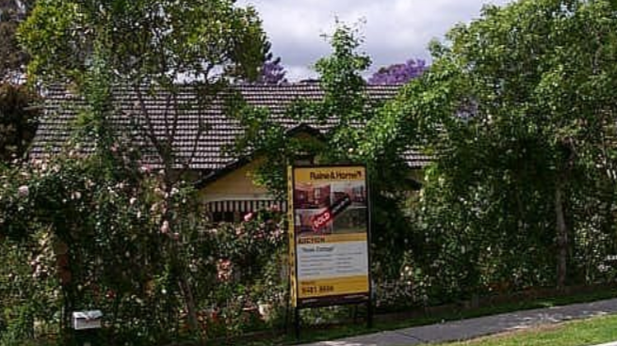

Lot 6 DP 7811

**Hornsby Shire Council details**

**Heritage Register: NONE**

**NOTE: 5 Lyne-road is Lot 6 DP 7811 however it is referred to as Lot 7 in 1940 (see below).**

In April 1923 Lot 5 on Lyne-road (one Lot from Beecroft-road), 80 x 209ft., was put up for sale.

**Problem: The BCHG website states that No. 3 was lived in from at least 1921 until 1933 by Edward Austin; and No. 5, *Stoke*, was lived in from at least 1922 by Mrs A Burrows and then from 1923 to 1932 by the Harton family.**

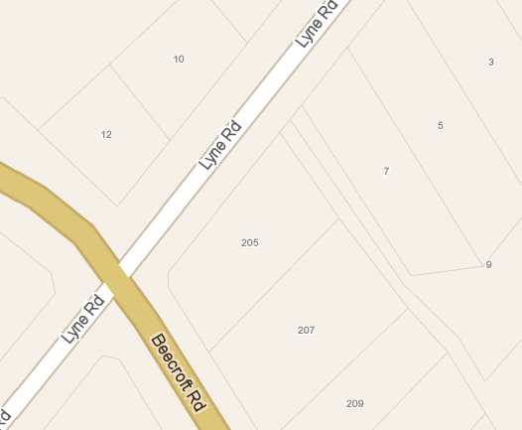

The 1923 Sands Directory lists Edward P. Austin as living in Lyne-road, Cheltenham.

In 1933 the house was occupied by Edward Picton Austin (clerk) and Alice Pauline Austin.

*[Edward P. Austin married Alice P. Rees in 1920, at Sydney]*

In 1937 the house was occupied by Edward Picton Austin (clerk), Alice Pauline Austin and Anna Olivia Rees.

In 1940 No. 5 Lyne-road was put up for sale, by order of the Mortgagee, described as follows:

‘DETACHED DOUBLE-FRONTED COTTAGE known as No. 5 LYNE ROAD off Beecroft-road, close to Cheltenham Crescent. Built of brick, tiled roof, having wide return verandah, part of front and one side, hall, 5 rooms, kitchen, breakfast-room, bathroom, laundry. Land 66 feet frontage, depth 209 feet 9 inches, being Lot 7, D.P. 7811. TORRENS TITLE.’

In 1943 the property, 5 Lyne-road, was still occupied by Edward Picton Austin (clerk), Alice Pauline Austin and Anna Olivia Rees.

Edward Picton Austin continued to occupy the property until his death in 1956.

**Bibliography:**

1 Sydney Morning Herald, 21st September 1940

**Resources available (varies):**

* Sands Directories 1858-1933 City of Sydney [Sands Postal Directory | City of Sydney Archives (nsw.gov.au)](https://archives.cityofsydney.nsw.gov.au/nodes/view/495003)
* Newspaper articles – TROVE - [Search - Trove (nla.gov.au)](https://trove.nla.gov.au/search/advanced/category/newspapers)
* Ancestry.com (subscription only) [Genealogy, Family Trees and Family History Records online - Ancestry.com](https://www.ancestry.com.au/) – Sands Directories, Electoral Rolls, Family photos (Public Member photos), Census lists, marriage details, + miscellaneous
* N.S.W. Births, Deaths & Marriages [Family history search | NSW Government](https://www.nsw.gov.au/family-and-relationships/family-history-search) (QLD & Victoria also obtainable online)
* House photos and information via Hornsby Shire Council website for Property Search and Heritage Register [Heritage | Hornsby Shire Council (nsw.gov.au)](https://www.hornsby.nsw.gov.au/property/build/heritage)
* House photos and associated information via Internet search on address via Real Estate websites (from 2005)
* “Beecroft and Cheltenham Heritage Walks” - Beecroft-Cheltenham History Group Inc. 2004 book (1st edition)
* Australian War Museum website [Home | Australian War Memorial (awm.gov.au)](https://www.awm.gov.au/)