**5 MASON AVENUE, CHELTENHAM (“Kelvin”)**

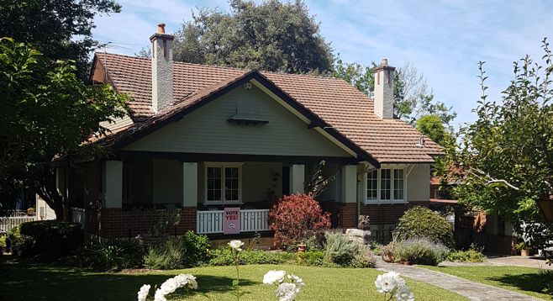

Lot C DP 339629

**Hornsby Shire Council details**

**Heritage Register: (NONE)**

Part of Cheltenham Park Estate Subdivision 1901

The 1901 Cheltenham Park Estate Subdivision created lots for sale along the Beecroft Road, Mason Avenue, Kent Road (later Cheltenham Road) and Boronia Avenue.

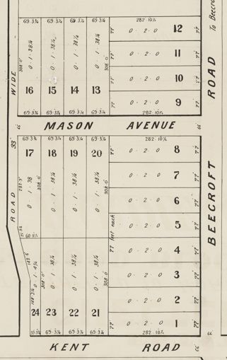

The cottage was built in 1917 for John Adair, of Boronia-avenue, Cheltenham

*[John Adair married Margaret Cunningham Farnie in 1896, Sydney]*

**Sands Directories: 1919-1932/3 – John Adair “Kelvin”**

**1933 Electoral Roll: John Adair No.5**

Up to 1937 the house was occupied by John Adair (accountant) and Margaret Cunningham Adair.

By 1943 Isa Jean Dougan (secretary) and Nancy Stuart Dougan (kindergartener) were the occupants. Mary Jane Dougan died at the house in 1947.

**Bibliography: none**

**Resources available (varies):**

* Sands Directories 1858-1933 City of Sydney [Sands Postal Directory | City of Sydney Archives (nsw.gov.au)](https://archives.cityofsydney.nsw.gov.au/nodes/view/495003)
* Newspaper articles – TROVE - [Search - Trove (nla.gov.au)](https://trove.nla.gov.au/search/advanced/category/newspapers)
* Ancestry.com (subscription only) [Genealogy, Family Trees and Family History Records online - Ancestry.com](https://www.ancestry.com.au/) – Sands Directories, Electoral Rolls, Family photos (Public Member photos), Census lists, marriage details, + miscellaneous
* N.S.W. Births, Deaths & Marriages [Family history search | NSW Government](https://www.nsw.gov.au/family-and-relationships/family-history-search) (QLD & Victoria also obtainable online)
* House photos and information via Hornsby Shire Council website for Property Search and Heritage Register [Heritage | Hornsby Shire Council (nsw.gov.au)](https://www.hornsby.nsw.gov.au/property/build/heritage)
* House photos and associated information via Internet search on address via Real Estate websites (from 2005)
* “Beecroft and Cheltenham Heritage Walks” - Beecroft-Cheltenham History Group Inc. 2004 book (1st edition)
* Australian War Museum website [Home | Australian War Memorial (awm.gov.au)](https://www.awm.gov.au/)