**5 THE BOULEVARD, CHELTENHAM (“Jenanbe”)**

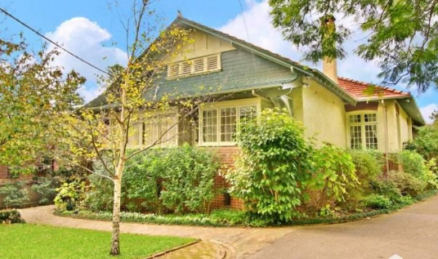

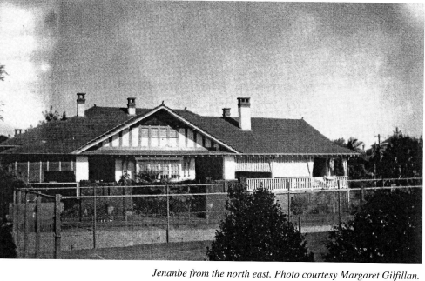

5 The Boulevard Lot 1 DP 580847

197 Beecroft Road Lot 1 DP 807998

**Hornsby Council Shire details**

**Heritage Register: Item Nos. 281 & 4/11 (HOUSE & GARDEN)**

Part of Mount Pleasant Estate – Cheltenham 1st Subdivision 1908

In 1912 Thomas Bailey Nossiter purchased, for the erection of his home, Lots 8 and 9 of the Mount Pleasant Estate, on the southern side of The Boulevard. Each lot was 70 feet by 200 feet, making about three-quarters of an acre in all. It cost him £262 10s. A building covenant was placed upon the land:

*Any building erected … shall be constructed in a proper and workman-like manner in brick and or stone … at a cost of not less than £450. And, no building … shall be used for any noxious or offensive trade or purpose which shall be a damage nuisance or annoyance to the owners or occupiers of adjoining property in the neighbourhood.*1

*In 1916 Thomas Nossiter purchased part of the adjoining Lot 10, a narrow strip ten feet wide running the length of the block, from his neighbour Rosabelle Trigg.*1

In July 1914 an application for a building permit was received by Hornsby Council:

‘Mr. Thos. Nossiter, Beecroft, brick residence and garage, The Boulevard, Cheltenham’

Sands Directories 1915-1932/3: Thomas B. Nossiter “Jananbe”

Electoral Roll 1933: Thomas Nossiter No.5

The house was designed by local architect William Nixon. It is a large brick house with the upper walls stuccoed, tall and slender chimneys that are also stuccoed with square brick pots. Ventilation slats are in the side and front gables. The house was sited on the south-west corner to maximise space for the garden and tennis court. It also had a horse paddock and stable, a poultry yard and dovecote.

The house name “Jenanbe” comes from a combination of each of the names of the Nossiter daughters – Jean, Nancy (‘Nan’) and Beatrice (‘Betty’).

Thomas was manager of the Peacock Jam Factory and he went on to be a director of Henry Jones IXL after that company took over Peacock.

Thomas was also the President of Pennant Hills Golf Club (1923-1932) and appointed a Life Member of the Club in 1944. His wife, Nell, worked on numerous local charities.

*[In 1902 Thomas Bailey (born 1877 Hunter’s Hill), eldest son of Thomas Simister Nossiter, of Auburn, married Helen Amy (‘Nell’), eldest daughter of Thomas Irons, J.P., of Granville.]*

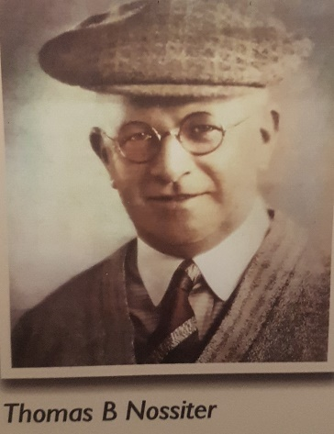

In February 1916 plans for additions to the property were approved by Hornsby Council.

In May 1916 Mrs. Nossiter advertised for ‘capable GENERAL, must be good cook and laundress, other help kept, 1 minute from station, references. Wages 22/6.’

In 1917, Annie Nossiter, wife of Thomas Simister Nossiter, died at “Jenanbe,” aged 71 years.

In 1918 Mrs. Nossiter advertised for ‘LADY HELP, good plain cook, no bedroom or laundry work, £1.’

The Mount Pleasant Estate – Cheltenham (2nd Subdivision) 1918 shows the house being occupied by Mr. Nossiter.

In 1919 Thomas B. Nossiter wrote to the Hornsby Council concerning the local roads and footpaths: “'During this wet season it is quite impossible to reach the station without wading through mud and wet. Yesterday morning I fell down the slippery green footpath and weakened my knee, and recently I broke a spring of my car trying to negotiate the crossing at the top of the Boulevarde leading on to the main Beecroft-road. Even the main road is impassable in wet weather between Cheltenham and Epping. Could not one of your councillors visit this district and bring these very urgent reforms under your council's notice? I trust that you will give those matters your kind and prompt attention."

In 1922, Mrs. Nell Nossiter’s mother, Matilda Ann Irons, widow of Thomas Irons, died at “Jenanbe.”

In 1923, Thomas Nossiter’s father, Thomas Simister Nossiter, born 1842 Warwickshire, England, died at Strathfield, aged 81 years.

**Thomas Simister Nossiter**

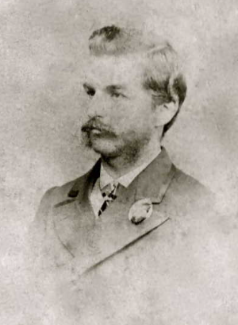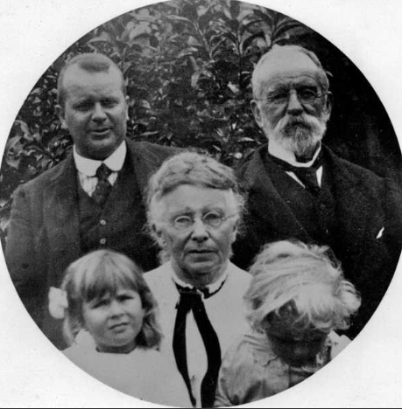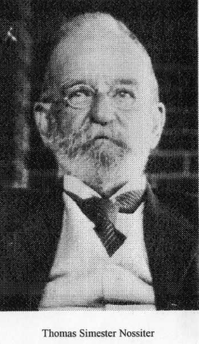

In 1926 Jean Nossiter, eldest daughter of Mr. & Mrs. T. B. Nossiter, was engaged to Martin C. Pines, of “Glenmore,” Collie, N.S.W., youngest son of the late F. P. Pines and Mrs. Pines, of "Red East," Cheltenham. The couple were married the following year.

In 1929 it was reported that “Mrs. Nossiter and her husband are prominently associated with the Royal Motor Yacht Club Ball, listed for the Ambassadors, September 18. Mr. Nossiter's yacht, Ban Yandah, is one of the finest in Australia.”

The 1933 Electoral Roll lists Thomas Bailey Nossiter (manufacturer), Helen Nossiter and Nancy Clare Nossiter at 5 The Boulevard, Cheltenham.

That year Nancy Clare (‘Nan’), 2nd daughter of Mr. & Mrs. T. B. Nossiter, was engaged to Alan Warden, only son of the late Thomas Napier and Mrs Napier, Cremorne. The couple were married the following year.

In 1934 “Jenanbe” was put up for sale, described as follows:

*LARGE COTTAGE RESIDENCE AND LAND.*

*"JENANBE," THE BOULEVARD.*

*Occupying a choice, elevated position, few yards from Station, and adjoining Recreation Club.*

*THE RESIDENCE is of most attractive design, faithfully built of O.K. Brick, and brick rough-cast, roof of tile, has extensive wide return front Verandah, side end back Verandahs, contains HALL, Cloakroom, LIVING-ROOM (with feature Fireplace and Window Seat), Music ROOM, large DINING ROOM (22 feet long), and 6 BEDROOMS, Tiled BATHROOM, Maid's Bathroom, KITCHEN, LAUNDRY, ample Cupboard accommodation.*

*Detached Brick DOUBLE GARAGE, with tile roof, with two men's rooms.*

*THE GROUNDS are attractively laid out with TURF TENNIS COURT and wide expanse of well-kept Lawns. Flower and Kitchen Gardens, Fowl runs, Paddock, Summer House, Fish Pond, etc.*

*LAND, about 286ft by about 200ft.*

*The Residence may also be purchased with 150ft frontage, and if sold in this manner the remainder of the land will be offered in one or two Lots of 70 feet and 66 feet respectively.*2

A bid of £3100 was received, but the sale did not go ahead and the house was let, as by 1937 Thomas B. Nossiter and family were living in New Zealand, where the youngest daughter Betty was engaged to Alan Harris, of Christchurch, New Zealand.

That year the new occupants of “Jenanbe” were Alfred Ernest Morgan (warehouseman), Elizabeth Jane Morgan, David Morgan (clerk), Noel Ernest Morgan (clerk), Grace Stella Morgan (stenographer) and Bertha Mary Morgan (stenographer)

In 1940 Alfred Ernest Morgan died suddenly at his residence, “Jenanbe,” aged 67 years.

By 1943 Thomas Bailey Nossiter (company director) and Helen Amy Nossiter were again back at “Jenanbe.”

In 1949 Thomas Bailey Nossiter, of 5 The Boulevard, Cheltenham, died of heart trouble, aged 76 years, leaving a widow, Helen Amy, and children Jean (Mrs. Pines), Nan (Mrs. Napier), Betty (Mrs. Harris), and Thomas Phillip Nossiter.

In 1952 the property was again put up for sale, described as follows:

*VACANT POSSESSION OF MAJOR PART*

*Under Instructions from*

*TRUSTEES OF THE ESTATE LATE T. B. NOSSITER*

*5 THE BOULEVARDE (NEAR BEECROFT ROAD)*

*ATTRACTIVE BRK. HOME with tiled rf., in PERF. ORDER. DBLE GAR., TURF TENNIS COURT, Sit. in SELECT LOCALITY with GLORIOUS OUTLOOK and BEAUT. BUSHLAND SURROUNDINGS. Well laid out gardens and lawns, and CLOSE to STATION. REAR of the HOUSE at present LET as a SELF-CONTAINED UNIT (Furn.) at £2.18.0 p. w. TENANT IS BUILDING - EXPECTS TO VACATE APPROX. DECEMBER.*

*ACCOM: 4 bedrooms, maid’s room, large lounge room, separate dining room, smoke room, 2 kitchens, 2 bathrooms, 2 toilets, laundry, large sun verandah (with drop blinds). All blinds Included in Sale.*

*LAND 150ft X 200ft. TORRENS.*3

The property was sold to Dr. Geoffrey Young, of Cheltenham.

Nell Nossiter left Cheltenham and purchased another house in Myola Road, Newport, having sold their holiday cottage there to her sister Clare Pollock. Nell Nossiter died in Mosman at the age of 94 years.

In 1959 “Jenanbe”, 5 The Boulevard, Cheltenham, was occupied by the Young family.

The house was last sold in 2012.4

**Bibliography:**

1 “Houses of Hornsby Shire Volume II” – Helen Barker

2 Sydney Morning Herald, 21st April 1934

3 Sydney Morning Herald, 15th March 1952

4 [5 The Boulevard , Cheltenham | Property History & Address Research | Domain](https://www.domain.com.au/property-profile/5-the-boulevard-cheltenham-nsw-2119)

**Resources available (varies):**

* Sands Directories 1858-1933 City of Sydney [Sands Postal Directory | City of Sydney Archives (nsw.gov.au)](https://archives.cityofsydney.nsw.gov.au/nodes/view/495003)
* Newspaper articles – TROVE - [Search - Trove (nla.gov.au)](https://trove.nla.gov.au/search/advanced/category/newspapers)
* Ancestry.com (subscription only) [Genealogy, Family Trees and Family History Records online - Ancestry.com](https://www.ancestry.com.au/) – Sands Directories, Electoral Rolls, Family photos (Public Member photos), Census lists, marriage details, + miscellaneous
* N.S.W. Births, Deaths & Marriages [Family history search | NSW Government](https://www.nsw.gov.au/family-and-relationships/family-history-search) (QLD & Victoria also obtainable online)
* House photos and information via Hornsby Shire Council website for Property Search and Heritage Register [Heritage | Hornsby Shire Council (nsw.gov.au)](https://www.hornsby.nsw.gov.au/property/build/heritage)
* House photos and associated information via Internet search on address via Real Estate websites (from 2005)
* “Beecroft and Cheltenham Heritage Walks” - Beecroft-Cheltenham History Group Inc. 2004 book (1st edition)
* Australian War Museum website [Home | Australian War Memorial (awm.gov.au)](https://www.awm.gov.au/)
* Beecroft and Cheltenham History Group website [Beecroft and Cheltenham History - Beecroft Cheltenham History Group (bchg.org.au)](https://bchg.org.au/)