**50 THE CRESCENT, CHELTENHAM (“Ginjulla”)**

**(The Crescent previously known as Cheltenham Crescent/Chorley Avenue)**

*[The Crescent – the name in use in the 1940’s, previously known as Carlingford Road, Cheltenham-avenue and Cheltenham Crescent]*

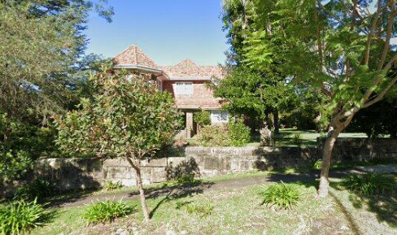

**1978 Photo of Cheltenham Railway bridge with “Ginjulla” in background**

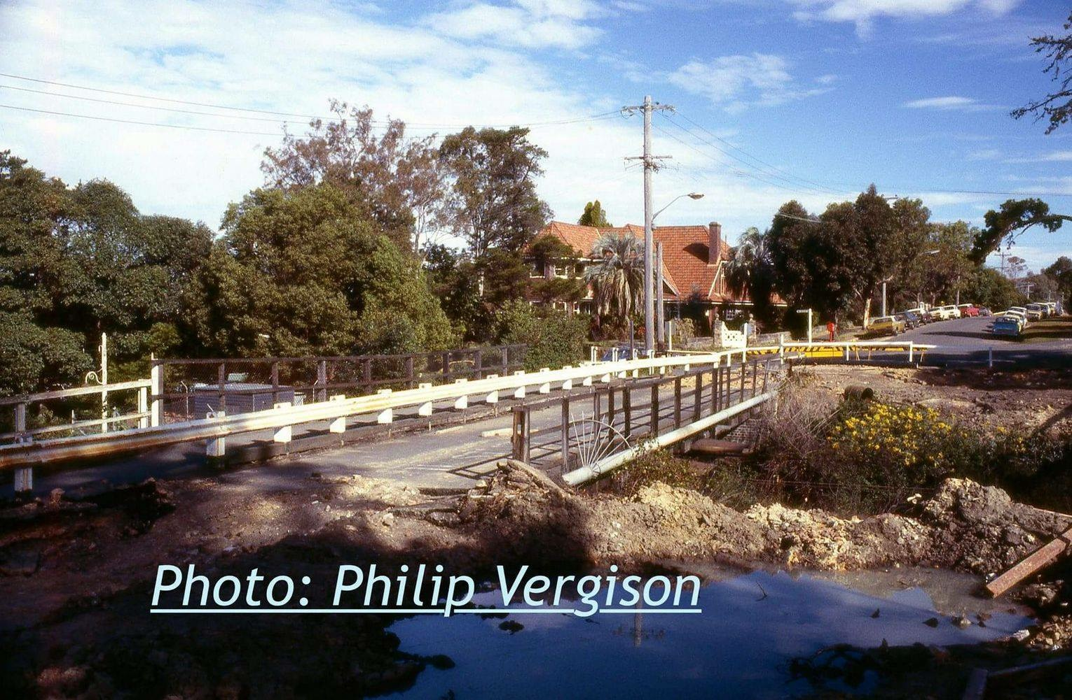

Lot 35 DP 5440  
Lot 36 DP 5440  
Lot 37 DP 5440

Alternate Address(es):  
29 - 31 Cheltenham Road CHELTENHAM NSW 2119  
29 - 31 Cheltenham Road CHELTENHAM NSW 2119  
29 - 31 Cheltenham Road CHELTENHAM NSW 2119

**Hornsby Shire Council details:**

**Heritage Register: Item No. 292**

Part of Mount Pleasant Estate – Cheltenham 1st Subdivision 1908

A large Inter-War period two-storey house, built in 1927-28. The land had once been the rose garden of the older house next door, No. 52.

Ginjulla is decorated with panels of brickwork, leadlight windows and a fish pond. It is double brick downstairs and brick veneer upstairs.

The house has recessed panels of brickwork, terracotta shingle tiles on the front wall and a restrained use of leadlight windows, with a fish pond in the front garden.

“Ginjulla” is an Aboriginal word meaning ‘good.’1

The land was sold by auction in November 1908 as part of the 1st Subdivision of the Mount Pleasant Estate (Lots 35 & 36]. A 2nd Subdivision of the Mount Pleasant Estate occurred in 1918 and lot 37 is included.

These three lots would make up the property to be named “Ginjulla.”

Helen Martha Graham, of Sydney, widow, had purchased the land at some time from William Chorley who owned the Mount Pleasant Estate land.

Lots 35 & 36 are covered under Certificate of Title Volume 2476 Folio 212.

Lot 37 is covered under Certificate of Title Volume 3213 Folio 73 (previously Volume 2925 Folio 149).

Lots 35, 36 & 37 was originally granted to William Chorley by Crown Grant on 29th August 1904 under Volume 1560 Folio 106.

Sands Directories 1930-1932/3 W. P. Kerridge “Ginjulla)

Electoral Roll 1933: Walter Kerridge No. 50

In 1919, at “Tibbereenah,” The Boulevard, Cheltenham, lived Walter Platts & Eileen Veronica Kerridge.

Children to the couple were: John C. (1919), Keith E. (1921) and Noel Walter (1923).

*[Walter P. Kerridge married Eileen V. Charters in 1917, Sydney; Walter was born in 1891 in the district of Newtown, the son of Joseph & Isabella Kerridge]*

By 1927 ownership of the three lots was transferred to Walter Platts Kerridge. There were many covenants to the transfer.

A sketch plan dated 28th September 1927 for construction of a house at No.50 The Crescent, Cheltenham, on Lots 35, 36 & 37, was produced by Buckle, Carfrae and Turner, Architects, 84 Pitt Street, Sydney.

In February 1928 a contract was finalised for the erection of a large residence at Cheltenham, with Buckle, Carfrae, and Turner, as architects, and H. V. Horwood, of Parramatta, as builder.

By 1930 the house at Cheltenham-crescent (re-named The Crescent) had been named “Ginjulla.”

In 1933 occupants were Walter Platts Kerridge (merchant), Eileen Veronica Kerridge, Isabel Kerridge (Walter’s mother), and Mabel Isabel Wallace (maid)

*[Isabella died in 1938 in the district of Burwood, her husband Joseph died in 1909 in the district of Petersham]*

That year the business previously carried on at 171 Sussex-street, Sydney, by Walter Platts Kerridge, Edward David McMahon and Arthur Henry Castley as a registered firm under the name of Kerridge and McMahon will be carried on by a company known as Kerridge and McMahon Ltd.

For 1936-7 occupants of the house were Walter Platts Kerridge (merchant), Eileen Veronica Kerridge and Mabel Isabel Wallace.

In 1938 Kerridge and McMahon Pty. Ltd, was described as specialising in the supply of oats, chaff, and potatoes, and being buyers of hay and grain. The firm operated at Wagga Wagga, with the firm’s head office being in Sussex-street, Sydney.

In 1942 Walter Platts Kerridge, still at Kerridge and McMahon, 171 Sussex-street, was appointed a member of the Potato Advisory Committee.

In 1943 occupants of the house were Walter Platts Kerridge (merchant), Eileen Veronica Kerridge and John Charters Kerridge (medical student)

In September 1945 Walter’s son, Keith, W./O. R.A.A.F., was killed in air operations.

In May 1949 Noel Walter, son of Mr. & Mrs. W. P. Kerridge, of Cheltenham, was engaged to Betty Chorley, only daughter of Mr. & Mrs. William Chorley Jnr., of Cheltenham.

In that month “Ginjulla” was advertised for sale, described as follows:

*CHELTENHAM. Large Brick Bungalow Residence with VACANT POSS. Having front and side verandahs and containing loungeroom, dining-room, 5 bedrooms and maid’s room, kitchen, etc. Detached garage and laundry, workshop. Hot-water service. LAND CORNER POSITION, 132 feet frontage, ample room for additional cottage. PR1CE £4100. For full particulars apply RICHARDSON & WRENCH LTD., Pitt Street Sydney.*2

In November 1949 Noel Kerridge married Betty Chorley. By then Mr. & Mrs. Walter Kerridge were living at Manly.

**Mr. & Mrs. Noel Kerridge**

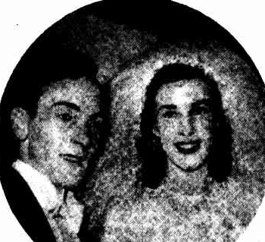

Walter Platts Kerridge, Produce Merchant, died in 1955.

By 1984 the house was owned by Dr. & Mrs. Miltiadas Gerasimos Roxanas.

A 1984 report comments on some aspects of the house:

*It is double brick downstairs and brick veneer upstairs. Wood panelling exists throughout downstairs. What is now the dining room was the smoke room, and the family room has a sprung dance floor.*

*Upstairs we find the original bathroom with its wonderful shower recess. Some years ago, what was originally a verandah was covered in to make an extra room, but it interesting to note that one must walk through either bedroom to enter the extra room.*2

The present owner (2023) has made additional internal alterations, as well as reconstructing the sandstone fence along Cheltenham-road, which had subsided due to a lack of base material. The fence has post holes for a once-existing wooden fence to add height for privacy however it has not been reinstated due to cost.

**Bibliography:**

1 Source: Rev. E. J. Watkin’s “Australian Native Words” (1834)

‘Larmer’s Vocabulary of Native Names 1853’ by James Larmer, September 1832 to 24 November 1853 – Page 3

[**https://transcripts.sl.nsw.gov.au/page/372467/view**](https://transcripts.sl.nsw.gov.au/page/372467/view)

2 Sydney Morning Herald, 7th May 1949

3 National Trust Activities Group, Activity No. 646

**Resources available (varies):**

* Sands Directories 1858-1933 City of Sydney [Sands Postal Directory | City of Sydney Archives (nsw.gov.au)](https://archives.cityofsydney.nsw.gov.au/nodes/view/495003)
* Newspaper articles – TROVE - [Search - Trove (nla.gov.au)](https://trove.nla.gov.au/search/advanced/category/newspapers)
* Ancestry.com (subscription only) [Genealogy, Family Trees and Family History Records online - Ancestry.com](https://www.ancestry.com.au/) – Sands Directories, Electoral Rolls, Family photos (Public Member photos), Census lists, marriage details, + miscellaneous
* N.S.W. Births, Deaths & Marriages [Family history search | NSW Government](https://www.nsw.gov.au/family-and-relationships/family-history-search) (QLD & Victoria also obtainable online)
* House photos and information via Hornsby Shire Council website for Property Search and Heritage Register [Heritage | Hornsby Shire Council (nsw.gov.au)](https://www.hornsby.nsw.gov.au/property/build/heritage)
* House photos and associated information via Internet search on address via Real Estate websites (from 2005)
* “Beecroft and Cheltenham Heritage Walks” - Beecroft-Cheltenham History Group Inc. 2004 book (1st edition)
* Australian War Museum website [Home | Australian War Memorial (awm.gov.au)](https://www.awm.gov.au/)
* Beecroft and Cheltenham History Group website [Beecroft and Cheltenham History - Beecroft Cheltenham History Group (bchg.org.au)](https://bchg.org.au/)