**51 CHELTENHAM ROAD, CHELTENHAM (“Mooredean”)**

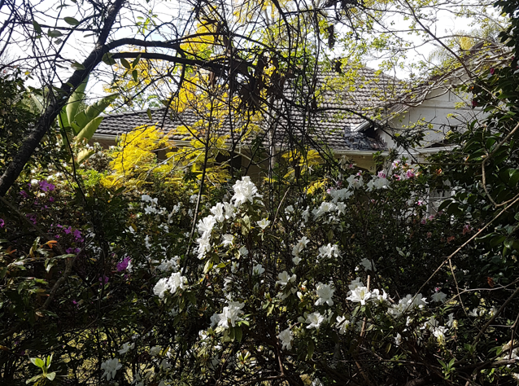

Lot 48 DP 5440

**Hornsby Shire Council details**

**Heritage Register: (NONE)**

Part of Mount Pleasant Estate – Cheltenham 1st Subdivision 1908

Sands Directories 1920-27 J. W. Johns “Moordean”; 1930-32/33 Mrs. J. W. Johns “Moordean”

Electoral Roll 1933: Lilian Johns

In 1920 John William Johns, and Lilian Johns were living at “Mooredean.”

*[John W. Johns married Lilian Nicholls in 1899, district of Burwood]*

In 1923 John William Johns died at “Mooredean,” aged 51 years, survived by his wife and children Jack & Wesley.

Probate Jurisdiction refers to J. W. Johns as boot manufacturer. Probate was granted to his widow.

In 1928 Jack Johns, of Cheltenham, was married to Edith Brodrick, third daughter of Mr. & Mrs. R. H. Brodrick, of Cheltenham.

In March 1950 Lilian Johns died at 51 Cheltenham-road, aged 75 years.

In April 1950 the house was put up for auction, described as follows:  
*Cheltenham - Vac. Poss. Bungalow (TRUSTEE SALE)*

*51 CHELTENHAM ROAD, NEAR BEECROFT ROAD,*

*ATTRACTIVE BRICK BUNGALOW offered with VAC. POSS., 4 mins., to train, ACCOM.: 3 bedrooms, lounge, dining-room, vers., kit., bath, etc. GARAGE. LAND: 70 x 194. T.T. Solicitors: M. B. BYLES & CO.*

In 1952, John George (“Jack”) Johns, of 16 The Promenade, Cheltenham, boot manufacturer, died.

**Bibliography: none**

**Resources available (varies):**

* Sands Directories 1858-1933 City of Sydney [Sands Postal Directory | City of Sydney Archives (nsw.gov.au)](https://archives.cityofsydney.nsw.gov.au/nodes/view/495003)
* Newspaper articles – TROVE - [Search - Trove (nla.gov.au)](https://trove.nla.gov.au/search/advanced/category/newspapers)
* Ancestry.com (subscription only) [Genealogy, Family Trees and Family History Records online - Ancestry.com](https://www.ancestry.com.au/) – Sands Directories, Electoral Rolls, Family photos (Public Member photos), Census lists, marriage details, + miscellaneous
* N.S.W. Births, Deaths & Marriages [Family history search | NSW Government](https://www.nsw.gov.au/family-and-relationships/family-history-search) (QLD & Victoria also obtainable online)
* House photos and information via Hornsby Shire Council website for Property Search and Heritage Register [Heritage | Hornsby Shire Council (nsw.gov.au)](https://www.hornsby.nsw.gov.au/property/build/heritage)
* House photos and associated information via Internet search on address via Real Estate websites (from 2005)
* “Beecroft and Cheltenham Heritage Walks” - Beecroft-Cheltenham History Group Inc. 2004 book (1st edition)
* Australian War Museum website [Home | Australian War Memorial (awm.gov.au)](https://www.awm.gov.au/)