**53 CHELTENHAM ROAD, CHELTENHAM (“Woorilla”, later “Malahide”)**

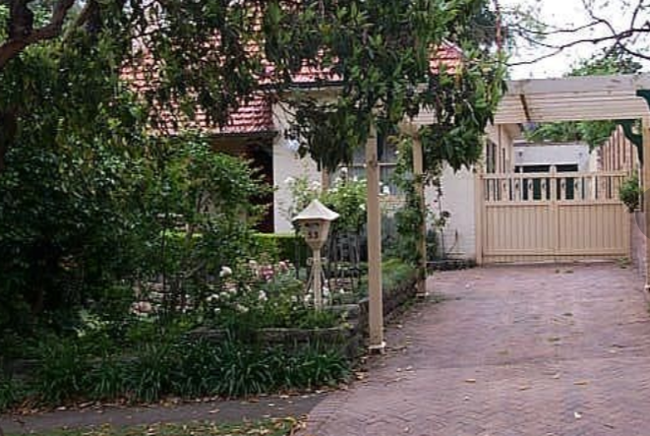

Lot 49 DP 5440

**Hornsby Shire Council details**

**Heritage Register: (NONE)**

Part of Mount Pleasant Estate – Cheltenham 1st Subdivision 1908

Sands Directories 1921-26 H. L. James “Woorilla”; 1927-32/33 Mrs. H. L. James “Woorilla”

Electoral Roll: Helen James No. 53

In 1923 Henry Layton James was living at “Woorilla.”

In 1925 Henry Layton James, formerly of Casino and Bellingen, died at “Woorilla,” aged 80 years.

**Henry Layton James**

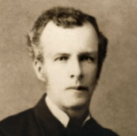

He was born in Sydney on May 3, 1845. His father, the late Layton O'Dell David James, was a member of the firm of Bradley and James, solicitors. Educated at Calder House, he entered the office of his father, who was then practising at Mudgee, and was admitted as a solicitor in 1872. Three years later he married, and commenced practice at Casino, where he resided for many years. Subsequently he practised at Bellingen until his retirement in 1919.

Mr. James left a widow, three sons— Lawrence Henry (of Casino), Walter Hubert (of Kyogle), and Richard Ernest (of the Commonwealth Bank, Brisbane)—and three daughters.

*[ Henry Layton James married Mary Anne/Ann Frost in 1875, in the district of Penrith]*

In 1933 Mary Ann James died at her residence, “Woorilla,” aged 81 years.

In 1943 Thomas Edward Jones (clerk in holy orders) and Lucy Jones were living there.

*[Thomas E. Jones married Lucy Vincent in 1929, in the district of Marrickville]*

Elizabeth Ann Hooper acquired the property. In 1949 she died and the home, and another at Eastwood, was put up for sale in March 1950, “Woorilla” described as follows:  
*Cheltenham - Brick Cottage*

*Under Instructions from*

*EXECUTRICES OF WILL OF THE LATE E. A. HOOPER, [Elizabeth Ann Hooper, died 28 Aug 1949]*

*53 CHELTENHAM ROAD. OFF BEECROFT ROAD.*

*LARGE BRICK COTTAGE, conveniently situated. ACCOM.: 3 bedrms., lnge., din., bath., living-rm.. kit., 3 vers., GARAGE. LET AT 35/ p.w. LAND, 70ft x 194ft. T.T.*

*Solicitors: M. B. BYLES & CO.*

[Another property belonging to E. A. Hooper, at Eastwood, was also put up for sale at this time]

In 1992 the house, now named “Malahide,” was again put up for sale, described as follows:

53 Cheltenham Road, Cheltenham.

Stately home in Cheltenham

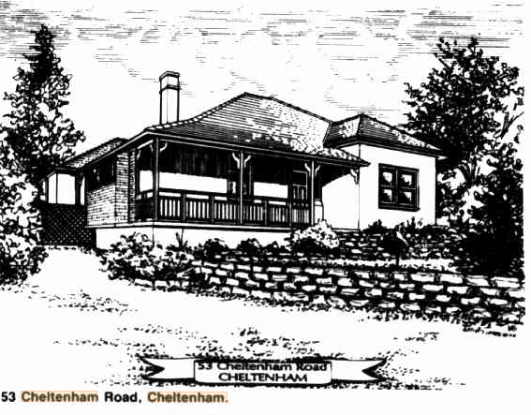

‘NAMED after a castle in Dublin, a 1915 home known as “Malahide" has been restored and will be auctioned by L. J. Hooker, Beecroft, on April 11.

It is a stately four-bedroom home at 53 Cheltenham Road, Cheltenham — the sister-suburb of Beecroft.

Set on 1260 square metres of land, it is of full brick construction with wool carpets, imported Spanish lighting and Australian colonial cedar furnishings.

The master bedroom features ornate, original ceilings.’1

**Bibliography:**

1 Australian Jewish News, 10th April 1992

**Resources available (varies):**

* Sands Directories 1858-1933 City of Sydney [Sands Postal Directory | City of Sydney Archives (nsw.gov.au)](https://archives.cityofsydney.nsw.gov.au/nodes/view/495003)
* Newspaper articles – TROVE - [Search - Trove (nla.gov.au)](https://trove.nla.gov.au/search/advanced/category/newspapers)
* Ancestry.com (subscription only) [Genealogy, Family Trees and Family History Records online - Ancestry.com](https://www.ancestry.com.au/) – Sands Directories, Electoral Rolls, Family photos (Public Member photos), Census lists, marriage details, + miscellaneous
* N.S.W. Births, Deaths & Marriages [Family history search | NSW Government](https://www.nsw.gov.au/family-and-relationships/family-history-search) (QLD & Victoria also obtainable online)
* House photos and information via Hornsby Shire Council website for Property Search and Heritage Register [Heritage | Hornsby Shire Council (nsw.gov.au)](https://www.hornsby.nsw.gov.au/property/build/heritage)
* House photos and associated information via Internet search on address via Real Estate websites (from 2005)
* “Beecroft and Cheltenham Heritage Walks” - Beecroft-Cheltenham History Group Inc. 2004 book (1st edition)
* Australian War Museum website [Home | Australian War Memorial (awm.gov.au)](https://www.awm.gov.au/)