**54 CHELTENHAM ROAD, CHELTENHAM (“Beaufort”)**

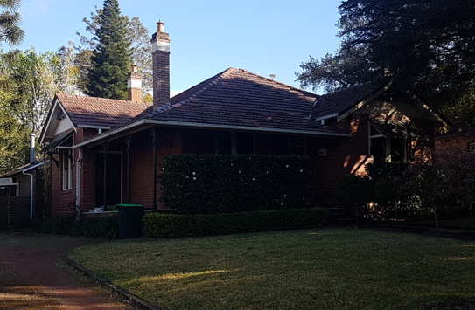

Lot 1 DP 966416

**Hornsby Shire Council details**

**Heritage Register: (NONE)**

Part of Cheltenham Park Estate Subdivision 1901

In February 1912 plans were approved by Hornsby Council for Mr. A. A. Vaughan to build a brick cottage (later named “Beaumont”) for Mrs. Parsons.

In 1913 occupants were: Richard Parsons (draper), Emily Frances Parsons and Hallie Constance Mary Parsons

Sands Directories 1915-30 Richard Parsons; 1932/33 E. L. Lewis

Electoral Roll 1933: ?

In 1920 Hilda (‘Hallie’), the only daughter of Mr. & Mrs. Parsons, was married to Frank Flew, of Mosman.

The Parsons lived at this address into the early 1930’s.

In 1934 Emily Parsons, now living in Mosman, died, aged 74 years.

By 1935 the home was occupied by David Edward Limburg (architect) and Eva Mileta Limburg (living at Thornleigh in 1934).

For 1937 Richard Winchester (manufacturer), Louisa Edith Winchester, Elizabeth Gwendolen Langley Winchester and Louisa Edith Knell were living at 54 Cheltenham-road, Cheltenham

In 1943 John Campion (seaman) and Emma Caroline Robarts were living at this address

**Bibliography: none**

**Resources available (varies):**

* Sands Directories 1858-1933 City of Sydney [Sands Postal Directory | City of Sydney Archives (nsw.gov.au)](https://archives.cityofsydney.nsw.gov.au/nodes/view/495003)
* Newspaper articles – TROVE - [Search - Trove (nla.gov.au)](https://trove.nla.gov.au/search/advanced/category/newspapers)
* Ancestry.com (subscription only) [Genealogy, Family Trees and Family History Records online - Ancestry.com](https://www.ancestry.com.au/) – Sands Directories, Electoral Rolls, Family photos (Public Member photos), Census lists, marriage details, + miscellaneous
* N.S.W. Births, Deaths & Marriages [Family history search | NSW Government](https://www.nsw.gov.au/family-and-relationships/family-history-search) (QLD & Victoria also obtainable online)
* House photos and information via Hornsby Shire Council website for Property Search and Heritage Register [Heritage | Hornsby Shire Council (nsw.gov.au)](https://www.hornsby.nsw.gov.au/property/build/heritage)
* House photos and associated information via Internet search on address via Real Estate websites (from 2005)
* “Beecroft and Cheltenham Heritage Walks” - Beecroft-Cheltenham History Group Inc. 2004 book (1st edition)
* Australian War Museum website [Home | Australian War Memorial (awm.gov.au)](https://www.awm.gov.au/)