**54 THE CRESCENT, CHELTENHAM (“Windsor Lodge”, prev. “Mimosa”)**

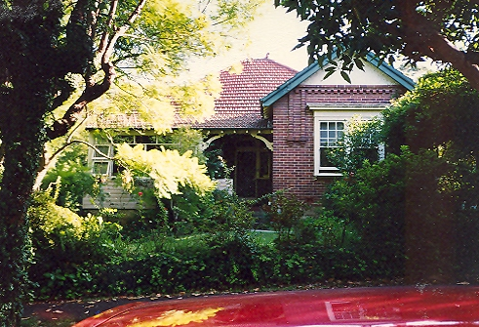

Lot 33 DP 5440

**Hornsby Shire Council details**

**Heritage Register: Item No. 294**

Constructed in 1909 for the same family (Chorley) as No. 52.

Originally named *Windsor Lodge* and then *Mimosa* before reverting to its original name, was built for William Chorley Jnr in 1909. After William relocated to Cheltenham Road it became the home of his sister, Edith, and her husband George Graham. The house also has an octagonal studio and this was used by Mr Graham, as a fitting room for boot making in World War 1.

In 1904 in St. John’s Church, Beecroft, Edith Bertha, eldest daughter of Mr. and Mrs. W. Chorley, of “Mount Pleasant,” Cheltenham, was married to Mr. George Jennings Graham, only son of Mr. George Graham, of Mosman.

**1904 Marriage of George Graham & Edith Chorley**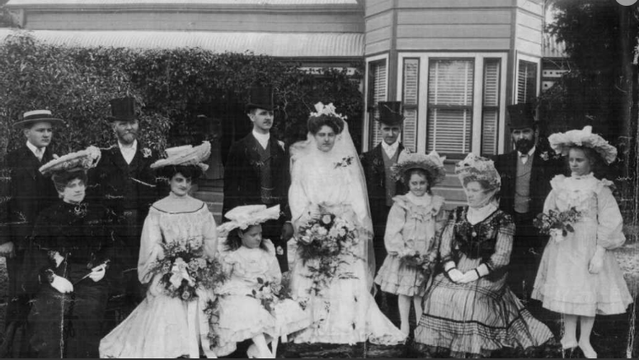

In 1911 George Graham senior, boot manufacturer, died suddenly at his residence “Hillview,” Cheltenham, aged 70 years. He was born at Windsor, London, in 1840 and arrived in Sydney about 1884. His son, George Jnr, continued in that profession. His widow, Helen Martha Graham, born London 1852, would die in 1944 within the district of Ryde.

**1890’s – Helen Martha Jennings, George Graham Jnr, George Graham Snr, Ethel Graham**

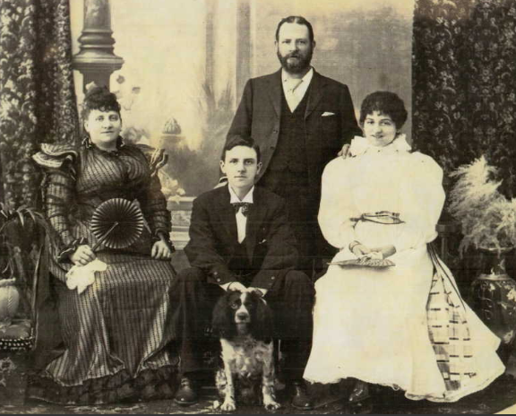

Sands Directories 1916-1932/3 George J. Graham

Electoral Roll 1933: George Graham No. 54

In 1915 William Chorley Jnr is listed as living at “Mimosa.”

In 1917 George Gunnel Jennings Graham was living at the house, now renamed “Windsor Lodge.”

The Mount Pleasant Estate – Cheltenham (2nd Subdivision) 1918 shows the house being occupied by Mr. Graham.

In 1930 occupants were George Gunnel Jennings Graham (manufacturer), Edith Bertha Amery Graham and George William Jennings Graham (boot manufacturer)

In 1931 George & Edith’s 2nd son, Henry Charles Graham, married Miss Pat Brett, a London girl, whom he had met when he was on a visit to England.

In 1943 occupants were George Gunnel Jennings Graham (manufacturer), Edith Bertha Amery Graham, Jean Edith Graham (stenographer) and Alan Keith Graham (tailor).

In 1954 George, Edith, & Alan Graham were still living at 54 The Crescent.

In 1957 George Jennings Gunnell Graham, retired boot manufacturer, of Cheltenham, died.

In 1959 Edith Bertha Amery Graham, of The Crescent, Cheltenham, died, aged 84 years.

The house was last sold in 2014.1

**Bibliography:**

1 [54 The Crescent, Cheltenham, NSW 2119 - Property Details (realestate.com.au)](https://www.realestate.com.au/sold/property-house-nsw-cheltenham-113091683)

**Resources available (varies):**

* Sands Directories 1858-1933 City of Sydney [Sands Postal Directory | City of Sydney Archives (nsw.gov.au)](https://archives.cityofsydney.nsw.gov.au/nodes/view/495003)
* Newspaper articles – TROVE - [Search - Trove (nla.gov.au)](https://trove.nla.gov.au/search/advanced/category/newspapers)
* Ancestry.com (subscription only) [Genealogy, Family Trees and Family History Records online - Ancestry.com](https://www.ancestry.com.au/) – Sands Directories, Electoral Rolls, Family photos (Public Member photos), Census lists, marriage details, + miscellaneous
* N.S.W. Births, Deaths & Marriages [Family history search | NSW Government](https://www.nsw.gov.au/family-and-relationships/family-history-search) (QLD & Victoria also obtainable online)
* House photos and information via Hornsby Shire Council website for Property Search and Heritage Register [Heritage | Hornsby Shire Council (nsw.gov.au)](https://www.hornsby.nsw.gov.au/property/build/heritage)
* House photos and associated information via Internet search on address via Real Estate websites (from 2005)
* “Beecroft and Cheltenham Heritage Walks” - Beecroft-Cheltenham History Group Inc. 2004 book (1st edition)
* Australian War Museum website [Home | Australian War Memorial (awm.gov.au)](https://www.awm.gov.au/)
* Beecroft and Cheltenham History Group website [Beecroft and Cheltenham History - Beecroft Cheltenham History Group (bchg.org.au)](https://bchg.org.au/)