**56 CHELTENHAM ROD, CHELTENHAM (“Normanton”)**

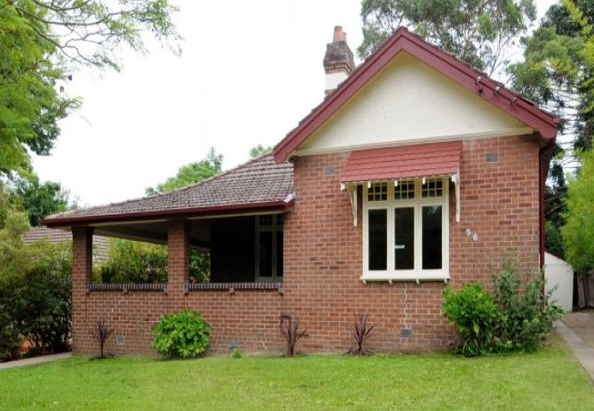

Lot B DP 415717

**Hornsby Shire Council details**

**Heritage Register: (NONE)**

Part of Cheltenham Park Estate Subdivision 1901

**NOTE**: Land for No. 58 Cheltenham-road believed to have owned initially by owner of No. 60 Cheltenham-road, and sold to J. A. Peach or H. S. Peach in the early 1930s.

Sands Directories 1915-1932/33 Joseph A. Peach

Electoral Roll 1933: Joseph Peach No. 58

The Peach family were living at this address in 1912.

Children of Joseph A. Peach were: Bert, Arthur, Frank, Harold, Norman and Dorothy

In 1913 occupants were Joseph Arthur Peach (artist), Annie Peach, Arthur Peach (clerk) -Cheltenham-road, Cheltenham. That year a daughter, Dorothy Emmie Marie, was born there.

Arthur Peach was born in 1864, Derbyshire, England.

**Joseph Arthur Peach**

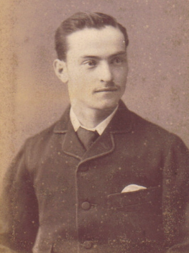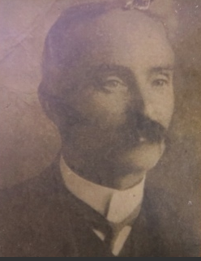

In 1915 Arthur Peach, aged 24 years, son of Joseph Arthur Peach of Cheltenham, enlisted for WW1.

In 1923 the Public Services listed Joseph Arthur Peach as Teacher of China Painting and Art, Sydney; date of appointment 17 Jul 1895

In 1932 Harold Sydney Peach, a son of Joseph, was put on the Architects’ Roll.

In 1933 Joseph Arthur Peach (artist), Annie Peach, Harold Sydney Peach (architect) were living at 58 Cheltenham-road, Cheltenham

*[No. 58 Cheltenham-road could be considered as synonymous to No. 56 Cheltenham-road; the current house at No. 58 is a more recently built house, c.1950’s]*

From 1935 to 1937 Joseph Arthur Peach (artist) & Annie Peach are listed on the Electoral Rolls as living at 58 Cheltenham-road, with other family members at 56 Cheltenham-road.

In 1940 Annie Huntbach Peach, wife of Joseph Arthur Peach, died at Cheltenham.

By 1943 Edward James Holland (clerk) and Hilda Holland were living at 56 Cheltenham-road.

In 1951 Joseph Arthur Peach, died at the residence of his son, at Terrigal, aged 87 years, father of Bert, Arthur, Frank, Harold, Norman, and Dorothy (Mrs. Burley).

The house was last sold in 2011.**1**

**Joseph Arthur Peach painting (example below):**

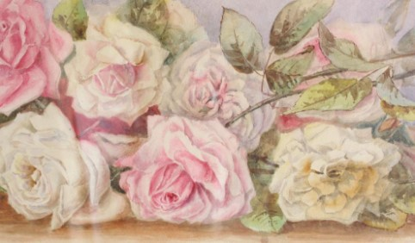

**Bibliography:**

**1** [56 Cheltenham Rd, Cheltenham, NSW 2119 - Property Details (realestate.com.au)](https://www.realestate.com.au/sold/property-house-nsw-cheltenham-107143495)

**Resources available (varies):**

* Sands Directories 1858-1933 City of Sydney [Sands Postal Directory | City of Sydney Archives (nsw.gov.au)](https://archives.cityofsydney.nsw.gov.au/nodes/view/495003)
* Newspaper articles – TROVE - [Search - Trove (nla.gov.au)](https://trove.nla.gov.au/search/advanced/category/newspapers)
* Ancestry.com (subscription only) [Genealogy, Family Trees and Family History Records online - Ancestry.com](https://www.ancestry.com.au/) – Sands Directories, Electoral Rolls, Family photos (Public Member photos), Census lists, marriage details, + miscellaneous
* N.S.W. Births, Deaths & Marriages [Family history search | NSW Government](https://www.nsw.gov.au/family-and-relationships/family-history-search) (QLD & Victoria also obtainable online)
* House photos and information via Hornsby Shire Council website for Property Search and Heritage Register [Heritage | Hornsby Shire Council (nsw.gov.au)](https://www.hornsby.nsw.gov.au/property/build/heritage)
* House photos and associated information via Internet search on address via Real Estate websites (from 2005)
* “Beecroft and Cheltenham Heritage Walks” - Beecroft-Cheltenham History Group Inc. 2004 book (1st edition)
* Australian War Museum website [Home | Australian War Memorial (awm.gov.au)](https://www.awm.gov.au/)