**57 CHELTENHAM ROAD, CHELTENHAM (“Bombala,” prev. “Narani”)**

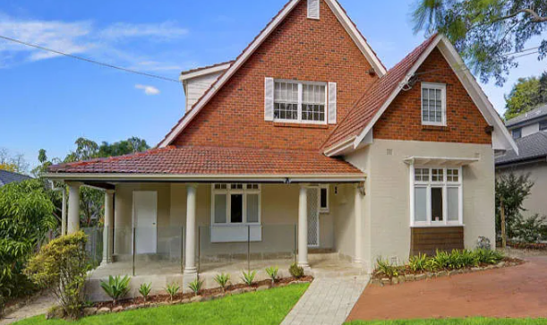

Lot 51 DP 5440

**Hornsby Shire Council details**

**Heritage Register: (NONE)**

Sands Directories 1915-30 E. G. Seale “Narani”; 1931-1932/3 Mrs. E. G. Seale No. 33

Electoral Roll 1933: Rose Seale No. 28

Currently the house appears to have been extensively altered.

In July 1914 Hornsby Council received a building application for a 6-roomed cottage on Cheltenham-road for E. G. Seale.

*[Ernest George Seale married Rose Spurway in 1897, district of Ryde]*

By the following year Ernest and Rose Seale moved into their home, named “Narani.” It was the 1st house after Beecroft-road leading to the railway station.

**1918 Mt. Pleasant Estate Subdivision (showing Mr. Seale’s home)**

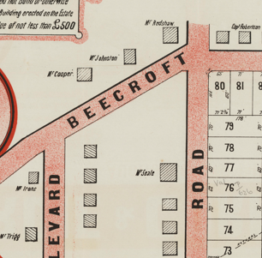

**Ernest George Seale**

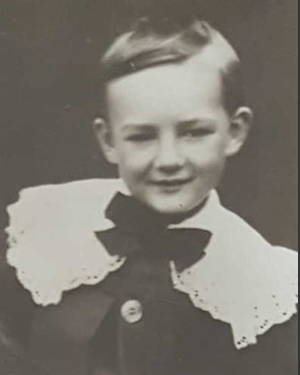

In 1920 Rose’s grandmother, Mrs. James Spurway, snr., leaving 47 grandchildren and 23 great-grandchildren. The Spurway family were long-term residents of Dundas.

In 1923 Ernest died, aged 53 years, referred to as ‘a member of an old North Sydney family. He was a native of East Maitland, and had resided at Cheltenham about thirty-five years. He was a keen cricketer, and followed the fortunes of the old Leichhardt Club many seasons. The deceased leaves a widow, two sons, and a daughter.’

Probate refers to him as being a public servant.

Rose Seale continued to live in the family home.

In 1925 her son, Eric Charles Seale, married Jessie Maud Tibbits, of Eagle Junction.

In 1930 occupants were Rose Seale, John Ernest Seale (engineer) and Freda Muriel Seale (clerk)

In 1931 Freda was engaged to Keith Edward Vyvyan Rogers, elder son of the late Mr. F. H. G. Rogers and Mrs. Rogers, of Cheltenham.

Also In 1931 Mrs. Seale moved to No. 33, just prior to No. 50 The Crescent. That year her daughter Freda was engaged to Keith Edward Vyvyan, elder son of the late Mr. F. H. G. Rogers and Mrs. Rogers, of Cheltenham – they were married in 1932.

In 1933 & 1934 Rose was living with her son John at 28 Cheltenham-road, Cheltenham.

*[By 1936 John had moved to Burwood and Rose to Strathfield (Rose died in 1963, district of North Sydney]*

Sands Directories 1931-32/3 Sep. Jonas

Electoral Roll 1933: Septimus Jonas No. 57

In 1931 Septimus Jonas was the new occupant of the house, which was renamed “Bombala.”

In 1933 occupants were Septimus Jonas (printer), Irene Elizabeth Jonas, Phillip Edward Jonas (traveller)

*[Septimus Jonas married Irene Lane in 1904, district of Sydney]*

In 1936 Emanuel Alfred, second son of Mr. and Mrs. Septimus Jonas, Bombala, Cheltenham, was engaged to Edna Mary, only daughter of Mr. and Mrs. David Shanks, “Deanbank”, Epping. In 1938 they were married.

By 1943 Arthur Janes Brear and Phyllis Brear were in the residence.

Septimus Jonas died in 1951 in the district of Burwood.

The house (now named “Bombala”) was last sold in 2010.1

**Bibliography:**

1 [57 Cheltenham Road, Cheltenham, NSW 2119 - Property Details (realestate.com.au)](https://www.realestate.com.au/sold/property-house-nsw-cheltenham-106728358)

**Resources available (varies):**

* Sands Directories 1858-1933 City of Sydney [Sands Postal Directory | City of Sydney Archives (nsw.gov.au)](https://archives.cityofsydney.nsw.gov.au/nodes/view/495003)
* Newspaper articles – TROVE - [Search - Trove (nla.gov.au)](https://trove.nla.gov.au/search/advanced/category/newspapers)
* Ancestry.com (subscription only) [Genealogy, Family Trees and Family History Records online - Ancestry.com](https://www.ancestry.com.au/) – Sands Directories, Electoral Rolls, Family photos (Public Member photos), Census lists, marriage details, + miscellaneous
* N.S.W. Births, Deaths & Marriages [Family history search | NSW Government](https://www.nsw.gov.au/family-and-relationships/family-history-search) (QLD & Victoria also obtainable online)
* House photos and information via Hornsby Shire Council website for Property Search and Heritage Register [Heritage | Hornsby Shire Council (nsw.gov.au)](https://www.hornsby.nsw.gov.au/property/build/heritage)
* House photos and associated information via Internet search on address via Real Estate websites (from 2005)
* “Beecroft and Cheltenham Heritage Walks” - Beecroft-Cheltenham History Group Inc. 2004 book (1st edition)
* Australian War Museum website [Home | Australian War Memorial (awm.gov.au)](https://www.awm.gov.au/)