**6 MASON AVENUE, CHELTENHAM (“Kainga”)**

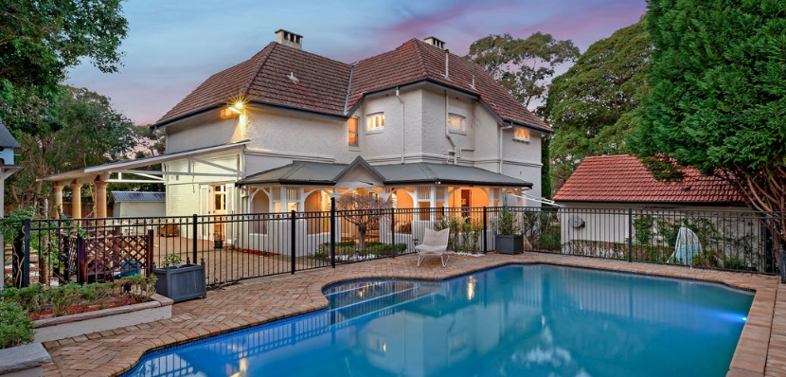

Lot 3 DP 332084

**Hornsby Shire Council details**

**Heritage Register: Item 277**

**Kainga** is a word from the **Maori** language that can mean different things depending on the context. It can mean leftovers, field of operation, or home, village or settlement.

Originally the house address was 156 Beecroft-road, thus the frontage faced Beecroft-road. The address would later become 6 Mason-avenue, Cheltenham.

[Land subdivision changed arrival access. Frontage faces Beecroft Road.]

Part of Cheltenham Park Estate Subdivision 1901

The 1901 Cheltenham Park Estate Subdivision created lots for sale along the Beecroft Road, Mason Avenue, Kent Road (later Cheltenham Road) and Boronia Avenue.

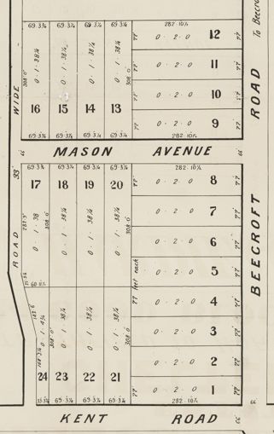

A Federation Arts & Crafts / Old English style home built for Robert Brodrick, an architect, in 1905. A neighbouring house was that of Joseph [Joseph Richard] Seale of “Boonga,” 12 Mason-avenue, Cheltenham, also an architect.

**Problems**: The Hornsby Shire Council Heritage Register gives Robert Brodrick as the designer however the Real Estate data refers to 6 Mason Avenue, Cheltenham, as having being designed and built by acclaimed early 1900s architect Joseph Seale (seemingly incorrect).

Also, the BCHG website refers to this house as No. 8.

**Robert Hargreave Brodrick (1860-1934)**

**B*orn Macclesfield, Cheshire, England, Arrived Sydney 1882***

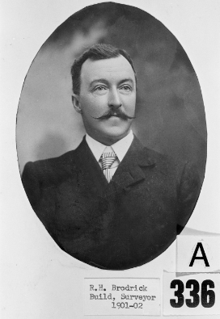

In 1901 the Cheltenham Park Estate subdivision auctioned 21 blocks of land, of about ½ acre each, with frontages to Beecroft-road, Kent-road (now Cheltenham-road) and Mason-avenue.1 About six lots would be acquired by Robert Hargreave Brodrick.

In April 1905 there is mention of Mr. Brodrick building next to Mr. Seale’s place, and in the following year Robert Brodrick, of Beecroft-road, became a new telephone subscriber (Epping 2).

The Land for Sale 1906–Beecroft and Cheltenham Subdivision shows the residence of Mr. Brodrick along Beecroft-road.

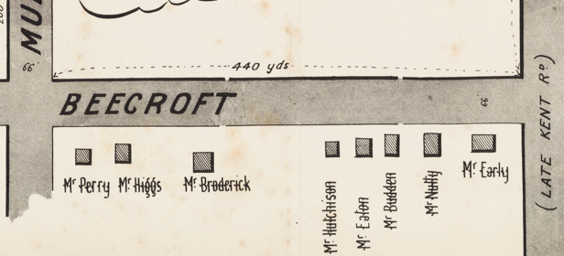

*(Mason Avenue is not shown although it did exist in 1901)*

The Hornsby Council Rate Books of 1907-1909 mention Robert Broderick [sic], surveyor, of Boronia-avenue, Beecroft – 3 acres, 38 perches. The land purchased by Robert Brodrick was probably be no. 156 Beecroft-road & nos. 2, 4 & 6 (and possibly no. 8) Mason-avenue.

The Mount Pleasant Estate – Cheltenham (1st Subdivision) 1908 shows the house being occupied by Mr. R. H. Brodrick.

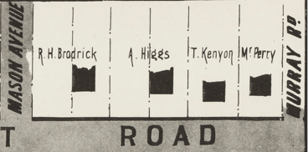

The 1913 Electoral Roll lists Robert Hargreave Brodrick, architect, and his wife Emily, of “Kainga,” Cheltenham

*[Robert H. Brodrick married Emily Jane Maher in 1896, Petersham]*

**Sands Directories 1915-1932/3: Robert H. Brodrick “Kainga” 156 Beecroft-road**

**1933 Electoral Roll: Robert Brodrick “Kainga”**

In 1923 his son, Norman H. Brodrick, born 1897, living at “Kainga,” was the architect of a small school church at Cheltenham. Norman would become engaged to Mildred Chapman of Epping in 1929 and were married in 1932.

**Norman Hargreave Brodrick, 1918-1919 (son of Robert)**

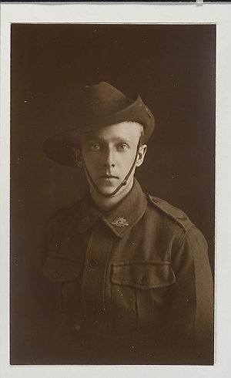

Robert Hargreave Brodrick died on 19th September 1934, aged 74 years, at his residence, “Kainga,” [156] Beecroft-road, Cheltenham, late City Architect and Building Surveyor, husband of Emily and father of Norman, Hilda, Dorothy, Edith, and Joan.

The 1943 Electoral Roll places Emily Jane Brodrick and her daughter, Joan Meredith Brodrick, at 156 Beecroft-road, Cheltenham.

The 1949 Electoral Roll gives Emily’s address as no. 2 Mason-avenue (on the corner of Mason-avenue and Beecroft-road).

For 1958 her address is 6 Mason-avenue.

Emily Brodrick died in 1959.

The last sale of the property was in 2021.2

Real estate information states that it was designed and built by architect Joseph Seale.

**Bibliography:**

1 [Cheltenham Park Estate - Cheltenham | Hornsby Shire (recollect.net.au)](https://hornsbyshire.recollect.net.au/nodes/view/3694?lsk=eb8c9558be87ae97ca3c113491f43038&keywords=cheltenham&type=all&highlights=WyJjaGVsdGVuaGFtLiIsImNoZWx0ZW5oYW0iLCJjaGVsdGVuaGFtOiIsImNoZWx0ZW5oYW0sIl0)

2 [6 Mason Avenue, Cheltenham, NSW 2119 - realestate.com.au](https://www.realestate.com.au/property/6-mason-ave-cheltenham-nsw-2119/)

**Resources available (varies):**

* Sands Directories 1858-1933 City of Sydney [Sands Postal Directory | City of Sydney Archives (nsw.gov.au)](https://archives.cityofsydney.nsw.gov.au/nodes/view/495003)
* Newspaper articles – TROVE - [Search - Trove (nla.gov.au)](https://trove.nla.gov.au/search/advanced/category/newspapers)
* Ancestry.com (subscription only) [Genealogy, Family Trees and Family History Records online - Ancestry.com](https://www.ancestry.com.au/) – Sands Directories, Electoral Rolls, Family photos (Public Member photos), Census lists, marriage details, + miscellaneous
* N.S.W. Births, Deaths & Marriages [Family history search | NSW Government](https://www.nsw.gov.au/family-and-relationships/family-history-search) (QLD & Victoria also obtainable online)
* House photos and information via Hornsby Shire Council website for Property Search and Heritage Register [Heritage | Hornsby Shire Council (nsw.gov.au)](https://www.hornsby.nsw.gov.au/property/build/heritage)
* House photos and associated information via Internet search on address via Real Estate websites (from 2005)
* “Beecroft and Cheltenham Heritage Walks” - Beecroft-Cheltenham History Group Inc. 2004 book (1st edition)
* Australian War Museum website [Home | Australian War Memorial (awm.gov.au)](https://www.awm.gov.au/): [View digital copy (naa.gov.au)](https://recordsearch.naa.gov.au/SearchNRetrieve/Interface/ViewImage.aspx?B=3127251)
* [Robert Hargreave Brodrick - Wikipedia](https://en.wikipedia.org/wiki/Robert_Hargreave_Brodrick)
* [Brodrick, Robert Hargreave | The Dictionary of Sydney](https://dictionaryofsydney.org/person/brodrick_robert_hargreave)
* [Portrait of Robert Hargreave Brodrick, Municipal Council of Sydney, circa 1901 | City of Sydney Archives (nsw.gov.au)](https://archives.cityofsydney.nsw.gov.au/nodes/view/681845)
* [Robert Brodrick Sydney Municipal council 45years (bchg.org.au)](https://bchg.org.au/2012/07/01/robert-hargreave-brodrick/)
* [The Cyclopedia of N.S.W. (illustrated) : an historical and commercial review, descriptive and biographical, facts, figures and illustrations ; an epitome of progress. (nla.gov.au)](https://nla.gov.au/nla.obj-34846518/view?partId=nla.obj-34846526#:~:text=%20%20%20CYCLOPEDIA%20of%20New%20South%20Wales,%20%2013%20%2046%20more%20rows%20) [page 427]
* Beecroft and Cheltenham History Group website [Beecroft and Cheltenham History - Beecroft Cheltenham History Group (bchg.org.au)](https://bchg.org.au/)