**6 THE BOULEVARD. CHELTENHAM (“Chepstow”)**

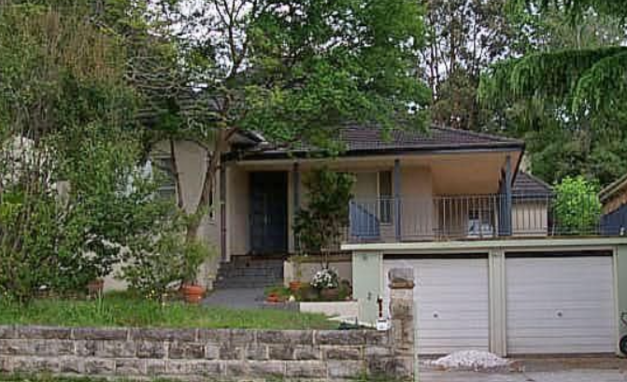

Lot 28 DP 5440

**Hornsby Shire Council details**

**Heritage Register: (NONE)**

Part of Mount Pleasant Estate – Cheltenham 1st Subdivision 1908

“Chepstow” was built as the second home for Henry ‘Harry’ Chorley. It was then owned by the Perdriau family.

Extensive alterations were made in the 1950s and again more recently so that very few original features can still be seen.

“Chepstow” is named after a town in Monmouthshire, Wales, where Henry wife, Amy, came from.

John William Fowler (accountant) and Lucy Ellen Fowler, along with Henry & Amy Chorley, were living together at “Chepstow” in 1913.

John W. & Lucy Fowler were the parents of Amy Mary Lucy Jane Fowler of Chepstow, England, who married Henry J. A. (James Alder) Chorley, eldest son of Mr. W. Chorley, of “Mount Pleasant,” Cheltenham, in 1909.

The couple had met when Henry was travelling in England, but his business required that he return to Australia. Later, Amy, at the request of Henry, travelled to Australia and they married.

Sands Directories 1915-1927 John W. Fowler “Chepstow”

Sands Directories 1915-1927: Henry Chorley

The 1918 Mount Pleasant Estate - Cheltenham (2nd Subd.) shows the home of H. Chorley.

In 1921 the villa was advertised to let, described as follows:

‘To Let, New Brick Bungalow, 6 rooms, bathroom, kit., laundry, etc., 50/- week. H. Chorley, 313 George-st., or Boulevard, Cheltenham.’

In 1933 Henry & Amy Chorley, along with his parents-in-law, John W. & Lucy Fowler, moved to “Hillview,” 52 The Crescent, Cheltenham. Henry and Amy moved to Gordon in 1937.

“Chepstow” was then occupied by Beulah Grace Gallard for a short time.

Sands Directories 1931-1932/3: Frederick Perdriau

Electoral Roll 1933: Frederick Perdriau

By 1943 “Chepstow,” 6 The Boulevard, was occupied by Frederick Henry Perdriau (engineer), Nelly Perdriau & Jean Nelly Rea Perdriau (student). Frederick and Nellie were still living there in 1954. Their previous address was no. 8 The Boulevard, Cheltenham.

Frederick Henry Perdriau, retired railway engineer, of Cheltenham, died in 1955.

**Bibliography: none**

**Resources available (varies):**

* Sands Directories 1858-1933 City of Sydney [Sands Postal Directory | City of Sydney Archives (nsw.gov.au)](https://archives.cityofsydney.nsw.gov.au/nodes/view/495003)
* Newspaper articles – TROVE - [Search - Trove (nla.gov.au)](https://trove.nla.gov.au/search/advanced/category/newspapers)
* Ancestry.com (subscription only) [Genealogy, Family Trees and Family History Records online - Ancestry.com](https://www.ancestry.com.au/) – Sands Directories, Electoral Rolls, Family photos (Public Member photos), Census lists, marriage details, + miscellaneous
* N.S.W. Births, Deaths & Marriages [Family history search | NSW Government](https://www.nsw.gov.au/family-and-relationships/family-history-search) (QLD & Victoria also obtainable online)
* House photos and information via Hornsby Shire Council website for Property Search and Heritage Register [Heritage | Hornsby Shire Council (nsw.gov.au)](https://www.hornsby.nsw.gov.au/property/build/heritage)
* House photos and associated information via Internet search on address via Real Estate websites (from 2005)
* “Beecroft and Cheltenham Heritage Walks” - Beecroft-Cheltenham History Group Inc. 2004 book (1st edition)
* Australian War Museum website [Home | Australian War Memorial (awm.gov.au)](https://www.awm.gov.au/)
* Beecroft and Cheltenham History Group website [Beecroft and Cheltenham History - Beecroft Cheltenham History Group (bchg.org.au)](https://bchg.org.au/)