**61 CHELTENHAM ROAD, CHELTENHAM (“Ballindrum”; prev. “Egilabra”)**

**Alternate address: 185 Beecroft Road**

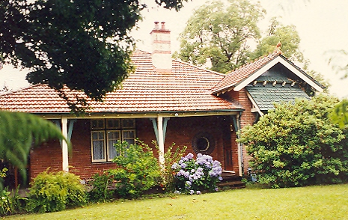

61 Cheltenham Road Lot 1 DP 779916

185 Beecroft Road Lot 1 DP 779916

**Hornsby Shire Council details**

**Heritage Register: (NONE)**

Part of Mount Pleasant Estate – Cheltenham 1st Subdivision 1908

First recorded in 1930 when it was home of Cecil Arthur Osborne Sindel (accountant) and Jean Livingstone Wallace Sindel.

It was situated on the corner of Beecroft-road and Cheltenham-road.

In 1933 the house was put up for sale, described as follows:

‘CHELTENHAM. – Gentleman’s BUNGALOW In best part, corner position, 4 minutes station, lounge, dining rooms connected, bevel plate sliding doors, dome ceiling, Jarrah floors, lead-light doors and windows. Beautiful bathroom and kitchen (fully tiled), 2 large verandahs. Garage standing in lovely grounds. Will sacrifice. £500 Deposit, balance 5 per cent. Best offer. Egilabra, corner Beecroft-road and Cheltenham-road Cheltenham.’

The Sindels moved to Artarmon.

In 1933 the house became occupied by Walter Charles Cover (electrician) and Nellie Eleanor Cover, who later moved to 24 Sutherland-road, Beecroft.

In 1937 the house was occupied by James Thompson (retired) and Viola Thompson.

In 1953, at 61 Cheltenham-road, Cheltenham, James Thompson, died.

In 2017 the house, now named “Ballindrum,” c1923, was last sold.**1**

**Bibliography:**

1 [61 Cheltenham Road, Cheltenham, NSW 2119 - Property Details (realestate.com.au)](https://www.realestate.com.au/sold/property-house-nsw-cheltenham-125414234)

**Resources available (varies):**

* Sands Directories 1858-1933 City of Sydney [Sands Postal Directory | City of Sydney Archives (nsw.gov.au)](https://archives.cityofsydney.nsw.gov.au/nodes/view/495003)
* Newspaper articles – TROVE - [Search - Trove (nla.gov.au)](https://trove.nla.gov.au/search/advanced/category/newspapers)
* Ancestry.com (subscription only) [Genealogy, Family Trees and Family History Records online - Ancestry.com](https://www.ancestry.com.au/) – Sands Directories, Electoral Rolls, Family photos (Public Member photos), Census lists, marriage details, + miscellaneous
* N.S.W. Births, Deaths & Marriages [Family history search | NSW Government](https://www.nsw.gov.au/family-and-relationships/family-history-search) (QLD & Victoria also obtainable online)
* House photos and information via Hornsby Shire Council website for Property Search and Heritage Register [Heritage | Hornsby Shire Council (nsw.gov.au)](https://www.hornsby.nsw.gov.au/property/build/heritage)
* House photos and associated information via Internet search on address via Real Estate websites (from 2005)
* “Beecroft and Cheltenham Heritage Walks” - Beecroft-Cheltenham History Group Inc. 2004 book (1st edition)
* Australian War Museum website [Home | Australian War Memorial (awm.gov.au)](https://www.awm.gov.au/)