**61a CHELTENHAM ROAD / 174 BEECROFT ROAD, CHELTENHAM (“Lorric”, prev. “Roldor” & “Ascot”)**



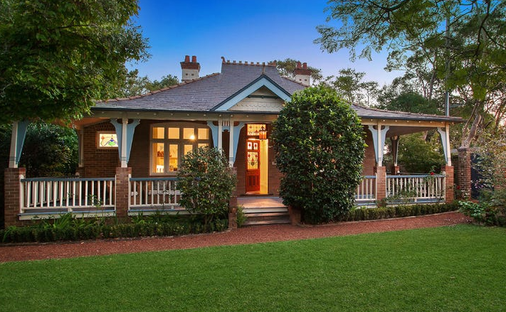

174 Beecroft Road Lot 1 DP 527556

61A Cheltenham Road Lot 1 DP 527556

**Hornsby Shire Council details**

**Heritage Register: Item No. 265**

A LARGE Federation period house on the corner of Cheltenham-road and Beecroft-road, Cheltenham (West side) owned by George Redshaw. The house was originally named “Roldor.”

Part of Beecroft & Cheltenham – Land for Sale Subdivision 1906

The 1906 Beecroft & Cheltenham – Land for Sale Subdivision shows vacant land on this site.

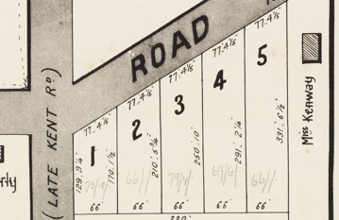

The 1908 Mount Pleasant Estate – Cheltenham (1st Subdivision) shows the house being occupied by Mr. Redshaw.

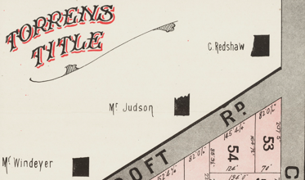

In January 1912 the home of Mr. Redshaw was broken into and jewellery and other valuables to the extent of £70 was stolen.

The 1913 Electoral Rolls recordsGeorge Redshaw (school teacher), Fanny Redshaw – Beecroft-road, Cheltenham

*[George Redshaw married Fannie Lillias Muir in 1902 at Cowra]*

In January 1915 it was reported that a villa was being completed for Mr. G. Redshaw at Beecroft.

1915-1916 George Redshaw “Rohlor”; 1921-4 George H. Matthews “Ascot”; 1925- 1932/3 Geo. Redshaw “Ascot”

Electoral Roll 1933: Fanny Redshaw

**George Redshaw (1872 N.S.W. - 1939**)

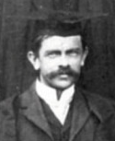

In April 1915 Mrs. George Redshaw was hon. secretary of a Red Cross committee in aid of the Belgians, whereby a ‘Bohemian evening’ was held at the School of Arts.

In October 1915 his house was advertised to let, described as follows:

*TO LET, at CHELTENHAM (N.S.W.) - the good health suburb - Modern COTTAGE (new this year) containing 5 rooms, kitchen, scullery, bathroom, pantry cellarette, 3 verandahs, usual outhouses, grounds 145 x 200. Low rent to good tenant. Blinds, hangings, and floor coverings can be taken over if desired.1*

George had been promoted to Headmaster of Young District School.

He was Master of English at the Sydney [Boys’] High School, and was previously at East Maitland High School and Fort-street School. His term at the Sydney High School had extended over 15 years. He had been a most successful teacher, and was responsible for a record number of passes in English at the previous year’s Intermediate examination, no less than 17 of the candidates from his English class having receiving "A" passes.

Prior to leaving for Young, his infant son, Arthur Muir Redshaw, died at “Roldor,” aged 5 days.

The 1918 Mount Pleasant Estate – Cheltenham (2nd Subdivision) shows the house as belonging to Mr. Redshaw.

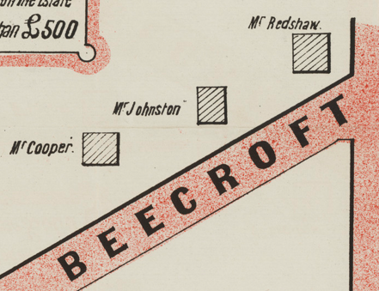

In 1921 George was transferred to Katoomba. His son, George M. Redshaw (born 1905), secured the highest pass for mathematics in the State at the Leaving Certificate Examination. He was the fourth in the State in Physics. His brother Errol (born 1903) also figured in the honours list. Both boys were then placed at the Sydney Boys High School.

In 1922 George M. Redshaw, son of the headmaster of Katoomba High School, won the Barker Scholarship and Horner Exhibition in mathematics at the recent University examination. He was one of the youngest students of the State, being just 16 years of age. He was educated at the Young District School, and at the Sydney Boys' High, and intends entering the Medical School. He matriculated with first-class honours in mathematics and physics.

During the 1920’s “Roldor” in Beecroft-road, Cheltenham, was occupied by George Matthews, and the house was renamed “**Ascot**.”

In 1927 George Redshaw was transferred to Cook's Hill High School, at Newcastle, but by 1930 had returned to Cheltenham to live, having been transferred to Manly.

The Electoral Rolls for 1932-4 record George Redshaw (teacher), Fanny Lillias Redshaw & Errol Muir Redshaw (university student) as occupants of “Ascot.”

In 1936 George Redshaw retired.

His first school was Randwick, in 1887. In 1901 he went to Sydney Boys' High, then transferred to Young, and was appointed headmaster at Katoomba in 1915. Thirteen years later he went to Cook's Hill, and in 1930 took charge at Manly.

In October 1939 George Redshaw died at his at his residence, “Ascot,” Beecroft Road, Cheltenham, following a long illness, leaving a widow and two sons George and Errol.

In his Will, all his real and personal estate was bequeathed to his wife.

In 1943 the house was occupied by Cyril & Ruby Mandelson.

The house was last sold in 2017 and had been renamed “**Lorric**.”2

**Bibliography:**

1 Sydney Morning Herald, 21st August 1915

2 [174 Beecroft Road, Cheltenham, NSW 2119 - Property Details (realestate.com.au)](https://www.realestate.com.au/sold/property-house-nsw-cheltenham-125640930)

**Resources available (varies):**

* Sands Directories 1858-1933 City of Sydney [Sands Postal Directory | City of Sydney Archives (nsw.gov.au)](https://archives.cityofsydney.nsw.gov.au/nodes/view/495003)
* Newspaper articles – TROVE - [Search - Trove (nla.gov.au)](https://trove.nla.gov.au/search/advanced/category/newspapers)
* Ancestry.com (subscription only) [Genealogy, Family Trees and Family History Records online - Ancestry.com](https://www.ancestry.com.au/) – Sands Directories, Electoral Rolls, Family photos (Public Member photos), Census lists, marriage details, + miscellaneous
* N.S.W. Births, Deaths & Marriages [Family history search | NSW Government](https://www.nsw.gov.au/family-and-relationships/family-history-search) (QLD & Victoria also obtainable online)
* House photos and information via Hornsby Shire Council website for Property Search and Heritage Register [Heritage | Hornsby Shire Council (nsw.gov.au)](https://www.hornsby.nsw.gov.au/property/build/heritage)
* House photos and associated information via Internet search on address via Real Estate websites (from 2005)
* “Beecroft and Cheltenham Heritage Walks” - Beecroft-Cheltenham History Group Inc. 2004 book (1st edition)
* Australian War Museum website [Home | Australian War Memorial (awm.gov.au)](https://www.awm.gov.au/)
* Beecroft and Cheltenham History Group website [Beecroft and Cheltenham History - Beecroft Cheltenham History Group (bchg.org.au)](https://bchg.org.au/)