**62 CHELTENHAM ROAD, CHELTENHAM (“Downend”)**

**Demolished & replaced with new house in 1929 then again in more recent years.**

62 Cheltenham Road Lot 1 DP 9361

48A Boronia Avenue Lot 1 DP 9361

**Hornsby Shire Council details**

**Heritage Register: (NONE)**

The Land for Sale 1906 – Beecroft and Cheltenham Subdivision shows the residence of Mr. Wills.

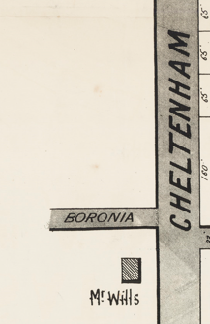

**The 1913 Electoral Roll records** Charles Rundle Wills (retired), Matilda Wills, Annie Bassett Wills, Mary Wills, Rose Emily Wills, Frank Rundle Wills (orchardist) - Cheltenham-road, Cheltenham

*[Charles Rundle Wills married Matilda Coombes in 1876, at Clifton, Gloucestershire, England.]*

The home of Charles R. Wills was called “Downend” and recorded as such in 1915 & 1917.

Sands Directories 1915-19 Charles R. Wills; 1920-1932/33 W. J. Grant

Electoral Roll 1933: Walter Grant No. 62

In November 1918 the Wills Estate & Boronia Estate Subdivision sales took place in Cheltenham-road, on opposite sides of Cheltenham-road from Boronia-avenue to Castle Howard-road.

The Wills Estate consisted of a cottage on the corner of Cheltenham-road and Boronia-avenue followed by 7 building sites.

The Boronia Estate consisted of 8 building sites.

On 9th October 1918 Mr. Wills, of Carlingford had announced to his agents that his property at Cheltenham, also at Carlingford, was withdrawn from sale. He may just have been referring to his house on the corner of Cheltenham-road and Boronia-avenue.

However, he seems to have changed his mind and the auction sale went ahead as in late November, under his instructions, there was an auction sale of his household furniture and effects at his home in Cheltenham-road.

*[In April 1924, at Carlingford, Charles Rundle Wills died, aged 78 years]*

**Wills Estate & Boronia Estate Subdivision**

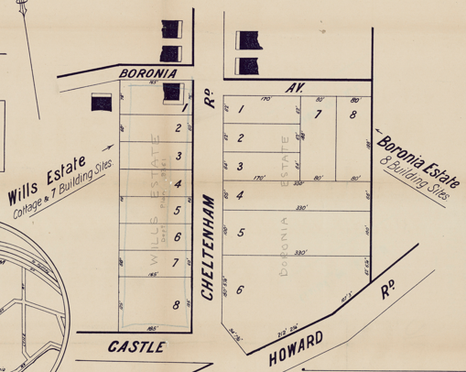

In 1917 Walter Grant was living in Cheltenham-road, Cheltenham.

*[Walter James Grant married Amy R. May 1907 Newtown]*

In 1929 the Construction & Local Government Journal records the demolition and removal of a cottage on the corner of Cheltenham-road and Boronia-avenue, with reference to M. L. (Malcolm Lindsay) Grant of 2 O’Connell Street, Sydney.

In 1933 occupants of 62 Cheltenham-road were Walter James Grant, Amy Ruby Grant, Malcolm Lindsay Grant and Matthew McDowell (labourer)

In 1935 Walter James Grant died at his residence, aged 55 years.

Occupants in 1937 were Amy Ruby Grant (home duties), Malcolm Lindsay Grant (accountant), Walter Donald Saxby Grant (wool classer) and Mavis Elaine Ruby Grant (home duties)

In 1939 Lot 1 DP 9361 (62 Cheltenham-road), along with Lots 2 & 3 DP 9361 (64 & 66 Cheltenham-road) were sold for default due to overdue rates.

[Amy Ruby Grant, of Cheltenham, Georgina Kate Corderoy, of Manly, and Isabel Sonter Miller, of Parramatta; overdue rates, £123 9s. 10d.; land, lots 1, 2 and 3, d.p. 9,361, Boronia-avenue and Cheltenham-road, Cheltenham.]

However, the 1943 Electoral Roll lists at this address Walter Donald Saxby Grant (wool classer), Amy Ruby Grant, Phyllis Elwyn Grant (clerk) and Mavis Elaine Lalchere

Amy Grant was living in the house in 1949 but had moved to Epping by 1954.

A later owner, whose daughter would live there until her death in late 2023, destroyed the house and burnt it in the backyard and had a new house built. He had fled the Russian Revolution, when many of his relatives were killed, and went to Vladivostok then to China where he stayed until the Communist takeover in 1949. He and his family then moved to Australia. Although not being familiar with the English language he made good in his new homeland, first moving to Maroubra where persons of similar experience lived.

The property came up for sale in 2023.1

**Bibliography:**

1 [62 Cheltenham Road, Cheltenham, NSW 2119 - House for Sale - realestate.com.au](https://www.realestate.com.au/property-house-nsw-cheltenham-143147736)

**Resources available (varies):**

* Sands Directories 1858-1933 City of Sydney [Sands Postal Directory | City of Sydney Archives (nsw.gov.au)](https://archives.cityofsydney.nsw.gov.au/nodes/view/495003)
* Newspaper articles – TROVE - [Search - Trove (nla.gov.au)](https://trove.nla.gov.au/search/advanced/category/newspapers)
* Ancestry.com (subscription only) [Genealogy, Family Trees and Family History Records online - Ancestry.com](https://www.ancestry.com.au/) – Sands Directories, Electoral Rolls, Family photos (Public Member photos), Census lists, marriage details, + miscellaneous
* N.S.W. Births, Deaths & Marriages [Family history search | NSW Government](https://www.nsw.gov.au/family-and-relationships/family-history-search) (QLD & Victoria also obtainable online)
* House photos and information via Hornsby Shire Council website for Property Search and Heritage Register [Heritage | Hornsby Shire Council (nsw.gov.au)](https://www.hornsby.nsw.gov.au/property/build/heritage)
* House photos and associated information via Internet search on address via Real Estate websites (from 2005)
* “Beecroft and Cheltenham Heritage Walks” - Beecroft-Cheltenham History Group Inc. 2004 book (1st edition)
* Australian War Museum website [Home | Australian War Memorial (awm.gov.au)](https://www.awm.gov.au/)