**65 CHELTENHAM ROAD, CHELTENHAM**

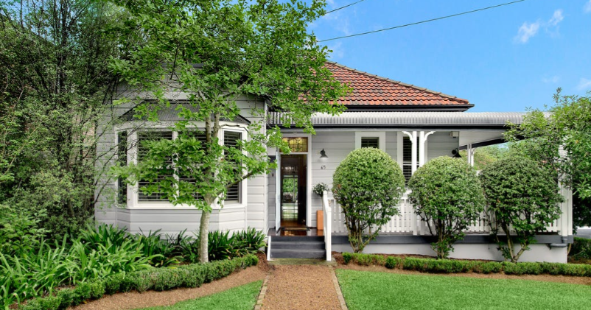

Lot 15 DP 220464

**Hornsby Shire Council details**

**Heritage Register: (NONE)**

Part of Beecroft & Cheltenham – Land for Sale Subdivision 1906

Sands Directories 1916-1921 William J. Rule; 1922-27 Thomas Bellamy

Electoral Roll 1933: William Richardson No. 65

Between 1917 and 1921 William J. Rule was living in Cheltenham-road, Cheltenham (East side), situated between “Ettalong” (no. 67) and “Brackland” (no. 63)

In 1932 the house was advertised to let, described as follows:  
‘FURNISHED. CHELTENHAM. 65 Cheltenham-Road.

COTTAGE, living-room, 4 bedrooms, kitchen, sleeping-out verandah, electric light, gas stove.

Perpetual Trustee Company (Limited). 33-39 Hunter-street.’

In 1933 it was occupied by William Richardson (electrical fitter), Ivy Kate Richardson, Albert Richardson (iron turner) and William Moylan Lynch (orchardist)

From 1935 to 1937 it was occupied by Wilfred Hutchinson (clerk), Jean Adah Mary Hutchinson (clerk) and Irene Hutchinson (home duties)

By 1943 it was occupied by Stanley Rey Bailey (gear cutter), Jessie Oritstoff Monk Bailey, Katharine Jane Plumbe (teacher), Muriel Katharine Plumbe and Eilene Winifred Mills

**Bibliography:**

1

**Resources available (varies):**

* Sands Directories 1858-1933 City of Sydney [Sands Postal Directory | City of Sydney Archives (nsw.gov.au)](https://archives.cityofsydney.nsw.gov.au/nodes/view/495003)
* Newspaper articles – TROVE - [Search - Trove (nla.gov.au)](https://trove.nla.gov.au/search/advanced/category/newspapers)
* Ancestry.com (subscription only) [Genealogy, Family Trees and Family History Records online - Ancestry.com](https://www.ancestry.com.au/) – Sands Directories, Electoral Rolls, Family photos (Public Member photos), Census lists, marriage details, + miscellaneous
* N.S.W. Births, Deaths & Marriages [Family history search | NSW Government](https://www.nsw.gov.au/family-and-relationships/family-history-search) (QLD & Victoria also obtainable online)
* House photos and information via Hornsby Shire Council website for Property Search and Heritage Register [Heritage | Hornsby Shire Council (nsw.gov.au)](https://www.hornsby.nsw.gov.au/property/build/heritage)
* House photos and associated information via Internet search on address via Real Estate websites (from 2005)
* “Beecroft and Cheltenham Heritage Walks” - Beecroft-Cheltenham History Group Inc. 2004 book (1st edition)
* Australian War Museum website [Home | Australian War Memorial (awm.gov.au)](https://www.awm.gov.au/)