**67 CHELTENHAM ROAD, CHELTENHAM (“Ettalong”; later “Lorna Doone”)**

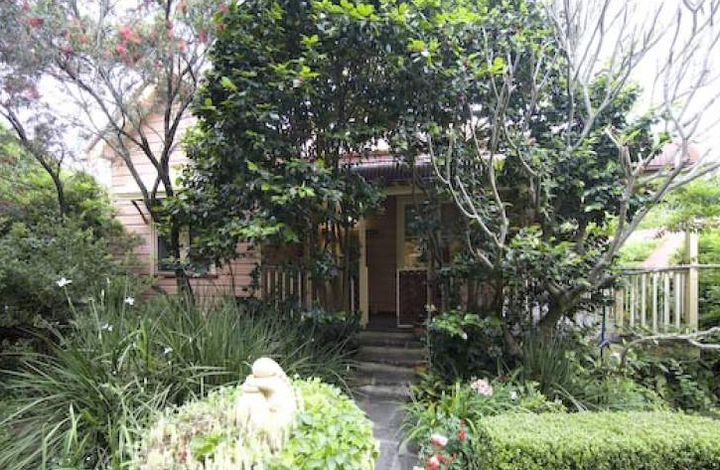

Lot 16 DP 220464

**Hornsby Shire Council details**

**Heritage Register: (NONE)**

Part of Beecroft & Cheltenham – Land for Sale Subdivision 1906

Sands Directories 1915 Richard C. Mumford; 1916-17 Andrew C. Miller; 1918 Ernest G. Bourne; 1919 John C. Bell; 1920-22 Robert Love; 1923-24 Charles E. Barnett; 1926-27 Mrs. C. O’Neil; 1930 F. Badger “Lorna Doone”; 1932/33 Albert G. Rothery

Electoral Roll 1933: Albert Rothery “Lorna Doone”

In 1917 Andrew C. Miller was living at “Ettalong.”

*[Andrew C. Miller married Ruth Coleman in 1888, district of Prospect]*

By 1923 Charles E. Barrett was in residence.

For 1934-5 Cecil Trives (no occupation) & Nellie Trives was living at 67 Cheltenham-road, who thereafter moved to 63 Cheltenham-road, Cheltenham

In 1943 Alan Tranter Brown (clerk), Dorothy Jean Brown & Margaret Jean Brown were in residence.

The house was last sold in 2012.**1**

**Bibliography:**

**1** [67 Cheltenham Road, Cheltenham, NSW 2119 - Property Details (realestate.com.au)](https://www.realestate.com.au/sold/property-house-nsw-cheltenham-110108157)

**Resources available (varies):**

* Sands Directories 1858-1933 City of Sydney [Sands Postal Directory | City of Sydney Archives (nsw.gov.au)](https://archives.cityofsydney.nsw.gov.au/nodes/view/495003)
* Newspaper articles – TROVE - [Search - Trove (nla.gov.au)](https://trove.nla.gov.au/search/advanced/category/newspapers)
* Ancestry.com (subscription only) [Genealogy, Family Trees and Family History Records online - Ancestry.com](https://www.ancestry.com.au/) – Sands Directories, Electoral Rolls, Family photos (Public Member photos), Census lists, marriage details, + miscellaneous
* N.S.W. Births, Deaths & Marriages [Family history search | NSW Government](https://www.nsw.gov.au/family-and-relationships/family-history-search) (QLD & Victoria also obtainable online)
* House photos and information via Hornsby Shire Council website for Property Search and Heritage Register [Heritage | Hornsby Shire Council (nsw.gov.au)](https://www.hornsby.nsw.gov.au/property/build/heritage)
* House photos and associated information via Internet search on address via Real Estate websites (from 2005)
* “Beecroft and Cheltenham Heritage Walks” - Beecroft-Cheltenham History Group Inc. 2004 book (1st edition)
* Australian War Museum website [Home | Australian War Memorial (awm.gov.au)](https://www.awm.gov.au/)