**69 CHELTENHAM ROAD, CHELTENHAM (“Jesmond Dene”)**

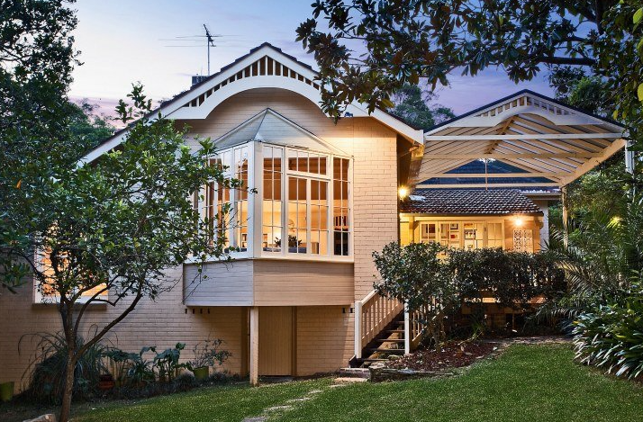

Lot 1 DP 934825 & Lot 1 DP 973617

**Hornsby Shire Council details**

**Heritage Register: (NONE)**

Part of Beecroft & Cheltenham – Land for Sale Subdivision 1906

“Jesmond Dene” is named after a public park in Newcastle upon Tyne, England, laid out in the 1860’s. In north-east England, valleys are commonly known as denes, with the name Jesmond meaning ‘mouth of the Ouseburn’ (a nearby small river).

There was also the holy well of Jesmond Dene in Northumberland.

In 1913 the house was occupied by Charles William Peacock (clerk) & Fanny Peacock.

*[Charles W. Peacock married Fanny Warren in 1895, in the district of Burwood]*

Sands Directories 1915-1932/33 Chas. W. Peacock “Jesmond Dene”

Electoral Roll 1933: Fanny Peacock No. 69

In 1929 Charles Peacock died at his residence, “Jesmond Dene,” aged 62 years, leaving a widow (Fanny), and two children, Marjorie (wife of Dr. Murray of the Quarantine Department, Brisbane, and Millicent Helena (Millie) Peacock.

He was born in Yorkshire and came to Australia about 1890. He Joined the clerical staff of Sydney University in 1902 and retired in 1928. In 1927 he had visited England but after an absence of eight months returned to his home at Cheltenham in ill-health.

In 1949 Fanny Peacock and her daughter Millie Peacock (typist) were still living at “Jesmond Dene.”

The house was last sold in 2013.1

**Bibliography:**

1 [69 Cheltenham Road, Cheltenham, NSW 2119 - Property Details (realestate.com.au)](https://www.realestate.com.au/sold/property-house-nsw-cheltenham-114054879)

**Resources available (varies):**

* Sands Directories 1858-1933 City of Sydney [Sands Postal Directory | City of Sydney Archives (nsw.gov.au)](https://archives.cityofsydney.nsw.gov.au/nodes/view/495003)
* Newspaper articles – TROVE - [Search - Trove (nla.gov.au)](https://trove.nla.gov.au/search/advanced/category/newspapers)
* Ancestry.com (subscription only) [Genealogy, Family Trees and Family History Records online - Ancestry.com](https://www.ancestry.com.au/) – Sands Directories, Electoral Rolls, Family photos (Public Member photos), Census lists, marriage details, + miscellaneous
* N.S.W. Births, Deaths & Marriages [Family history search | NSW Government](https://www.nsw.gov.au/family-and-relationships/family-history-search) (QLD & Victoria also obtainable online)
* House photos and information via Hornsby Shire Council website for Property Search and Heritage Register [Heritage | Hornsby Shire Council (nsw.gov.au)](https://www.hornsby.nsw.gov.au/property/build/heritage)
* House photos and associated information via Internet search on address via Real Estate websites (from 2005)
* “Beecroft and Cheltenham Heritage Walks” - Beecroft-Cheltenham History Group Inc. 2004 book (1st edition)
* Australian War Museum website [Home | Australian War Memorial (awm.gov.au)](https://www.awm.gov.au/)