**7 LYNE ROAD, CHELTENHAM (“Stoke”)**

**New house erected**

**A new house (below) was built.**

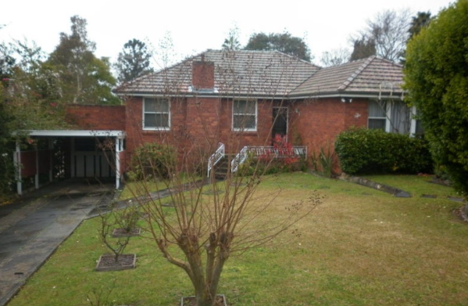

Lot A DP 323398

**Hornsby Shire Council details**

**Heritage Register: (NONE)**

**Problem: The BCHG website states that No. 3 was lived in from at least 1921 until 1933 by Edward Austin; and No. 5, *Stoke*, was lived in from at least 1922 by Mrs A. [S.A.?] Burrows and then from 1923 to 1932 by the Harton family.**

In 1923 Sheffield Ernest Harton was occupying “Stoke”.

He also owned No. 3 Lyne-road, Cheltenham.

S. E. Harton was born c1871 at Penn, Buckinghamshire, England. In 1894 he went to New York (occupant: merchant). In 1900 he married Beatrice Darville at Eton, Buckinghamshire. In 1901 Sheffield, manufacturer, and Beatrice were living at Luton, Bedfordshire.

By 1909 they had arrived in Sydney and were living at Coogee. A son, Henry Sheffield Harton was born that year.

In 1912 S. E. Harton went to England. In 1913 he went to Vancouver, Canada, where he was pre-examined for entry to the U.S.A. His details are: Australian, Manager, wife in Coogee, 42, 5’ 7”, 155lbs, brown hair, blue eyes.

The 1930 Electoral Roll lists Sheffield Ernest Harton (sales rep.), Beatrice Harton and Henry Sheffield Harton (law clerk) as occupants of “Stoke”.

In October 1930 H. S. Harton of “Stoke,” Lyne-road, applied to the Supreme Court to be examined to obtain a Certificate authorising him to practice as a Conveyancer.

However, the 1930 Sands Directory has John Frederick Moseley as the occupant of “Stoke.” Perhaps J. F. Moseley and his wife Kathleen were renting rooms at “Stoke.”

The 1931 Electoral Roll lists John Frederick Moseley (broker) and Kathleen Patricia Moseley as living in Lyne-road, Cheltenham, and in 1933 at 7 Lyne-road, Cheltenham

The 1933 Electoral Roll lists S. E. Harton as living in Homebush, Sydney.

In 1937 No. 7 Lyne-road was advertised for rent, described as follows: ‘Gentleman's Home, 6 rooms, kitchen, large verandah, beautiful views, 35/.’

In 1940 No. 7 is up for sale, described as a ‘Detached Double-fronted Cottage of Brick.’

By 1943 the home was occupied by George Daniel Curtis (tailor), Elizabeth Ann Curtis, Georgina Edna Florence Curtis, Lorna Beryl Alexandria Curtis (nurse) and Neta Blanche Curtis. The following year, Elizabeth Ann, wife of George Daniel Curtis, died at the residence.

**Bibliography:** **none**

**Resources available (varies):**

* Sands Directories 1858-1933 City of Sydney [Sands Postal Directory | City of Sydney Archives (nsw.gov.au)](https://archives.cityofsydney.nsw.gov.au/nodes/view/495003)
* Newspaper articles – TROVE - [Search - Trove (nla.gov.au)](https://trove.nla.gov.au/search/advanced/category/newspapers)
* Ancestry.com (subscription only) [Genealogy, Family Trees and Family History Records online - Ancestry.com](https://www.ancestry.com.au/) – Sands Directories, Electoral Rolls, Family photos (Public Member photos), Census lists, marriage details, + miscellaneous
* N.S.W. Births, Deaths & Marriages [Family history search | NSW Government](https://www.nsw.gov.au/family-and-relationships/family-history-search) (QLD & Victoria also obtainable online)
* House photos and information via Hornsby Shire Council website for Property Search and Heritage Register [Heritage | Hornsby Shire Council (nsw.gov.au)](https://www.hornsby.nsw.gov.au/property/build/heritage)
* House photos and associated information via Internet search on address via Real Estate websites (from 2005)
* “Beecroft and Cheltenham Heritage Walks” - Beecroft-Cheltenham History Group Inc. 2004 book (1st edition)
* Australian War Museum website [Home | Australian War Memorial (awm.gov.au)](https://www.awm.gov.au/)

**.**